

**OnRTLS Web Application  
Comprehensive Manual**  
  
  
October 2025 – v1.0

## Prologue

This manual provides a comprehensive guide to the OnRTLS Web Application, covering all operational modules, configuration tools, and monitoring dashboards. It is designed to assist administrators, supervisors, and technical personnel in managing real-time tracking, forklift guidance, mission execution, and warehouse optimization tasks within the OnRTLS ecosystem.

**Scope**

The document includes detailed explanations of each system module—ranging from RTLS tracking and forklift configuration to monitoring, data management, and warehouse layout definition. It serves as a reference for setup, maintenance, and troubleshooting of OnRTLS environments.

**Audience**

This manual is intended for:

* **System Administrators:** Configuring and maintaining OnRTLS and its services.
* **Warehouse Supervisors:** Managing missions, stock, and forklift activity.
* **Engineers and Integrators:** Setting up localization sensors, safety systems, and third-party connections.
* **Operators:** Using FGS and monitoring modules for daily operations.

**Structure**

The manual is organized into core sections that follow the OnRTLS application layout:

1. **RTLS and FGS Overview**
2. **Monitoring Module** – Real-time status, events, and KPIs
3. **Configuration Module** – Forklifts, Zones, Users, and System setup
4. **Locations Module** – Areas, Racks, Bays, and Location Groups
5. **Extensions** – Add-on modules and integration tools

**Version Control**

This document applies to software version **3.4.2670.0** and later.  
Future revisions will expand on new features and system updates.

Table of Contents

Prologue 2

1.1 RTLS – Home Page 7

2.1 RTLS – FGS 8

2.1.1 RTLS – Forklifts 8

2.1.2 RTLS – 3D Live Map 10

3.1 Monitoring – Stock 13

3.1.1 Monitoring – Stock – +New 15

3.2 Monitoring – Movements 18

3.3 Monitoring – Missions 20

3.3.1 Monitoring – Missions – +New 22

3.4 Monitoring – KPI 24

3.5 Monitoring – Replay 26

3.6 Monitoring – Safety – Near Miss 28

3.7 Monitoring – Safety – Forklifts Status 30

3.8 Monitoring – Safety – Live Status 31

3.9 Monitoring – Heatmap 33

3.10 Monitoring – Forklifts – User Log-ons 34

3.11 Monitoring – Forklifts – Audit 36

3.12 Monitoring – Forklifts – Log 39

3.13 Monitoring – Forklifts – Log Server 40

3.14 Monitoring – Forklifts – Data Log 42

3.15 Monitoring – Forklifts – States 44

3.16 Monitoring – Forklifts – Messages 46

3.17 Monitoring – Dragonfly Localization – Cameras 48

3.18 Monitoring – System – Log 50

3.19 Monitoring – System – Status 52

4.1 Configuration – Forklifts 53

4.1.1 Configuration – Forklifts – ⋮ – Modify group 56

4.1.2 Configuration – Forklifts – ⋮ – Zone parameters 71

4.1.3 Configuration – Forklifts – ⋮ – Safety zones parameters 77

4.1.4 Configuration – Forklifts – ⋮ – Mesh color 80

4.1.5 Configuration – Forklifts – ⋮ – Forks sensors calibration 82

4.1.6 Configuration – Forklifts – +New 85

4.1.7 Configuration – Forklifts – Forklift groups 86

4.1.8 Configuration – Forklifts – Forklift groups – ⋮ – Zones parameters 88

4.1.9 Configuration – Forklifts – Forklift groups – ⋮ – Safety zones parameters 89

4.1.10 Configuration – Forklifts – Forklift groups – ⋮ – Mesh color 90

4.2 Configuration – Zone 90

4.2.1 Configuration – Zone – +New 92

4.3 Configuration – Navigation Graph 94

4.3.1 Configuration – Navigation Graph – +New 96

4.4 Configuration – Warehouses 98

4.5 Configuration – Users – FGS Users 100

4.5.1 Configuration – Users – FGS Users – +New 102

4.6 Configuration – Users – User Groups 104

4.6.1 Configuration – Users – User Groups – +New 105

4.7 Configuration – Users – User Roles 107

4.7.1 Configuration – Users – User Roles – +New 108

4.8 Configuration – Configuration – System 110

4.9 Configuration – Configuration – Reference System 114

4.9.1 Configuration – Configuration – Reference System – Calculate UTM parameters 117

4.10 Configuration – Configuration – RTCM 120

4.11 Configuration – Configuration – Roaming Areas 123

4.12 Configuration – Configuration – 3D Graphics 126

4.13 Configuration – Configuration – FGS Personalizations 129

4.14 Configuration – Configuration – Data Pages Config 134

4.15 Configuration – More – Ublox ZED 135

4.16 Configuration – More – Migrations 136

4.17.1 Configuration – More – Checklist Login 138

4.17.2 Configuration – More – Checklist Login – +New 139

4.17.3 Configuration – More – Checklist Login – History 141

4.18 Configuration – More – Tablet Script 142

4.18.1 Configuration – More – Tablet Script – +New 144

4.18.2 Configuration – More – Tablet Script – Import 146

4.19 Configuration – More – Dotnet Runtimes 147

4.19.1 Configuration – More – Dotnet Runtimes – +New 148

4.20 Configuration – More – HU Containers 149

4.20.1 Configuration – More – HU Containers – +New 151

5.1 Locations 152

5.2 Locations – Racks 154

5.2.1 Locations – Racks – +New 157

5.3 Locations – Loading Bays 159

5.3.1 Locations – Loading Bays – +New 162

5.4 Locations – Location Groups 164

5.4.1 Locations – Location Groups – +New 166

5.5 Locations – Areas 169

5.5.1 Locations – Areas – +New 170

6.1 Extensions 172

7.1 Glossary of Terms 173

8.1 Document Control & Revision History 174

## 1.1 RTLS – Home Page

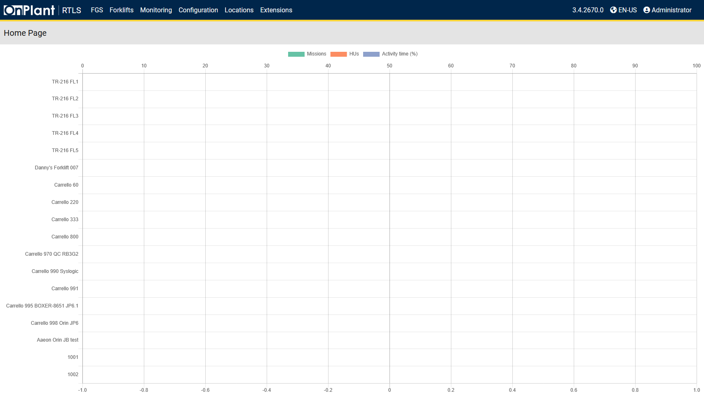  
The RTLS (Real-Time Location System) Home Page provides an overview of forklift activity in the system. It displays a summary graph of **Missions**, **HUs (Handling Units)**, and **Activity Time (%)** for each forklift registered in the system.

**Layout Overview**

|  |  |
| --- | --- |
| Area | Description |
| Navigation Bar | Contains links to the main application modules: RTLS, FGS, Forklifts, Monitoring, Configuration, Locations, and Extensions. The upper right corner shows the application version, language selection, and current user. |
| Chart | The chart lists registered forklifts and their Missions, HU, and Activity Time. |
| Legend | • Missions – Green  • HUs – Orange  • Activity Time (%) – Blue |

**User Actions**

1. **Review Key Metrics**  
   The graph provides a quick way to evaluate forklift usage and workload balance.
2. **Log in**Click the user menu (Administrator) in the top-right corner to sign in.
3. **Navigation Bar**Main bar to access the rest of the web application.
4. **Verify Software Version**Verify the software version in the top-right banner (for example, 3.4.2670.0).
5. **Select Language**Click EN-US to change web application language settings.

## 2.1 RTLS – FGS

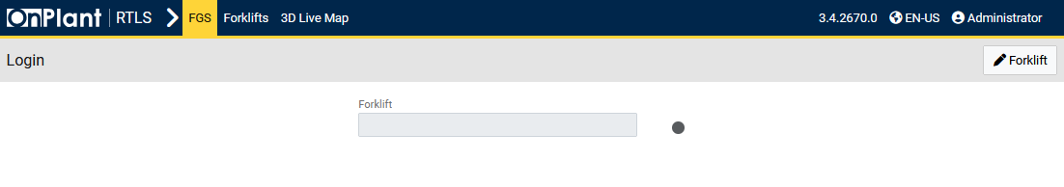

Click **Forklift** on the right to select a forklift/vehicle.

### 2.1.1 RTLS – Forklifts

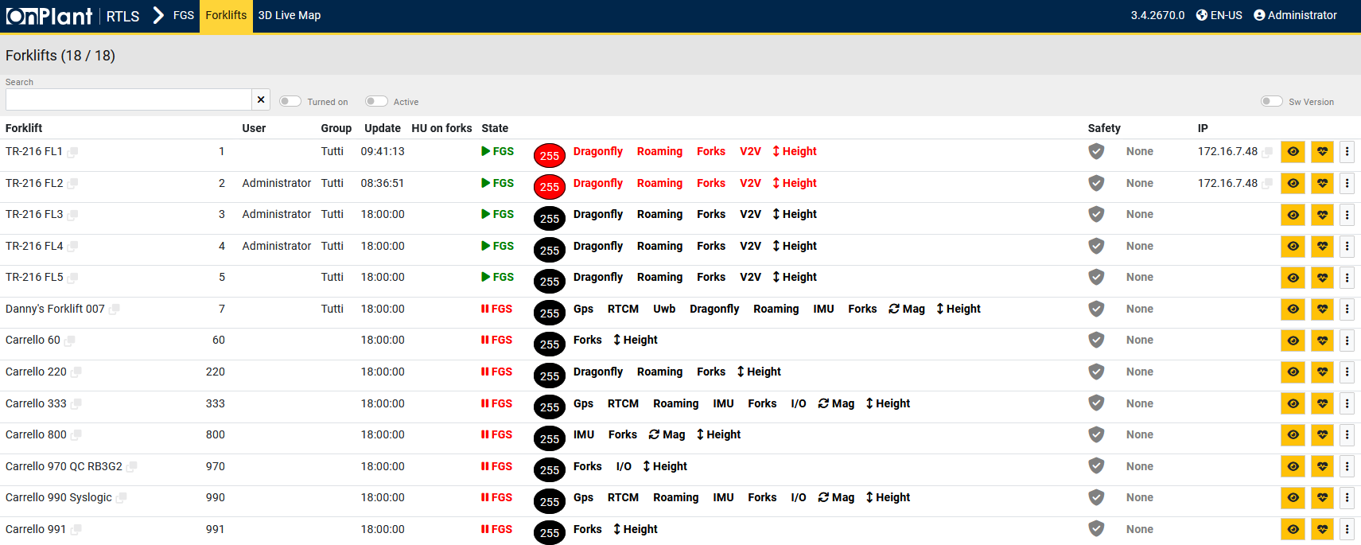  
The *Forklift Fleet Status* page displays all forklifts registered in the FGS system. It provides detailed operational data for each forklift, including user, group, semaphores, safety status, and network IP address. Key users can access each forklift’s graphical user interface (GUI), diagnostics, or technical controls from this page.

**Layout Overview**

|  |  |
| --- | --- |
| Area | Description |
| Search Bar | Filters forklifts by ID or keyword. |
| Toggles | • **Turned On** – Displays forklifts that are powered on.  • **Active** – Displays forklifts currently active.  • **Sw Version** – Displays software version for each forklift. |

**Table**

|  |  |
| --- | --- |
| Column | Description |
| Forklift | Forklift name or ID. |
| User | User ID or operator currently assigned. |
| Group | User group association. |
| Update | Last recorded data update time. |
| HU on forks | Displays the Handling Units (HUs) currently detected on the forklift forks. |
| State (Semaphores) | Represents the forklift’s overall and modular system condition through **semaphores**:  • **Black** – Device not initialized.  • **Green** – Functioning properly.  • **Yellow** – Warning or partial issue detected.  • **Red** – Error or failure detected.  Hovering over a semaphore reveals the component or error description. |
| Safety | Displays the safety status of the forklift. |
| IP | Forklift’s network IP address. |
| Actions | • **Eye icon** – Opens the **FGS User Interface** (forklift GUI).  • **Heart icon** – Opens the **Diagnostic Page** to review real-time parameter data.  • **⋮ Three-dot menu** – Opens the **Forklift Control Menu**, containing additional commands and monitoring tools. |

**Forklift Control Menu (⋮)**

|  |  |  |
| --- | --- | --- |
| Section | Function | Description |
| Controls | Command forklift | Opens the forklift’s onboard application. |
|  | Deactivate forklift | Deactivates or stops the virtual forklift. |
| Monitoring | Log | Opens the forklift’s log entries for review. |
|  | Data log | Redirects to Monitoring > Forklifts > Data log. |
|  | Safety actuations | Redirects to Monitoring > Safety > Live status. |
|  | Send message | Redirects to Monitoring > Forklifts > Messages. |
|  | Diagnostics endpoint | Opens technical diagnostic parameters linked to the forklift’s sensors. |
|  | IO-Link Master input/output | Displays the port’s status connected via IO-Link Master. |
| Actions | Restart Forklift | Restarts the forklift’s onboard application. |
|  | Edit configuration | Opens the configuration editor for forklift settings. |

**User Actions**

1. Use the **search field** to locate a forklift.
2. Use toggle filters to refine displayed forklifts (Turned On, Active, Sw Version).
3. Review **semaphores** to assess forklift operational status.
4. Hover over semaphores to see sensor or system-level details.
5. Click the **Eye icon** to open the forklift’s GUI.
6. Click the **Heart icon** to open the forklift’s **Diagnostic Page**.
7. Click the **Three-dot menu (⋮)** for forklift control, monitoring, or configuration actions.

**Additional Information**

* The **Diagnostic Page** displays detailed parameters related to the forklift’s semaphores.
* The **Restart Forklift** command only restarts the forklift’s onboard software, not its hardware power cycle.

### 2.1.2 RTLS – 3D Live Map

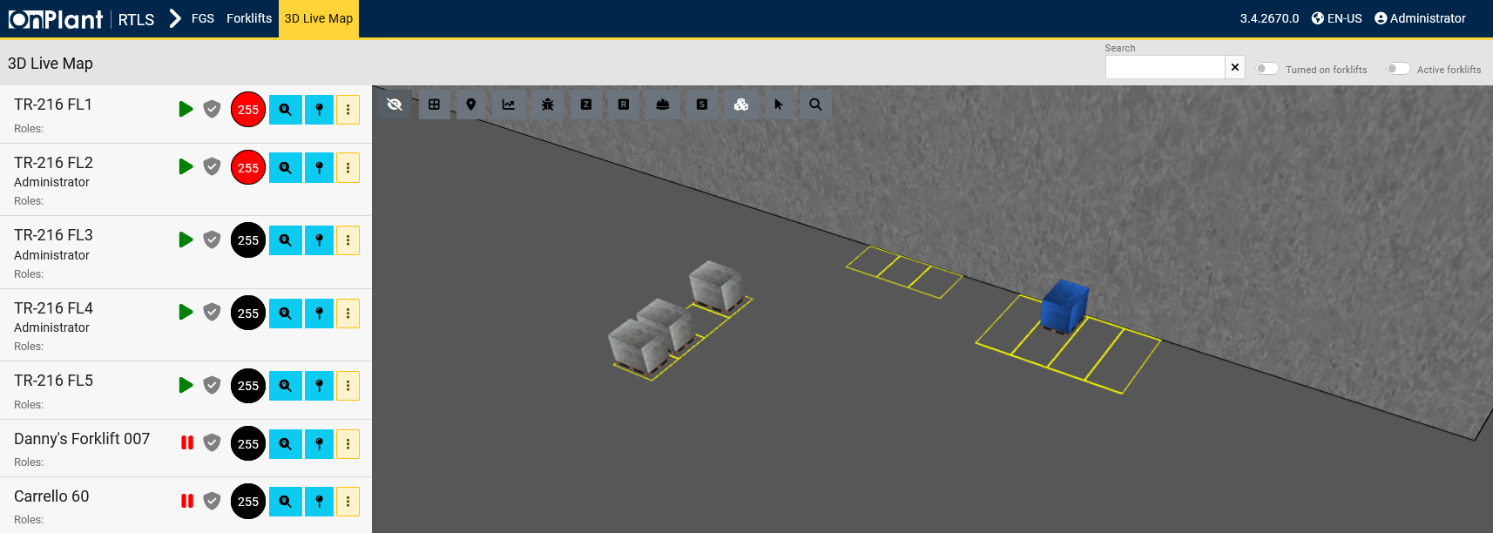  
The *3D Live Map* provides a real-time, three-dimensional view of the warehouse layout and forklift activity. It is used to visually monitor forklift positions, obstacles, zones, and other environmental elements in the facility. The map updates automatically to reflect the current system status.

**Layout Overview**

|  |  |
| --- | --- |
| Area | Description |
| Toolbar | Contains 12 map interaction buttons for enabling or disabling map layers and features. |
| Left Panel | Displays registered forklifts. Each forklift entry includes its name or ID and its semaphores, showing live status information. |
| 3D Live Map | The interactive 3D environment representing the site location. Users can move, rotate, and zoom to observe forklift positions, zones, and events in real time. |
| Search Bar | Used to search for a specific forklift or asset within the map. |
| Toggles | • **Turned on forklifts** – Displays forklifts that are powered on.  • **Active forklifts** – Displays forklifts currently in operation. |

**Map Interaction**

|  |  |
| --- | --- |
| Action | Description |
| Right-click + Drag | Pans the map. |
| Left-click + Drag | Rotates the map. |
| Mouse Wheel | Zooms in and out of the map. |

**Map Controls**

|  |  |
| --- | --- |
| Button | Function |
|  | Toggles the visibility of obstacles within the 3D environment. |
|  | Shows or hides the ground surface textures and material layers. |
|  | Allows or disables position selection within the map. |
|  | Shows or hides the 3D coordinate axes used for orientation. |
|  | Activates or deactivates the inspector tool for reviewing object properties. |
|  | Shows or hides warehouse zone boundaries on the map. |
|  | Displays or hides designated roaming areas used for positioning or movement control. |
|  | Toggles visibility of recorded safety events in the 3D view. |
|  | Shows or hides defined safety zones on the map. |
|  | Displays or hides stock items or Handling Units in the map view. |
|  | Enables or disables the interactive cursor tool for selecting map objects. |
|  | Activates or deactivates the search function used to locate elements in the 3D map. |

**Forklift Display Panel**

|  |  |
| --- | --- |
| Element | Description |
| Forklift List | Displays all forklifts currently connected to the system and visible in the 3D map. |
| Semaphores | Show each forklift’s operational status. |
|  | Centers map to the selected forklift/vehicle. |
|  | Auto follow selected forklift/vehicle. |
|  | Sub menu to access the GUI, Diagnostics or Logs. |

**User Actions**

1. Navigate throughout the map.
2. Use toolbar buttons to toggle visibility of zones, obstacles, and other layers.
3. Use the **Search bar** to locate a specific forklift or object.
4. Use **Turned on forklifts** and **Active forklifts** toggles to filter displayed vehicles.
5. Select a forklift from the **Left Panel** to focus the view on its position.

## 3.1 Monitoring – Stock

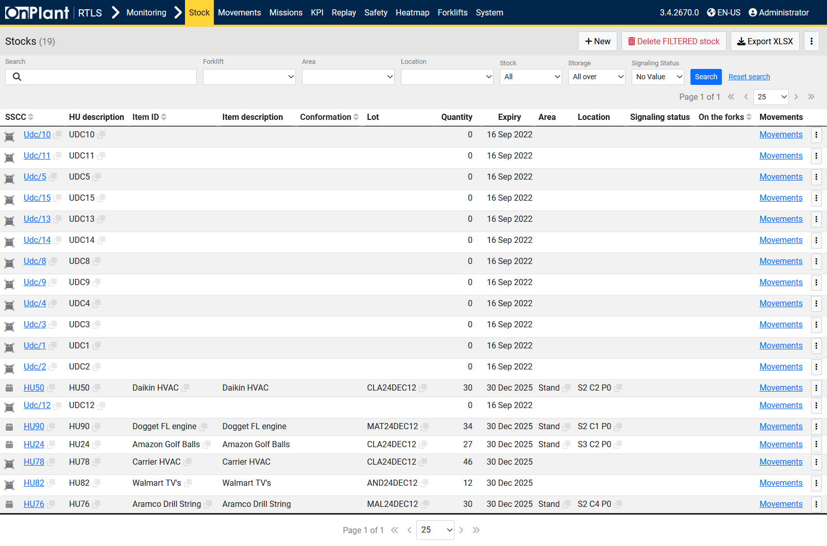  
The *Stock* page displays all Handling Units (HUs) currently recorded in the system, including identifying information, quantities, expiration dates, and storage locations.  
Administrators and supervisors use this page to review warehouse inventory, trace item locations, and export or modify stock data.

**Layout Overview**

|  |  |
| --- | --- |
| Area | Description |
| Search and Filter Bar | Provides filters for searching Handling Units by forklift, area, location, or signaling status. |
| Toolbar | • + New – Creates a new stock record.  • Delete filtered stock – Deletes all stock entries currently visible under active filters.  • Export XLSX – Exports the displayed data table to an Excel file.  • ⋮ (Three-dot menu) – Opens additional options:   – Delete all stock – Permanently removes all stock records from the database.   – Import/Export – Opens the import/export dialog to exchange data with external sources. |
| Table | Displays all Handling Units and their related data. Each row represents one Handling Unit (HU). |

**Search and Filter Options**

|  |  |
| --- | --- |
| Field | Description |
| Search | Searches stock records by SSCC, HU ID, or description. |
| Forklift | Filters results by forklift ID associated with the HU. |
| Area | Filters results by warehouse area. |
| Location | Filters results by location within the area. |
| Stock | Filters by stock category. |
| Storage | Filters by storage type. |
| Signaling Status | Filters by HU signaling condition. |
| Search / Reset search | Executes or clears the active filters. |

**Table Columns**

|  |  |
| --- | --- |
| Column | Description |
| SSCC | Serial Shipping Container Code – unique ID for each HU. |
| HU Description | Description or label of the Handling Unit. |
| Item ID | Internal identifier for the stored item. |
| Item Description | Full item name or description. |
| Conformation | Displays the internal reference or classification for the HU. |
| Lot | Batch or lot number of the item. |
| Quantity | Amount or count contained within the HU. |
| Expiry | Expiration or validity date for the item. |
| Area | Warehouse area containing the HU. |
| Location | Specific storage location. |
| Signaling Status | Indicates the signaling state associated with the HU. |
| On the Forks | Displays if the HU is currently on a forklift. |
| Movements | Opens the *Movements* page filtered for this HU. |
| ⋮ (Row Menu) | Opens options specific to the selected HU:   • **Clone** – Creates a duplicate of the selected HU entry.   • **Delete HU** – Deletes the selected HU record from the system. |

**User Actions**

1. Use the **Search** bar or dropdown filters to locate Handling Units.
2. Click **Search** to apply filters or **Reset search** to clear them.
3. Click an **SSCC** link to open detailed HU information.
4. Click **Movements** to view the movement history of a selected HU.
5. Click **+ New** to create a new Handling Unit record.
6. Use **Export XLSX** to download visible stock data in Excel format.
7. Use the toolbar **⋮ menu** for system-wide actions such as:  
    • **Delete all stock** – Removes all HU records.  
    • **Import/Export** – Opens file transfer options for stock data.
8. Use the **row-specific ⋮ menu** to clone or delete individual HU records.

**Troubleshooting**

|  |  |  |
| --- | --- | --- |
| Issue | Description | Action |
| No results shown | Filters exclude available data. | Click **Reset search** to clear filters. |
| Export produces empty file | No visible rows in current view. | Ensure stock data is visible before exporting. |
| Unable to delete HU | Restricted by permissions or dependencies. | Confirm administrator access or unlink HU from movements. |

**Additional Information**

* The **Stock** page is part of the Monitoring module and provides read/write control over Handling Unit data.
* All stock entries are traceable through the *Movements* history.
* Import/Export functions support bulk data management and backup of warehouse inventory records.

### 3.1.1 Monitoring – Stock – +New

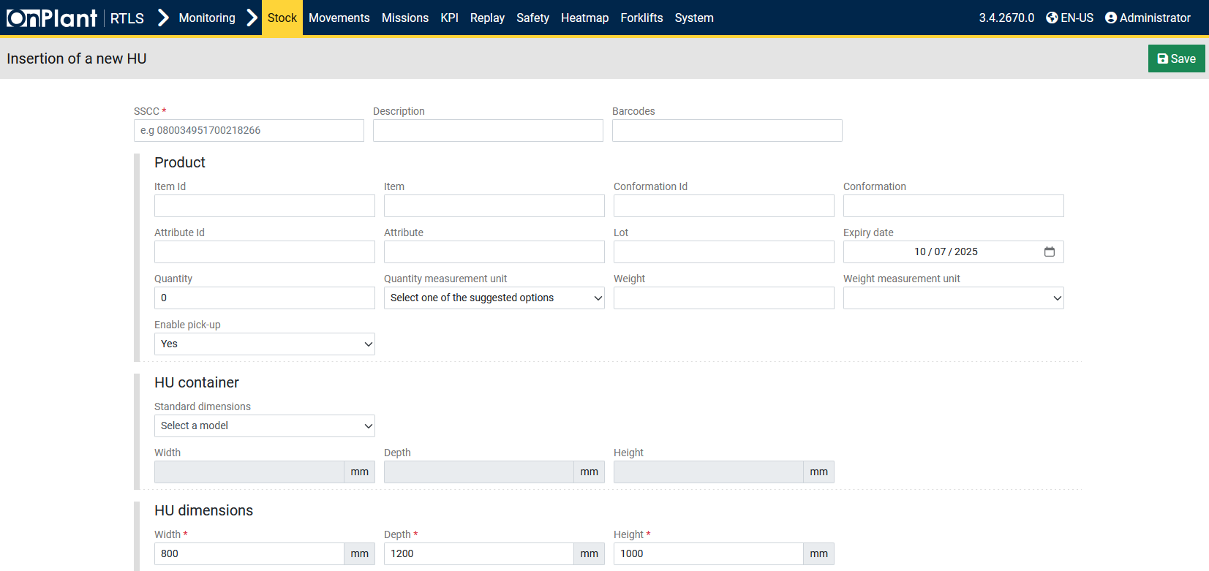

The *Insertion of a New HU* page is used to manually create and register a new Handling Unit (HU) in the system. Administrators can define product details, assign identifiers, and set physical dimensions for warehouse traceability. HU Containers use Width / Length / Height (ISO container orientation). HU Dimensions use Width / Depth / Height for the placed HU; Depth typically aligns with container Length along the forklift’s travel axis.

**Layout Overview**

|  |  |
| --- | --- |
| Area | Description |
| Save | Saves the entered HU data to the system. |
| Form | Divided into three main areas: *Product*, *HU Container*, and *HU Dimensions*. |

**Fields**

|  |  |
| --- | --- |
| Field | Description |
| SSCC | Serial Shipping Container Code. *(Required)* |
| Description | Text field describing the Handling Unit contents or purpose. |
| Barcodes | Barcode reference number for external scanning systems. |

**Product**

|  |  |
| --- | --- |
| Field | Description |
| Item ID | Internal identifier of the product contained in the Handling Unit. |
| Item | Name or short description of the product. |
| Conformation ID | Code identifying the product’s configuration or type. |
| Conformation | Description of the configuration type. |
| Attribute ID | Optional attribute code for classification. |
| Attribute | Attribute description or label. |
| Lot | Batch or lot number assigned to the product. |
| Expiry Date | Date when the product expires or becomes invalid. Selectable from the date picker. |
| Quantity | Numeric quantity contained within the Handling Unit. |
| Quantity Measurement Unit | Drop-down list to select the unit of measure for quantity. |
| Weight | Numeric weight of the Handling Unit or its contents. |
| Weight Measurement Unit | Drop-down list to select weight units. |
| Enable Pick-up | Option to make the HU available for forklift pick-up. Default: *Yes*. |

**HU Container**

|  |  |
| --- | --- |
| Field | Description |
| Standard Dimensions | Drop-down menu to select a predefined container model, if applicable. |
| Width / Depth / Height | Displays the container’s default measurements when a model is selected (values are shown in millimeters). |

**HU Dimensions**

|  |  |
| --- | --- |
| Field | Description |
| Width | Actual width of the Handling Unit in millimeters. *(Required)* |
| Depth | Actual depth of the Handling Unit in millimeters. *(Required)* |
| Height | Actual height of the Handling Unit in millimeters. *(Required)* |

**User Actions**

1. Enter relevant **Product** and **HU Container** data.
2. Define **HU Dimensions** with accurate physical measurements.
3. Confirm the **Enable Pick-up** option if the HU will be handled by forklifts.
4. Click **Save** (top-right corner) to store the new Handling Unit.

**Additional Information**

* Newly created Handling Units immediately appear in the *Stock* table upon saving.
* All HU identifiers (SSCC, Item ID, Lot) must be unique to prevent duplication errors.
* Editing or deleting a created HU is done from the main *Stock* page using the row menu (**⋮ → Delete HU** or **Clone**).

## 3.2 Monitoring – Movements

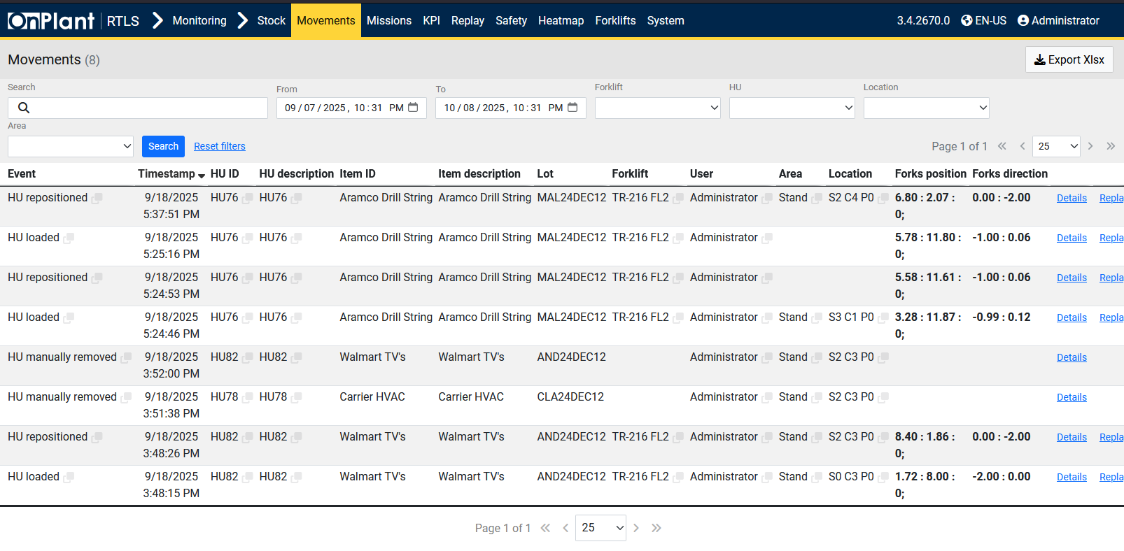  
The *Movements* page lists all Handling Unit (HU) movement events recorded by the system.  
Each record corresponds to a tracked action. This is used to review forklift activity, confirm completed missions, and trace the full history of HUs across warehouse locations.

**Layout Overview**

|  |  |
| --- | --- |
| Area | Description |
| Search and Filter Bar | Contains fields for filtering by date range, forklift, Handling Unit, location, or area. |
| Export XLSX | Exports the list of filtered movement events to an Excel file. |
| Main Table | Displays movement records in chronological order, including forklifts, HUs, and event data. |

**Search and Filter Options**

|  |  |
| --- | --- |
| Field | Description |
| Search | Filters by event type, HU ID, or description text. |
| From / To | Defines the start and end date/time for filtering movement history. |
| Forklift | Filters by forklift that performed the movement. |
| HU | Filters by Handling Unit ID. |
| Location | Filters by specific warehouse location. |
| Area | Filters by warehouse area or zone. |
| Search / Reset search | Applies or clears the current filter set. |

**Table Columns**

|  |  |
| --- | --- |
| Column | Description |
| Event | The recorded activity. |
| Timestamp | Date and time the event occurred. |
| HU ID | The Handling Unit identifier involved in the event. |
| HU Description | Description or label of the Handling Unit. |
| Item ID | Identifier of the item stored within the HU. |
| Item Description | Full description of the item. |
| Lot | Batch or lot number of the item. |
| Forklift | The forklift that executed the event. |
| User | The logged-in user who performed or triggered the event. |
| Area | Warehouse area where the event occurred. |
| Location | Specific position or stand where the event took place. |
| Forks Position | Fork position coordinates (X : Y : Z) at the time of the event. |
| Forks Direction | Fork orientation values recorded at that time. |
| Details | Opens a detailed modal view containing event information such as operator, sensor readings, and semaphore states. |
| Replay | Opens the *3D Live Map* view showing the event replayed at the exact time it occurred, including forklift and Handling Unit positioning. |

**User Actions**

1. Use the filter bar to select a date range, forklift, or HU.
2. Click **Search** to refresh the list with filtered results.
3. Click **Details** to review detailed parameters for the selected event.
4. Click **Replay** to open a 3D Live Map visualization of the event, showing forklift and HU positions at that moment.
5. Use **Export XLSX** to export the filtered results to Excel format.
6. Use Reset search to clear all applied filters.

**Additional Information**

* All events on this page are logged automatically by the RTLS system through forklift activity sensors and mission tracking.

## 3.3 Monitoring – Missions

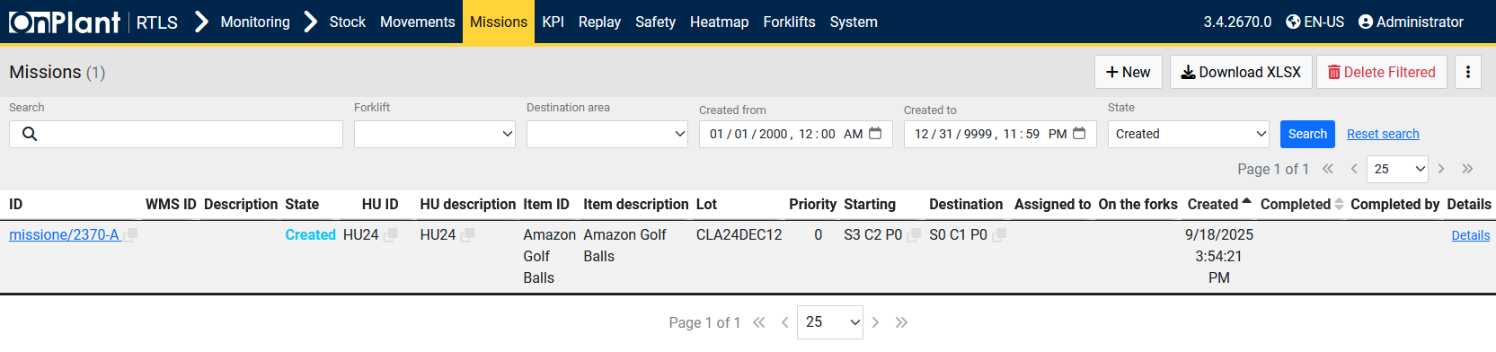  
The *Missions* page lists all work missions assigned within the OnRTLS system.  
Each mission represents a specific forklift task, such as transporting, loading, or unloading a Handling Unit (HU) between defined areas. This page allows administrators to review, create, and manage mission data as well as monitor completion status.

**Layout Overview**

|  |  |
| --- | --- |
| Area | Description |
| Search and Filter Bar | Used to filter missions by forklift, date range, state, or destination area. |
| Toolbar | • **+ New** – Creates a new mission manually.  • **Download XLSX** – Exports mission data to Excel format.  • **Delete Filtered** – Deletes all missions currently displayed by the active filters.  • **⋮ (Three-dot menu)** – Opens additional options for bulk actions (if available). |
| Table | Displays all missions, their current states, assigned forklifts, Handling Units, and completion details. |

**Search and Filter Options**

|  |  |
| --- | --- |
| Field | Description |
| Search | Searches missions by ID, description, or item name. |
| Forklift | Filters missions by assigned forklift. |
| Destination Area | Filters by the destination area of the mission. |
| Created From / Created To | Defines the time range for mission creation. |
| State | Filters missions by state. |
| Search / Reset Search | Applies or clears the selected filter set. |

**Table Columns**

|  |  |
| --- | --- |
| Column | Description |
| ID | Unique mission identifier. Clicking the ID opens detailed mission information. |
| WMS ID | Warehouse Management System reference number, if available. |
| Description | Mission description or label. |
| State | The current mission state (e.g., *Created*, *In Progress*, *Completed*). |
| HU ID | The Handling Unit assigned to the mission. |
| HU Description | Description of the Handling Unit. |
| Item ID | Identifier for the item handled in the mission. |
| Item Description | Full name or description of the handled item. |
| Lot | Lot or batch number associated with the item. |
| Priority | Mission priority level (numeric value). |
| Starting | Starting location for the mission. |
| Destination | Target location or delivery area for the Handling Unit. |
| Assigned To | Forklift or operator assigned to execute the mission. |
| On the Forks | Displays whether the Handling Unit is currently being carried by a forklift. |
| Created | Timestamp of when the mission was created. |
| Completed | Timestamp of mission completion, if applicable. |
| Completed By | User or forklift that completed the mission. |
| Details | Opens a detailed mission overview containing all mission parameters. |

**User Actions**

1. Use filters (date range, forklift, area, or state) to locate missions.
2. Click **Search** to apply the filters or **Reset Search** to clear them.
3. Click a Mission ID to view full details of that mission.
4. Click **Details** to open the mission’s configuration and progress data.
5. Click **+New** to manually create a new mission.
6. Use **Download XLSX** to export the current mission list.
7. Use **Delete Filtered** to remove all missions currently shown under the applied filters.

**Troubleshooting**

|  |  |  |
| --- | --- | --- |
| Issue | Description | Action |
| Mission not visible | Filters may exclude it. | Clear filters or verify mission creation date. |
| Replay not loading | No spatial data available for mission. | Confirm the mission was linked to a tracked forklift. |
| Incorrect HU shown | HU assignment modified after mission creation. | Check mission details or review the movement history. |

### 3.3.1 Monitoring – Missions – +New

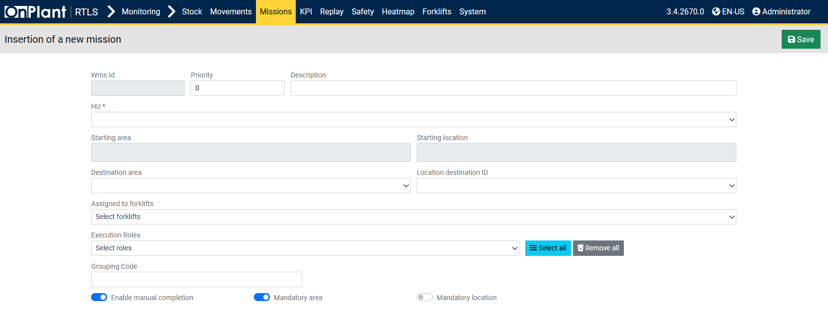  
The *Insertion of a New Mission* page allows users to manually create a new mission for Handling Units (HUs). A mission defines a forklift task, including which HU to move, where it starts, where it must be placed, and which forklifts or roles are authorized to perform the action.

**Layout Overview**

|  |  |
| --- | --- |
| Area | Description |
| Header | Displays the page title (*Insertion of a new mission*). |
| Save Button | Saves the new mission to the system. |
| Form | Contains all fields for defining the mission parameters and conditions. |

**Form Fields**

|  |  |
| --- | --- |
| Field | Description |
| WMS ID | Warehouse Management System reference number for the mission. |
| Priority | Numeric field that determines the mission’s execution priority. |
| Description | Free text field for describing the mission or its purpose. |
| HU | Required field to assign a Handling Unit to this mission. *(Required)* |
| Starting Area | Source area from which the Handling Unit will be picked up. |
| Starting Location | Specific location where the HU currently resides. |
| Destination Area | Target area where the Handling Unit must be delivered. |
| Location Destination ID | The precise destination point within the area (e.g., shelf, stand, or position ID). |
| Assigned to Forklifts | Drop-down list for selecting which forklifts can execute this mission. |
| Execution Roles | Drop-down list for assigning operator or role types that can perform the mission. Includes options to **Select all** or **Remove all** roles. |
| Grouping Code | Optional code used to group missions under a shared identifier. |

**Toggles**

|  |  |
| --- | --- |
| Toggle | Description |
| Enable Manual Completion | Allows the mission to be completed manually without automatic confirmation from the forklift system. |
| Mandatory Area | When enabled, requires the Handling Unit to be placed inside the specified *destination area* (e.g., a general aisle). |
| Mandatory Location | When enabled, requires the Handling Unit to be positioned at the exact *destination location* within the area (e.g., a specific shelf position). |

**User Actions**

1. Enter mission details, such as **Priority** and **Description**.
2. Specify the **Handling Unit (HU)** for the mission.
3. Select the **Starting Area** and **Destination Area**.
4. If required, define the Starting Location and Location Destination ID.
5. Assign **Forklifts** and **Execution Roles** that can perform this mission.
6. Optionally define a **Grouping Code** to categorize missions.
7. Configure **Manual Completion**, **Mandatory Area**, or **Mandatory Location** as needed.
8. Click **Save** (top-right) to confirm and register the mission.

**Additional Information**

* Missions can be reviewed later in *Monitoring → Missions* for completion status, or opened in *Replay* to visualize the performed movement.
* The **Mandatory Area** and **Mandatory Location** options ensure correct spatial placement for precise warehouse operations.

## 3.4 Monitoring – KPI

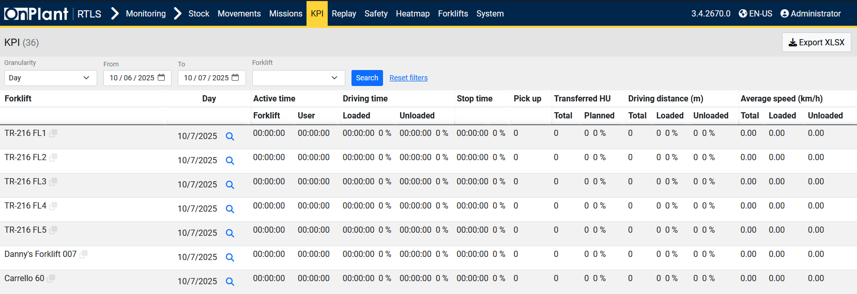  
The *KPI (Key Performance Indicators)* page provides a detailed summary of forklift operational performance. It displays activity metrics such as driving time, stop time, load handling, and driving distance for each forklift. This page helps administrators and supervisors measure productivity, usage efficiency, and movement distribution.

**Layout Overview**

|  |  |
| --- | --- |
| Area | Description |
| Filter Bar | Contains controls for selecting time range, granularity, and forklift. |
| Export XLSX | Exports all displayed KPI data into an Excel file. |
| Table | Displays a list of forklifts with associated activity and performance data. |

**Filters and Controls**

|  |  |
| --- | --- |
| Field | Description |
| Granularity | Defines the data aggregation level (e.g., *Day*). |
| From / To | Sets the time range for the KPI analysis period. |
| Forklift | Filters the KPI data to a specific forklift. |
| Search | Applies the selected filters to display results. |
| Reset search | Clears all active filters and reloads the default table view. |

**Table Columns**

|  |  |
| --- | --- |
| Column | Description |
| Forklift | The forklift name or ID. |
| Day | The calendar date for which the KPI data is recorded. |
| Active Time | The total time the forklift was active during the period. |
| Driving Time (Loaded / Unloaded) | The total time spent driving with and without a Handling Unit. |
| Stop Time | The total time the forklift remained stationary. |
| Pick Up | Number of Handling Units picked up during the period. |
| Transferred HU (Total / Planned) | The number and percentage of Handling Units successfully transferred, compared to planned transfers. |
| Driving Distance (m) | The total, loaded, and unloaded distance driven by the forklift, expressed in meters. |
| Average Speed (km/h) | The average total, loaded, and unloaded speed of the forklift during operation. |
| Magnifying Glass Icon | Opens detailed performance data for the selected forklift and date, if available. |

**User Actions**

1. Select the desired **granularity** (e.g., *Day*).
2. Choose a **date range** using the *From* and *To* fields.
3. Optionally select a **specific forklift**.
4. Click **Search** to generate KPI results for the selected criteria.
5. Click the **magnifying glass icon** to view detailed records for a specific forklift and date.
6. Click **Export XLSX** to download the KPI dataset in Excel format.
7. Click Reset search to clear selections and reload the default view.

**Troubleshooting**

|  |  |  |
| --- | --- | --- |
| Issue | Description | Action |
| No data shown | No recorded activity for the selected period. | Expand the date range or verify forklift operation data. |
| Incorrect values displayed | Filter conflict or outdated view. | Reset search and reapply search criteria. |
| Exported file empty | No visible rows in current view. | Confirm results are displayed before exporting. |

## 3.5 Monitoring – Replay

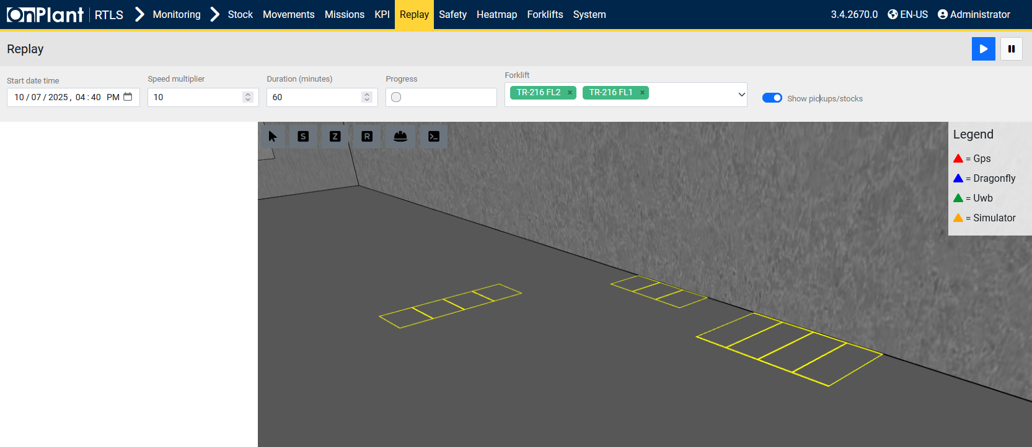  
The *Replay* page allows users to review recorded forklift and Handling Unit (HU) activity within a defined time window. It replays movements inside a 3D environment, showing forklift routes, sensor data, and operational events as they occurred. This feature is used to analyze operations, verify missions, or investigate incidents.

**Layout Overview**

|  |  |  |
| --- | --- | --- |
| Area | Description | |
| 3D Replay Area | Displays a three-dimensional map with forklift activity replays based on the selected time range. | |
| Legend | • GPS – Red  • Dragonfly – Blue | • UWB – Green  • Simulator – Yellow |
| Playback Toolbar | Contains six map interaction buttons for enabling or disabling visualization features. See *Toolbar Controls*. | |
| Playback Controls | • Play – Starts playback of the recorded data.  • Pause – Pauses playback. | |

**Filter and Control Bar**

|  |  |
| --- | --- |
| Field | Description |
| Start Date Time | Sets the beginning timestamp for the replay session. |
| Speed Multiplier | Adjusts playback speed (for example, 10× for faster review). |
| Duration (Minutes) | Determines how many minutes of recorded data are replayed from the selected start time. |
| Progress | Displays the current position in the playback timeline. |
| Forklift | Filters playback to a specific forklift. |
| Show Pickups/Stocks (Toggle) | When enabled, shows pick-up and stock markers during playback. |

**Toolbar Controls**

|  |  |
| --- | --- |
| Button | Function |
| Cursor (icon-only) | Enables or disables the cursor on the live map, allowing the user to select or interact with elements during replay. |
| Safety (icon-only) | Shows or hides safety-related overlays such as safety events or restricted zones. |
| Zones (icon-only) | Enables or disables the display of warehouse zones on the map. |
| Roaming areas (icon-only) | Shows or hides roaming areas used for localization coverage. |
| Obstacles (icon-only) | Displays or hides obstacles, structures, and environmental models. |
| More options (icon-only) | Expands or collapses extended visualization options. |

**User Actions**

1. Set the **Start Date Time**, **Speed Multiplier**, and **Duration**.
2. Select a **Forklift**, or leave blank to replay all available forklifts.
3. Enable **Show Pickups/Stocks** to include handling events in the replay.
4. Click **Play** and **Pause** to start and stop the replay.
5. Use the **Toolbar Controls** to adjust layer visibility and visualization options.
6. Use the **Arrow Icon** to enable the cursor and interact with map elements.

**Troubleshooting**

|  |  |  |
| --- | --- | --- |
| Issue | Description | Action |
| No replay visible | No data recorded for the selected period. | Extend the time range or confirm forklift telemetry data. |
| Replay not interactive | Cursor disabled. | Click the **Arrow Icon** to enable cursor mode. |
| Map objects missing | Certain map layers hidden. | Re-enable layers using the toolbar buttons. |
| Playback too fast or too slow | Incorrect speed multiplier selected. | Adjust the **Speed Multiplier** and restart playback. |

## 3.6 Monitoring – Safety – Near Miss

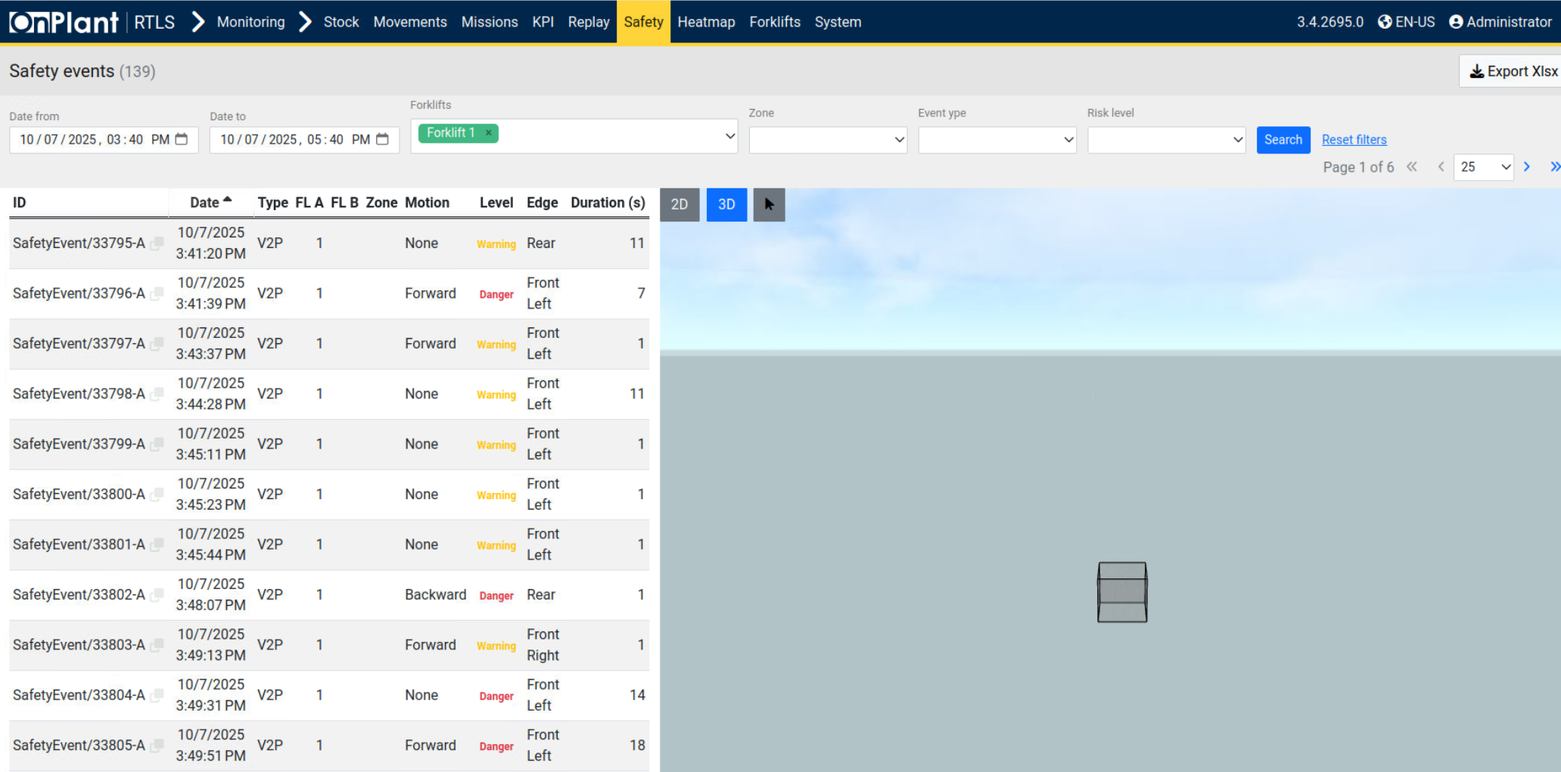

The Near Miss page lists all safety-related events detected by the system, including proximity alerts, risk-level warnings, and potential collisions between forklifts and pedestrians (V2P). This page is used to analyze unsafe interactions, review forklift motion behavior, and identify potential hazards before they result in incidents.

**Layout Overview**

|  |  |
| --- | --- |
| Area | Description |
| Filter Bar | Provides search filters to refine safety event data by date, forklift, zone, event type, or risk level. |
| Export XLSX | Exports the filtered safety events list to an Excel file for reporting or analysis. |
| Table | Displays recorded safety events with key data such as timestamp, event type, risk level, and duration. |
| Map View | Provides 2D and 3D visualization modes of the event area, enabling users to see where the event occurred. |

**Search and Filter Options**

|  |  |
| --- | --- |
| Field | Description |
| Date From / To | Sets the start and end time window for the displayed events. |
| Forklifts | Filters events by the selected forklift(s). Multiple forklifts can be selected if applicable. |
| Zone | Filters safety events by warehouse or operational zone. |
| Event Type | Filters events based on the type (e.g., V2P, Zone Violation). |
| Risk Level | Filters results by severity level (e.g., *Warning*, *Danger*). |
| Search / Reset search | Executes or clears all active filters. |

**Table Columns**

|  |  |
| --- | --- |
| Column | Description |
| ID | Unique event identifier. |
| Date | Timestamp of when the safety event occurred. |
| Type | Type of detected event. |
| FL A / FL B | Forklift identifiers involved in the event. |
| Zone | Area or zone where the event occurred. |
| Motion | Direction of forklift motion at the time. |
| Level | Severity classification. |
| Edge | Indicates the event’s trigger side or position. |
| Duration (s) | Duration of the safety event in seconds. |

**Map Controls**

|  |  |
| --- | --- |
| Control | Function |
| 2D / 3D Toggle | Switches between two-dimensional and three-dimensional map visualization modes. |
| Cursor Icon | Enables or disables interactive cursor selection within the map view. |

**User Actions**

1. Use the **Date From / To** fields to define the event period.
2. Select one or multiple **Forklifts** from the drop-down menu.
3. Optionally apply **Zone**, **Event Type**, or **Risk Level** filters.
4. Click **Search** to load filtered results.
5. Switch between **2D** and **3D** views to visualize the event environment.
6. Use **Export XLSX** to download event data for analysis.
7. Click Reset search to clear the active filters and reload default data.

**Additional Information**

* Near Miss data originates from RTLS safety sensors, proximity alerts, and motion detectors integrated into forklifts.
* Each record includes directional and positional data for risk source identification.

## 3.7 Monitoring – Safety – Forklifts Status

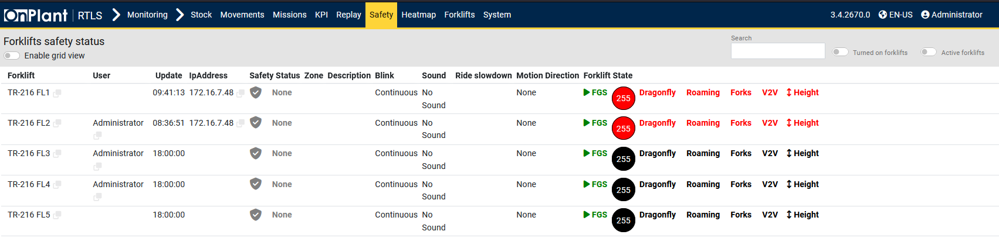

The *Forklifts Status* page provides a real-time overview of the safety conditions for all forklifts connected to the system. It allows administrators to monitor forklift communication, sensor states, motion directions, and active safety mechanisms such as zone alerts, ride slowdowns, and motion restrictions.

**Layout Overview**

|  |  |
| --- | --- |
| **Area** | **Description** |
| Table | Shows the safety status of each forklift, including communication, motion, and safety feedback details. |
| Toolbar | Toggles for Enable grid view, Turned on Forklifts, and Active forklifts. Search bar to search forklifts. |

**Table Columns**

|  |  |
| --- | --- |
| Column | Description |
| Forklift | Displays the forklift’s unique identifier. |
| User | Indicates the operator or system user currently associated with the forklift. |
| Update | Timestamp of the last data update received from the forklift. |
| IP Address | Shows the forklift’s current network IP connection. |
| Safety Status | Displays the active safety condition. |
| Zone Description | Describes the operational safety zone currently applied to the forklift (if any). |
| Blink | Indicates the light signal state on the forklift. |
| Sound | Reports the forklift’s audible alert condition. |
| Ride Slowdown | Displays whether the forklift’s driving speed has been reduced by a safety condition. |
| Motion Direction | Indicates the current motion state of the forklift. |
| Forklift State | Semaphores showing connections to several features. |

**User Actions**

1. Use the Search field to locate a forklift by ID or name.
2. Toggle **Turned on forklifts** or **Active forklifts** to filter by power or operational state.
3. Observe **Safety Status** and **Forklift State** indicators to identify potential warnings or disconnections.
4. Check **Sound**, **Blink**, or **Ride Slowdown** fields to confirm if the forklift has an active safety response.
5. Monitor **Update** timestamps to ensure real-time data communication is active.

**Additional Information**

* Data shown in this page originates from each forklift’s onboard safety controller and FGS telemetry.
* Safety conditions are continuously updated and displayed with visual and textual indicators.
* The page is mainly used by supervisors to ensure safety mechanisms are active and to confirm that warning events are properly managed.
* All listed parameters refresh automatically based on forklift communication cycles.
* Hover over semaphores for additional status information.

## 3.8 Monitoring – Safety – Live Status

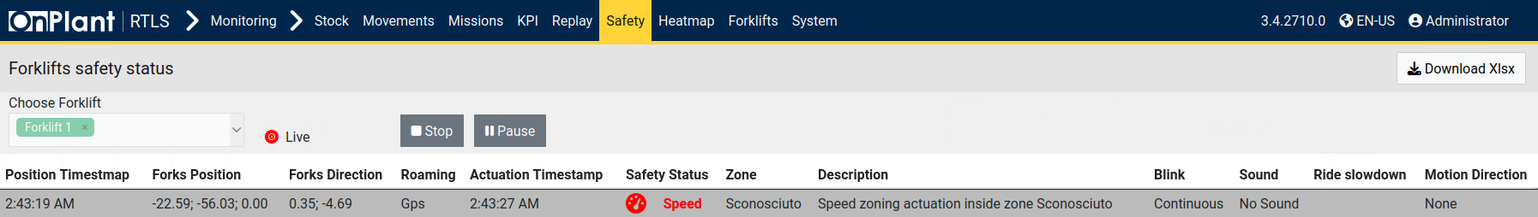

The *Live Status* page displays real-time safety data for individual forklifts. It allows administrators to monitor current speed zoning, motion status, actuation triggers, and sensor feedback as the forklift operates. This page is primarily used to confirm that safety responses (such as speed limits, slowdowns, and alerts) are functioning correctly during live operation.

**Layout Overview**

|  |  |
| --- | --- |
| Area | Description |
| Choose Forklift | Allows the user to select a specific forklift to observe in real time. |
| Live Controls | **Stop** and **Pause** buttons to start or temporarily pause live monitoring. |
| Download XLSX | Exports the currently visible real-time log to Excel format. |
| Table | Displays live telemetry and safety parameters for the selected forklift. Data updates dynamically while monitoring is active. |

**Table Columns**

|  |  |
| --- | --- |
| Column | Description |
| Position Timestamp | Timestamp of the last recorded forklift position. |
| Forks Position | Shows the current X, Y, and Z coordinates of the forklift’s fork position. |
| Forks Direction | Displays directional values representing the angle or heading of the forks. |
| Roaming | Indicates the positioning source used for location tracking. |
| Actuation Timestamp | Time of the last recorded safety actuation or trigger. |
| Safety Status | Displays the active safety event. |
| Zone | Indicates the warehouse or operational zone currently associated with the forklift. |
| Description | Provides a text description of the detected safety condition. |
| Blink | Displays the light signal status of the forklift. |
| Sound | Indicates if the forklift is producing an audible alert. |
| Ride Slowdown | Shows whether a speed reduction is being enforced due to safety conditions. |
| Motion Direction | Displays the current movement direction of the forklift. |

**User Actions**

1. Use the **Choose Forklift** dropdown to select a forklift to monitor.
2. Click **Live** to begin real-time monitoring.
3. Observe updates in the table as the system reports positional and safety status data.
4. Use **Pause** to temporarily halt updates while keeping data visible.
5. Use **Stop** to end live monitoring.
6. Click **Download XLSX** to export the recorded live data for review or documentation.

**Additional Information**

* Data is refreshed in real time through the forklift’s onboard safety controller and RTLS network.
* *Safety Status* fields will highlight in red when critical events (e.g., over-speed) are detected.
* The *Live*, *Pause*, and *Stop* buttons directly control the live data stream display.
* This page is primarily used for diagnostics and validation of forklift behavior within active zones.

## 3.9 Monitoring – Heatmap

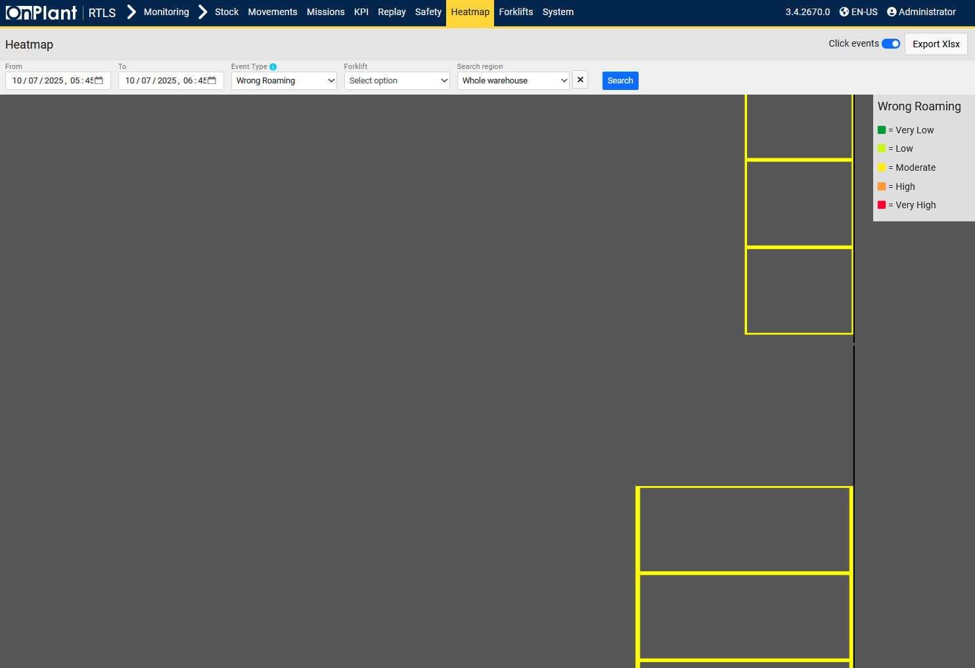

The *Heatmap* page visualizes forklift movement density and operational intensity across the monitored area. It allows administrators to identify frequently used paths, high-activity zones, and underutilized areas. This feature helps optimize warehouse layouts, evaluate congestion risks, and improve route efficiency.

**Layout Overview**

|  |  |
| --- | --- |
| Area | Description |
| Filter Bar | Enables selection of Date Range, Event Type, Forklift, and region parameters to refine the heatmap dataset. Click Search to activate filters. Toggle for Click events. |
| Export XLSX | Exports the selected data parameters to Excel format. |
| 3D Map Area | Displays the generated heatmap in a two- or three-dimensional view. Areas with higher movement frequency are highlighted using warmer colors (red/yellow), while less active zones appear cooler (green/blue). |
| Legend | Explains the color scale representing motion density or frequency. |

**User Actions**

1. Select a **Date Range** to define the period of forklift activity to analyze.
2. Optionally choose **Forklifts** or **Zones** to filter data.
3. Use **Export XLSX** if raw data is required for analytical reporting.

**Additional Information**

* The heatmap aggregates positional data from the RTLS tracking system and forklift telemetry.
* Data intensity is computed from recorded forklift positions over the defined time period.
* This page provides visual insight for workflow optimization, congestion analysis, and space utilization studies.

## 3.10 Monitoring – Forklifts – User Log-ons

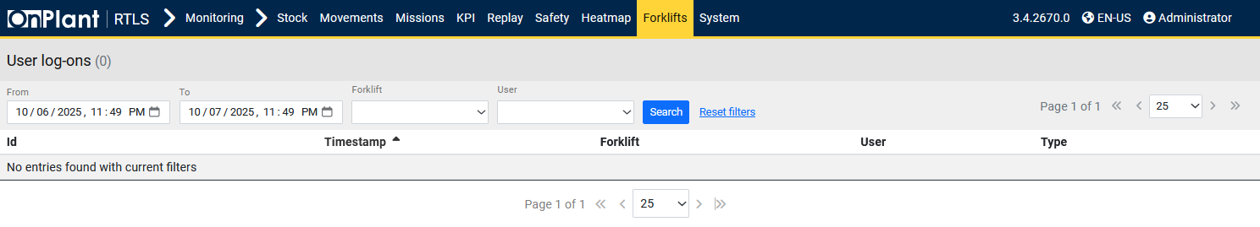The *User Log-ons* page displays a historical record of forklift user authentication events.  
It allows administrators to review when operators log into and out of forklifts, supporting activity tracking and accountability within daily operations.

**Layout Overview**

|  |  |
| --- | --- |
| Area | Description |
| Filter Bar | Contains search fields for date range, forklift, and user selection. |
| Table | Lists user log-on and log-off events with timestamped details. |

**Search and Filter Options**

|  |  |
| --- | --- |
| Field | Description |
| From / To | Defines the start and end dates for event retrieval. |
| Forklift | Filters the list to events from the selected forklift. |
| User | Filters results by operator name or ID. |
| Search / Reset search | Executes or clears the current filter selection. |

**Table Columns**

|  |  |
| --- | --- |
| Column | Description |
| ID | Internal identifier for each log-on event. |
| Timestamp | Date and time when the event occurred. |
| Forklift | Identifier of the forklift where the event was recorded. |
| User | Name or ID of the operator who logged on or off. |
| Type | User’s account type. |

**User Actions**

1. Set the **From** and **To** fields to define the desired date range.
2. Optionally select a **Forklift** or **User** to refine the results.
3. Click **Search** to display the corresponding authentication events.
4. Use Reset search to clear the search criteria and reload the full record list.

**Troubleshooting**

|  |  |  |
| --- | --- | --- |
| Issue | Description | Action |
| No entries found | The selected date range or filters returned no results. | Expand the time window or clear filters. |
| Unexpected timestamps | Times shown may differ due to time zone settings. | Verify the system’s configured time zone. |
| Table not sorting | Sort order not applied to column. | Click the **Timestamp** column header to toggle sorting direction. |

**Additional Information**

* Events on this page are recorded automatically by the forklift’s onboard login system.
* Filtering by forklift or user is the most efficient way to isolate a specific operator’s history.

## 3.11 Monitoring – Forklifts – Audit

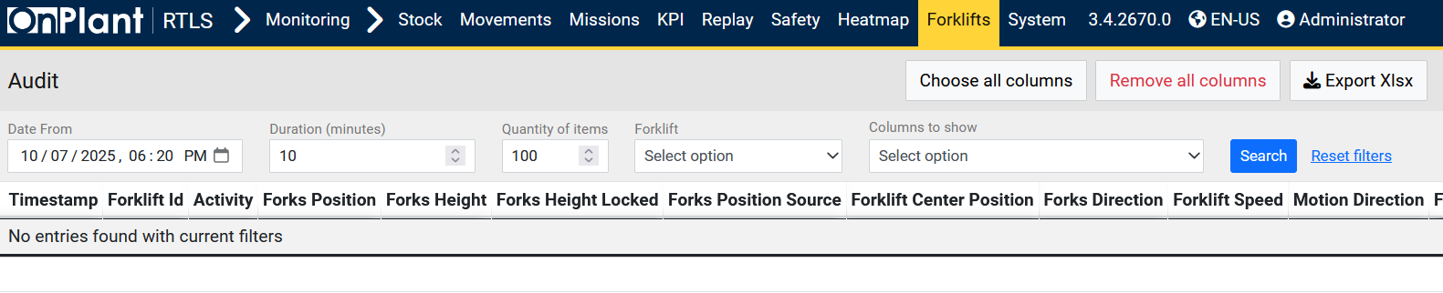The *Audit* page provides a detailed technical record of forklift activity and sensor feedback over time. It is used by administrators and engineers to review operational telemetry, verify module status, and trace safety or motion-related events at the sensor level. This data supports diagnostics, performance analysis, and troubleshooting of integrated forklift systems.

**Layout Overview**

|  |  |
| --- | --- |
| **Area** | **Description** |
| Filter Bar | Contains date, forklift, and user filters for narrowing recorded events. |
| Table | Displays all logged parameters associated with forklift operations and subsystem states. |

**Search and Filter Options**

|  |  |
| --- | --- |
| Field | Description |
| From / To | Defines the date and time range for event retrieval. |
| Forklift | Filters audit data for a specific forklift. |
| User | Filters entries related to a particular logged-in operator. |
| Search / Reset search | Applies or clears the selected filter criteria. |

**Table Columns**

The Audit page includes a comprehensive set of parameters covering motion, positioning, communication, and safety subsystems. Each entry corresponds to one captured state update from the forklift telemetry feed.

|  |  |
| --- | --- |
| Column | Description |
| Timestamp | Time when the data record was logged. |
| Forklift ID | Identifier of the forklift from which the record originated. |
| Activity | Current forklift activity or operational event type. |
| Forks Position / Height / Height Locked | Real-time position and lock state of the forks. |
| Forks Position Source | Source of positional data (e.g., UWB, GPS, Dragonfly). |
| Forklift Center Position | Central coordinate position of the forklift. |
| Forks Direction | Directional vector or orientation of the forks. |
| Forklift Speed | Real-time velocity reading. |
| Motion Direction | Direction of movement (Forward, Backward, or Still). |
| Forks Distance | Measured distance between forks or reference object. |
| Udc ID / Location ID / Mission ID | Identifiers for Handling Units, locations, or missions associated with the record. |
| FL Active / Logged User ID / FL Turned On / FL Still / Delay / Total State | Forklift operational flags showing whether it’s active, idle, or delayed. |
| Auto ID State / GPS State / GPS State Description | GPS-related status and textual state information. |
| UWB State / Dragonfly State / Dragonfly State Description | Communication and positional integrity indicators for each module. |
| IMU State / IMU State Description | Inertial sensor (IMU) operational status and condition. |
| Forks State / RTCM State / V2V State / V2P State / V2P State Description | Status of communication and safety subsystems (Vehicle-to-Vehicle, Vehicle-to-Pedestrian, etc.). |
| FGS State / Roaming State / Roaming State Description | Indicates system-level connection and roaming link information. |
| Magnetometer State / IOModule State / Forks Height Locked State | Status of hardware sensors and I/O modules. |
| GPS Position / GPS Position Lat-Lon / GPS Carr Soln / GPS Horiz Accuracy | GPS positional readings, accuracy metrics, and carrier solution values. |
| UWB Position Timestamp / Received Timestamp / Position / Received Ranges / Avg InAccuracy / Position Guessed | Data timestamps, position estimates, and accuracy levels from UWB modules. |
| Dragonfly Position / Accuracy / FPS | Dragonfly module coordinates, accuracy, and frame rate. |
| Safety Actuation Timestamp / Description / Zone Description / Type / Motion Direction / Ride Slowdown Profile / Led Color / Led Blink / Buzzer Style / Buzzer Intensity | All safety actuation records, including event timing, type, and system response configuration. |
| V2V Danger Front / Rear / Side Offset | Front, rear, and side offsets for vehicle-to-vehicle danger proximity alerts. |
| V2V Warning Front / Rear / Side Offset | Front, rear, and side offsets for vehicle-to-vehicle warning proximity alerts. |

**User Actions**

1. Select the desired **From / To** date range to load forklift audit data.
2. Use the **Forklift** filter to isolate records for a specific vehicle.
3. Click **Search** to display audit entries.
4. Scroll horizontally to view all recorded parameters.
5. Click Reset search to clear filters and reload all available records.

**Additional Information**

* The Audit page logs real-time telemetry directly from forklift sensors and FGS modules.
* Recorded data includes over 60 parameters spanning motion, positioning, communication, and safety subsystems.
* This dataset provides the highest diagnostic depth among Monitoring pages and is primarily used for engineering analysis and support verification.

## 3.12 Monitoring – Forklifts – Log

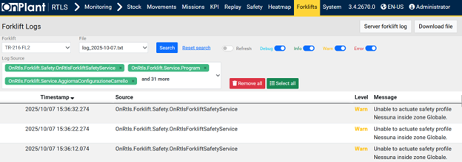

The **Log** page displays forklift application logs for a selected forklift and file. It’s used to filter by log **sources** and **severity levels**, review messages, and download the current log file.

**Layout Overview**

|  |  |
| --- | --- |
| **Area** | **Description** |
| Filter Bar | Controls for Forklift, File, Search, Reset search, Log Source selector with Remove all / Select all, Refresh toggle, and severity toggles (Debug / Info / Warn / Error). |
| Table | Lists log entries with Timestamp, Source, Level, and Message. |

**Search and Filter Options**

|  |  |
| --- | --- |
| Field / Control | Description |
| Forklift | Dropdown to select a forklift. |
| File | Dropdown to pick a log file. |
| Log Source | Multi-select/tag list of sources. |
| Severity | Toggle filters: **Debug**, **Info**, **Warn**, **Error**. |
| Refresh | Toggle to enable/disable auto-refresh of results. |
| Search | Applies current selections. |
| Reset search | Clears the active selections to defaults. |

**Table Columns**

|  |  |
| --- | --- |
| Column | Description |
| Timestamp | Date and time of the log entry. |
| Source | Subsystem/component that wrote the entry. |
| Level | Message severity. |
| Message | Log message text. |

**User Actions**

1. Choose **Forklift** and **File**.
2. (Optional) Adjust **Log Source** tags; use **Select all** / **Remove all** as needed.
3. (Optional) Set **Severity** toggles and **Refresh**.
4. Click **Search** to load entries (use **Reset search** to clear).
5. Click **Download file** to save the selected log file.

## 3.13 Monitoring – Forklifts – Log Server

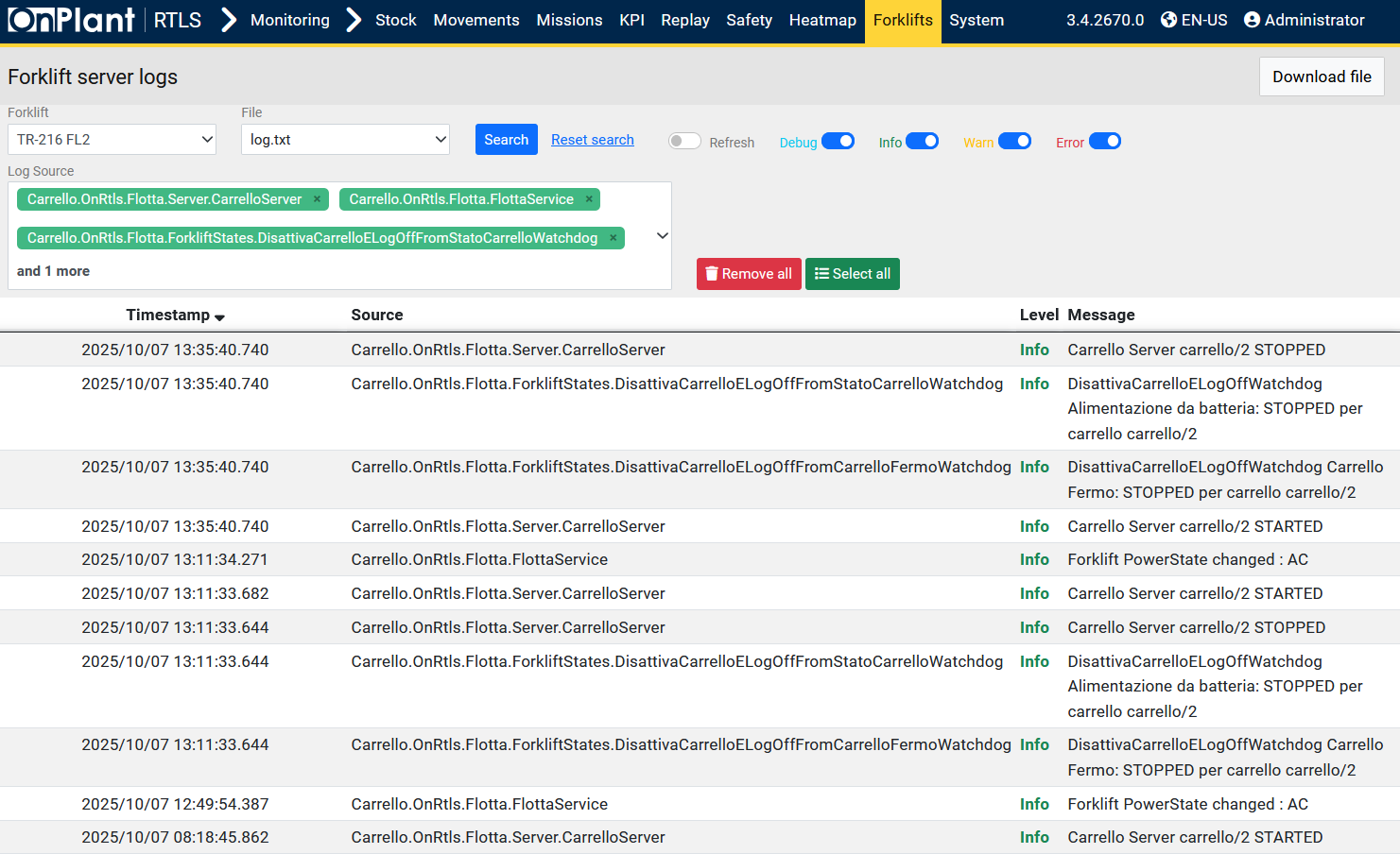

The Log Server page provides centralized access to all forklift log files stored on the OnRTLS server. It allows administrators to review, download, and manage logs generated by forklifts for diagnostic and audit purposes. Unlike Monitoring – Forklifts – Log (3.12), which displays logs from a specific forklift device, the Log Server page aggregates logs directly from the server repository, making it essential for system-wide maintenance, debugging, and historical review.

**Layout Overview**

|  |  |
| --- | --- |
| **Area** | **Description** |
| Filter Bar | Controls for Forklift, File, Search, Reset search, Log Source selector with Remove all / Select all, Refresh toggle, and severity toggles (Debug / Info / Warn / Error). |
| Table | Lists log entries with Timestamp, Source, Level, and Message. |

**Search and Filter Options**

|  |  |
| --- | --- |
| Field / Control | Description |
| Forklift | Dropdown to select a forklift. |
| File | Dropdown to pick a log file. |
| Log Source | Multi-select/tag list of sources. |
| Severity | Toggle filters: **Debug**, **Info**, **Warn**, **Error**. |
| Refresh | Toggle to enable/disable auto-refresh of results. |
| Search | Applies current selections. |
| Reset search | Clears the active selections to defaults. |

**Table Columns**

|  |  |
| --- | --- |
| Column | Description |
| Timestamp | Date and time of the log entry. |
| Source | Subsystem/component that wrote the entry. |
| Level | Message severity. |
| Message | Log message text. |

**User Actions**

1. Choose **Forklift** and **File**.
2. (Optional) Adjust **Log Source** tags; use **Select all** / **Remove all** as needed.
3. (Optional) Set **Severity** toggles and **Refresh**.
4. Click **Search** to load entries (use **Reset search** to clear).
5. Click **Download file** to save the selected log file.

## 3.14 Monitoring – Forklifts – Data Log

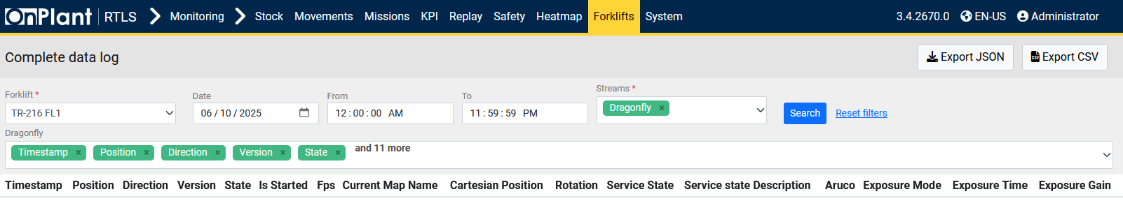

The **Data Log** page provides a complete record of telemetry and positional data streamed from each forklift. It is primarily used by engineers and administrators to analyze sensor feedback, localization accuracy, and camera (Dragonfly) performance over time.  
The page can export raw data for offline diagnostics or data analysis.

**Layout Overview**

|  |  |
| --- | --- |
| Area | Description |
| Filter Bar | Provides selection controls for forklift, date range, time window, and data stream source. |
| Table | Displays selected parameters such as Timestamp, Position, Direction, Version, and State. Additional columns include camera and service details. |
| Export Buttons | Allow exporting the displayed dataset to either **JSON** or **CSV** format for external analysis. |

**Filters and Controls**

|  |  |
| --- | --- |
| Field | Description |
| Forklift | Dropdown menu to select a specific forklift. Required field. |
| Date | Calendar selector to define the logging date. |
| From / To | Time range defining the period of data to retrieve. |
| Streams | Specifies the data source stream. Required field. |
| Search | Executes the query with selected filters. |
| Reset search | Clears all filters and reloads default parameters. |

**Displayed Columns**

|  |  |
| --- | --- |
| Column | Description |
| Timestamp | Time when each data record was received. |
| Position | Forklift’s current positional coordinates. |
| Direction | Orientation or heading direction of the forklift. |
| Version | Firmware or software version of the logging module. |
| State | Operational state of the data stream. |
| Is Started | Indicates whether the data stream is actively running. |
| Fps | Frames per second, representing camera update rate. |
| Current Map Name | The map or warehouse area the data corresponds to. |
| Cartesian Position | Forklift position expressed in X/Y/Z coordinates. |
| Rotation | Rotational orientation data of the forklift or Dragonfly camera. |
| Service State | Indicates the health and connectivity of the service component. |
| Service state Description | Provides textual information about current health and connectivity of the service component. |
| Aruco | ArUco marker tracking data used by Dragonfly for localization validation. |
| Exposure Mode / Time / Gain | Camera parameters describing current exposure configuration and settings. |

**User Actions**

1. Select the **Forklift** to analyze.
2. Choose a **Date** and specify the **From / To** time range.
3. Select the **Stream** (e.g., Dragonfly) to define which telemetry data source to query.
4. Click **Search** to load results into the data table.
5. Click Reset search to clear all selections.
6. Use **Export JSON** or **Export CSV** to download the full dataset.

**Technical Notes**

* The Data Log records raw data directly from the forklift’s telemetry stream and localization subsystems (e.g., Dragonfly camera, UWB, IMU).
* Data updates depend on active communication intervals and may vary by forklift model.
* Dragonfly logs include both vision and localization parameters, allowing sensor calibration and performance tracing.

**Troubleshooting**

|  |  |  |
| --- | --- | --- |
| Issue | Description | Action |
| No data returned | The selected forklift or time range has no available telemetry. | Expand the time window or verify forklift connectivity. |
| Export buttons inactive | Data not yet loaded or permission restricted. | Perform a search first or confirm admin access. |
| Missing Dragonfly data | Stream source not selected or camera offline. | Ensure **Dragonfly** is selected in the *Streams* field. |
| Columns appear empty | Parameters not logged for the selected stream. | Switch to a different stream or confirm sensor activation. |

## 3.15 Monitoring – Forklifts – States

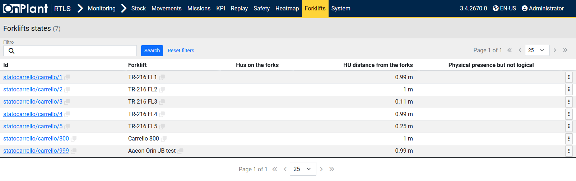

The **Forklifts States** page displays the current load detection and spatial relationship of Handling Units (HUs) with respect to each forklift. It helps operators and administrators verify whether an HU is correctly recognized on the forks, confirm its physical alignment, and detect mismatches between physical and logical assignments. This page is primarily used for quick validation and troubleshooting of HU pickup detection.

**Layout Overview**

|  |  |
| --- | --- |
| Area | Description |
| Filter Bar | Includes a search box labeled Filtro, Search and Reset search buttons to filter forklifts by ID or name. |
| Table | Lists forklifts with corresponding HU detection data and calculated distances. |
| Row Menu (⋮) | Provides administrative actions for each forklift state record, such as resetting status or deleting entries. |

**Table Columns**

|  |  |
| --- | --- |
| Column | Description |
| ID | Unique internal identifier of the forklift state entry. Each ID links to a detailed status endpoint. |
| Forklift | The forklift name or ID registered in the system. |
| HUs on the forks | Indicates whether any Handling Unit is currently detected on the forklift forks. |
| HU distance from the forks | Displays the measured distance between the HU’s detected position and the forklift fork sensors (in meters). A small distance implies correct pickup alignment. |
| Physical presence but not logical | Indicates situations where a Handling Unit is physically detected but not logically registered to the forklift within the system database. |

**Row Menu (⋮) Options**

|  |  |
| --- | --- |
| Option | Description |
| Reset status | Resets the forklift’s HU detection state. Used when a forklift shows an incorrect or residual HU presence. |
| Delete | Permanently deletes the forklift state record from the database. |

**User Actions**

1. **Filter records:**
   * Enter part of a forklift ID or name in the Filtro box.
   * Click **Search** to display matching forklifts.
   * Click Reset search to clear the search and reload all results.
2. **View details:**
   * Click a linked ID to open the forklift’s detailed status record.
3. **Open row menu (⋮):**
   * Select **Reset status** to clear the forklift’s HU detection values.
   * Select **Delete** to permanently remove a forklift state entry.

**Technical Notes**

* Data originates from the forklift’s onboard FGS system and RTLS localization modules.
* *HU distance from the forks* values are continuously updated based on sensor readings and 3D positioning data.
* The *Physical presence but not logical* indicator is crucial for detecting mismatches between physical pickups and mission-tracked assignments.

## 3.16 Monitoring – Forklifts – Messages

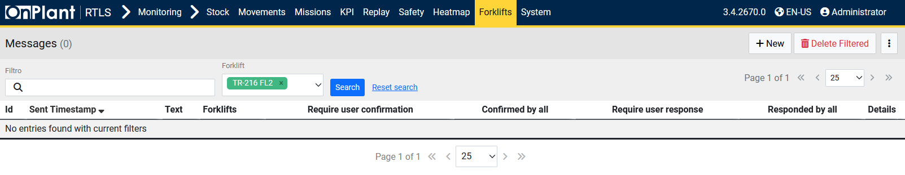

The **Messages** page displays all forklift-related communication messages exchanged between the OnRTLS system and forklift operators. It is used to review, send, or delete messages sent to forklifts, particularly those requiring operator confirmation or response. This feature helps supervisors track message delivery and acknowledgment within daily operations.

**Layout Overview**

|  |  |
| --- | --- |
| Area | Description |
| Filter Bar | Contains fields for filtering messages by forklift ID and text search. Includes Search and Reset search buttons. |
| Toolbar | Provides options to create new messages **(+ New**), delete all messages currently visible under active filters (**Delete Filtered**), and open additional settings via the three-dot menu (**⋮**). |
| Table | Displays forklift messages with detailed metadata, including timestamps, status, and confirmation requirements. |

**Search and Filter Options**

|  |  |
| --- | --- |
| Field / Control | Description |
| Filtro | Text field for keyword-based search across message text or identifiers. |
| Forklift | Drop-down selector to filter messages for a specific forklift. Multiple forklifts can be selected if supported. |
| Search / Reset search | Executes or clears the active filter criteria. |

**Table Columns**

|  |  |
| --- | --- |
| Column | Description |
| ID | Unique identifier for each message entry. |
| Sent Timestamp | The date and time when the message was sent to the forklift. |
| Text | Message body or content sent to the forklift. |
| Forklifts | Indicates which forklift(s) the message was sent to. |
| Require user confirmation | Specifies whether the forklift operator must confirm receipt of the message. |
| Confirmed by all | Displays whether all targeted forklifts have confirmed message receipt. |
| Require user response | Indicates if the message requires an active reply from the operator. |
| Responded by all | Shows whether all recipients have responded. |
| Details | Opens a detailed view of the selected message record, including responses and timestamps. |

**User Actions**

1. Use **Filtro** to search for messages by text or identifier.
2. Select a **Forklift** from the drop-down list.
3. Click **Search** to apply filters or **Reset search** to clear them.
4. Click **+ New** to compose and send a new message to selected forklifts.
5. Click **Delete Filtered** to remove all displayed messages matching the current filters.
6. Use the **⋮ (three-dot menu)** for additional bulk or advanced options (e.g., export or import, if available).
7. Click **Details** on a row to review full message history and operator confirmation data.

**Technical Notes**

* Messages can originate from system alerts or manual inputs via this interface.
* Confirmation and response tracking rely on forklift network connectivity.
* Only forklifts running the communication module and connected to the OnRTLS system will appear in the list.
* Data refreshes automatically as messages are logged or acknowledged.

**Troubleshooting**

|  |  |  |
| --- | --- | --- |
| Issue | Description | Action |
| No entries found | No messages match the selected filters. | Clear filters or expand the date range. |
| Message not received by forklift | Forklift not connected or communication service inactive. | Verify forklift network connection and restart message module if needed. |
| Confirmation not updating | Operator confirmation delay or desynchronization. | Check real-time status via Forklift Diagnostic page. |

## 3.17 Monitoring – Dragonfly Localization – Cameras

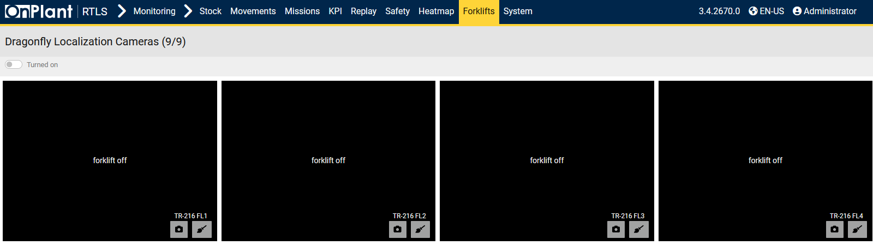

The **Dragonfly Localization Cameras** page provides live camera feeds and operational status for all forklifts equipped with the Dragonfly vision-based localization system.  
It allows supervisors and technicians to monitor visual data from onboard cameras, verify active connections, and confirm that each forklift’s localization module is functioning correctly.

**Layout Overview**

|  |  |
| --- | --- |
| Area | Description |
| Turned On | Filters camera panels to show only forklifts currently powered on and transmitting data. |
| Camera Grid | Displays live camera panels for each forklift. Each panel represents a unique forklift and includes its camera feed and status. |
| Panel Controls | Each camera tile includes icons for:  • Camera icon – Captures a snapshot from the live video feed. • Brush icon – Activates the air blower that cleans the camera lens. |

**User Actions**

1. Use the **Turned on** toggle to limit the view to active forklifts.
2. Identify forklifts by their ID labels.
3. Click the **Camera icon** to capture a snapshot from the current feed for diagnostics or documentation.
4. Click the Brush icon to activate the air blower that cleans the camera lens.
5. Observe each feed to confirm camera activity, lens alignment, and video responsiveness.

**Technical Notes**

* Each forklift’s Dragonfly module streams localization data alongside camera video.
* The page supports multiple simultaneous feeds depending on server bandwidth and client performance.
* If a panel shows *“forklift off”*, it indicates that the forklift’s Dragonfly service is inactive or the unit is not powered.

**Troubleshooting**

|  |  |  |
| --- | --- | --- |
| Issue | Description | Action |
| *Forklift off* message persists | Forklift not powered or Dragonfly module disabled. | Power on the forklift or verify camera service status. |
| Snapshot not saved | Permission or storage issue. | Confirm user access rights and available storage. |

## 3.18 Monitoring – System – Log

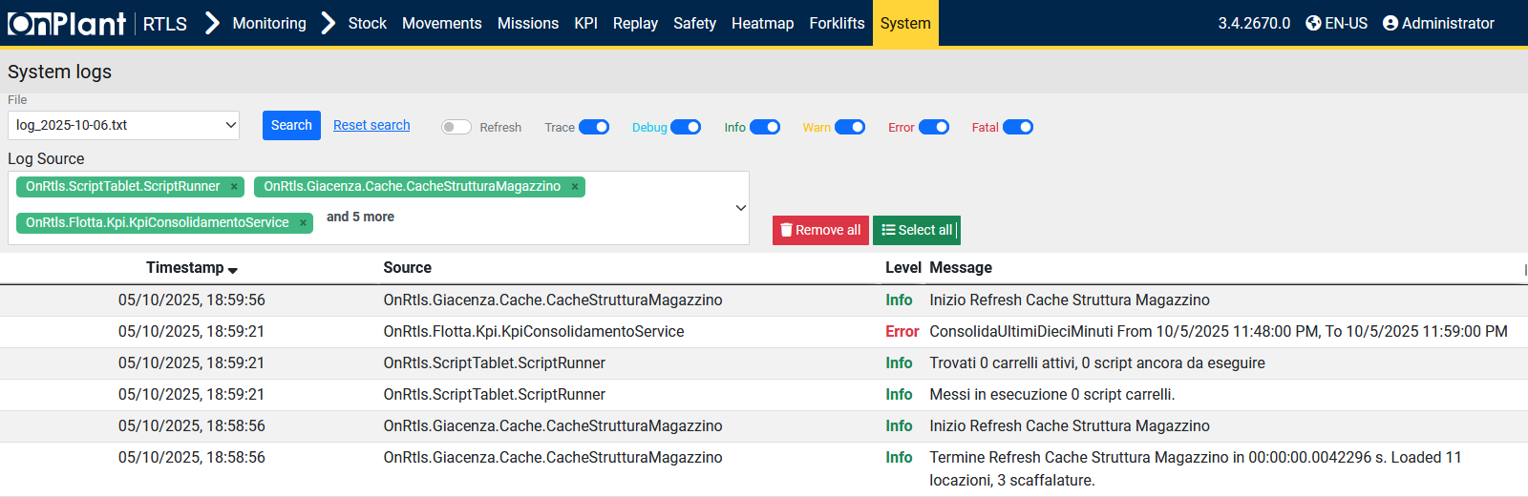

Monitoring → System → Log consolidates application and service logs across the OnRTLS platform. Use it to verify cache refreshes, track task execution, and diagnose warnings or errors in real time or by file date. This view is read-only.

**Layout Overview**

|  |  |
| --- | --- |
| Area | Description |
| File | Dropdown list for selecting a specific log file. The file name indicates the date of recorded events. |
| Search Controls | **Search** executes the query based on the selected file and filters. **Reset search** clears all applied filters. |
| Refresh Toggle | Enables or disables automatic log refresh in real time. When off, the view remains static until manually refreshed. |
| Log Source | Multi-select field listing internal service modules. Tags can be removed individually or collectively using **Remove all** / **Select all** buttons. |
| Severity Toggles | Enable or disable visibility for different log levels: **Trace**, **Debug**, **Info**, **Warn**, **Error**, and **Fatal**. Each toggle filters the table display accordingly. |
| Table | Displays log entries matching the selected criteria. Columns include Timestamp, Source, Level, and Message. |

**Table Columns**

|  |  |
| --- | --- |
| Column | Description |
| Timestamp | Date and time when the log entry was created. |
| Source | Internal service or module generating the log message. |
| Level | Severity of the log entry: *Info*, *Warn*, *Error*, or *Fatal*. |
| Message | Detailed log message. May include cache operations, task summaries, or error traces. |

**User Actions**

1. Select a **log file** from the File dropdown.
2. Select one or more **Log Sources** to filter specific modules.
3. Enable or disable log levels (Trace, Debug, Info, etc.) as required.
4. Click **Search** to display the log entries.
5. Use **Reset search** to clear filters.
6. Click **Remove all** or **Select all** to manage Log Source filters.
7. Enable **Refresh** for live updates of the system log stream.

**Troubleshooting**

|  |  |  |
| --- | --- | --- |
| Issue | Description | Action |
| No log entries displayed | Filters too narrow or file empty. | Use **Reset search** or select another log file. |
| Missing module in Log Source | The module didn’t produce logs in the selected period. | Expand date range or confirm service status. |
| Error messages in red | Module or task failure. | Review message details; verify task configuration or backend health. |

**Additional Information**

* System logs are stored as daily text files in the OnRTLS server directory.
* Each log file aggregates messages across all modules for that day.
* For detailed forklift or mission-level diagnostics, use **Monitoring → Forklifts → Log Server (4.13)**.

## 3.19 Monitoring – System – Status

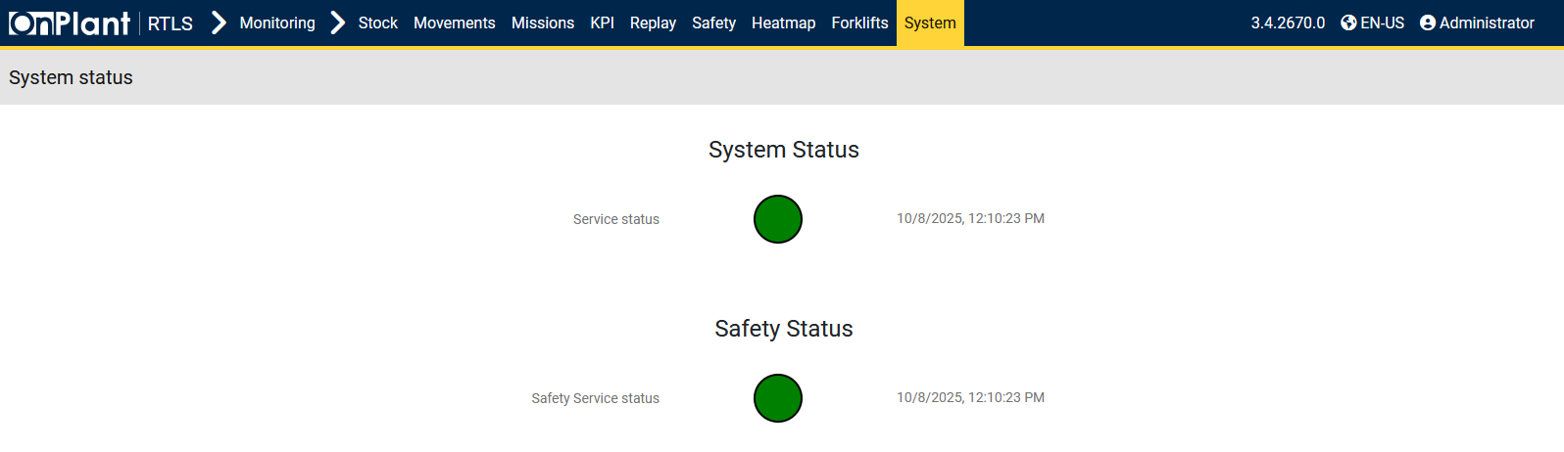

The **System Status** page provides a real-time overview of all OnRTLS backend services and connected components. It allows administrators to verify which modules are currently operational, detect errors or disconnections, and monitor the communication status between the FGS, RTLS, and Dragonfly systems. This view is primarily used for **infrastructure health monitoring** and **troubleshooting integration issues**.

**Layout Overview**

|  |  |
| --- | --- |
| Area | Description |
| Dashboard | Displays a live list of OnRTLS subsystems with their current health and connection state. |
| Status Indicators | Each row contains a colored indicator representing service condition:  • **Green** – Service is connected and functioning.  • **Yellow** – Service responding but showing delays or degraded performance.  • **Red/Black** – No connection or service failure detected. |

**User Actions**

1. Review **Status** colors to assess overall system health.

**Technical Notes**

* Data is fetched directly from the OnRTLS System Monitoring API.
* Offline status may result from service restarts or temporary communication loss.

**Additional Information**

* The **System Status** page complements the **System Log** (4.18) for cross-diagnosis: use Status to check connectivity and Log to see error details.
* Data is read-only; no manual service control can be performed here.
* If persistent red entries occur across multiple modules, contact Onit support.

## 4.1 Configuration – Forklifts

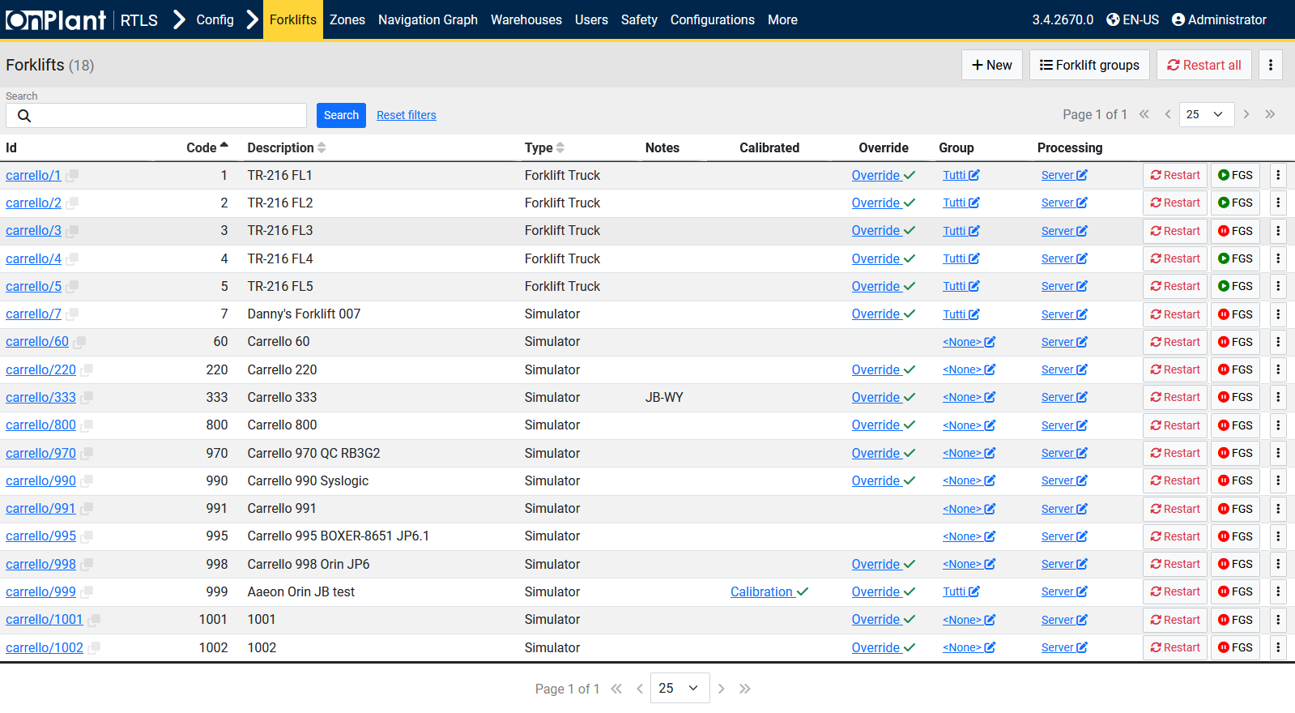

The **Forklifts Configuration** page provides a centralized interface for managing all forklifts and simulation vehicles registered in the OnRTLS system. Administrators can add, edit, group, calibrate, or restart forklifts, as well as manage their FGS (Forklift Guidance System) integration and override parameters.

**Layout Overview**

|  |  |
| --- | --- |
| Area | Description |
| Search Bar | Allows filtering forklifts by keyword, ID, or description. Includes Search and Reset search buttons. |
| Toolbar | Contains global management tools for forklift registration and system operations: • **+ New** – Registers a new forklift or vehicle. • **Forklift groups** – Creates or manages forklift groups. Groups can define shared (parental) configuration parameters, which can later be overridden per individual forklift. • **Restart all** – Sends a command to restart the junction box inside all forklifts currently displayed. |
| Table | Displays all forklifts with identifiers, status, and configuration properties. Each row includes a per-vehicle menu for detailed actions. |

**Table Columns**

|  |  |
| --- | --- |
| Column | Description |
| ID | Unique forklift identifier. Each ID links to detailed configuration data. |
| Code | Internal or user-defined numeric code for the forklift. |
| Description | Forklift or vehicle name. |
| Type | Defines whether the entry represents a real vehicle or a *Simulator*. |
| Notes | Optional text field for notes. |
| Calibrated | Displays a checkmark (✓) when the forklift’s sensors are successfully calibrated. Clicking **Calibration** shows calibration results. |
| Override | Indicates whether the forklift inherits group configurations or uses individual settings. Clicking Override shows the difference between group configurations and individual forklift settings. |
| Group | Shows the group assignment. Clicking the group link provides a way to change the groups and/or reset the forklift’s Overrides. |
| Processing | Shows the signal processing type. It can be either Server or Device. |
| Restart | Button to restart the forklift’s junction box individually. |
| FGS | Enable/Disable the Forklift Guidance System. |

**Three-Dot Menu (⋮) Options**

|  |  |
| --- | --- |
| Option | Description |
| Refresh all forklifts GUI | Reloads all forklift graphical user interfaces. |
| Enable FGS for filtered forklifts | Activates FGS functionality for all forklifts matching the active filter. |
| Disable FGS for filtered forklifts | Deactivates FGS for all forklifts matching the active filter. |
| Import/Export | Opens dialog to import or export forklift configuration data in JSON. |
| Export Filtered (JSON) | Exports all forklifts currently displayed (filtered set) in JSON format. |
| All forklifts override | Applies override mode to all forklifts. |
| Fork sensor calibration | Opens calibration tools for forklift fork sensors. |

**Row Menu (⋮) Options**

|  |  |
| --- | --- |
| Option | Description |
| Refresh GUI | Reloads the selected forklift’s user interface. |
| Delete | Removes the forklift record from the system. |
| Clone | Creates a duplicate of the forklift entry with identical parameters. |
| Modify group | Changes the forklift’s group configuration settings. |
| Zone parameters | Opens the forklift’s zone configuration for operational zones. |
| Safety zones parameters | Opens safety zone settings specific to that forklift. |
| Mesh color | Allows changing the visual color representation of the forklift in 3D maps. |
| Forks sensors calibration | Opens calibration interface for that forklift’s fork sensors. |
| Export JSON | Exports the selected forklift configuration to a JSON file. |

**User Actions**

1. **Add or register forklifts**
   * Click **+ New** to register a new forklift or simulator.
   * Fill in required identification and operational parameters.
2. **Manage groups**
   * Use **Forklift groups** to define shared configurations.
   * Modify group inheritance through the **Override** column or the **All forklifts override** option.
3. **Filter forklifts**
   * Use the Search field to locate forklifts by ID or description.
   * Click Reset search to restore the full list.
4. **Perform batch actions**
   * From the toolbar menu (⋮), use Import/Export, FGS enable/disable, or calibration tools across multiple forklifts.
5. **Individual forklift actions**
   * Use the row’s **Restart** button to reboot the forklift’s junction box.
   * Open the row (⋮) menu to clone, edit, calibrate, or export a specific forklift’s configuration.

**Technical Notes**

* Each forklift’s configuration file is stored on the OnRTLS server and linked to its **FGS module**.
* Restart operations only affect the **junction box (software module)**, not the forklift’s physical power system.
* Calibration data (e.g., fork sensors) synchronize automatically with the FGS backend upon saving changes.
* Group inheritance ensures consistent operational parameters for fleets while allowing local overrides.

### 4.1.1 Configuration – Forklifts – ⋮ – Modify group

The **Modify group** page allows key users to configure technical parameters shared across a forklift group. These parameters define geometric measurements, sensor offsets, data filters, and system integrations used by all forklifts assigned to the group. Changes made here affect all forklifts within the group unless overridden individually. This configuration ensures uniform operational performance, calibration accuracy, and compatibility across the Real-Time Location System (RTLS), Dragonfly localization, and Forklift Guidance System (FGS).

**Layout Overview**

The page is divided into multiple panels representing categories of configurable modules and sensors. The right side has a navigation bar for quick access to all panels. The panels are: Specifications, Dimensions, Filters, UWB, GPS, Dragonfly, Lidar, IO-Link Master, Forks sensors, Barcode scanner, IMU, Direction, Motion Direction, Safety, Forklift UI, Shutdown, and More.

* **Most values on this page are predetermined and do NOT need to be adjusted.**
* Values with outlined *yellow dashes* represent a different value than the parent forklift group.

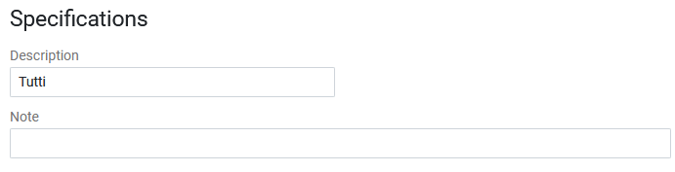

|  |  |
| --- | --- |
| Field | Description |
| Description | Defines the forklift group name. |
| Note | Optional text field for notes. |

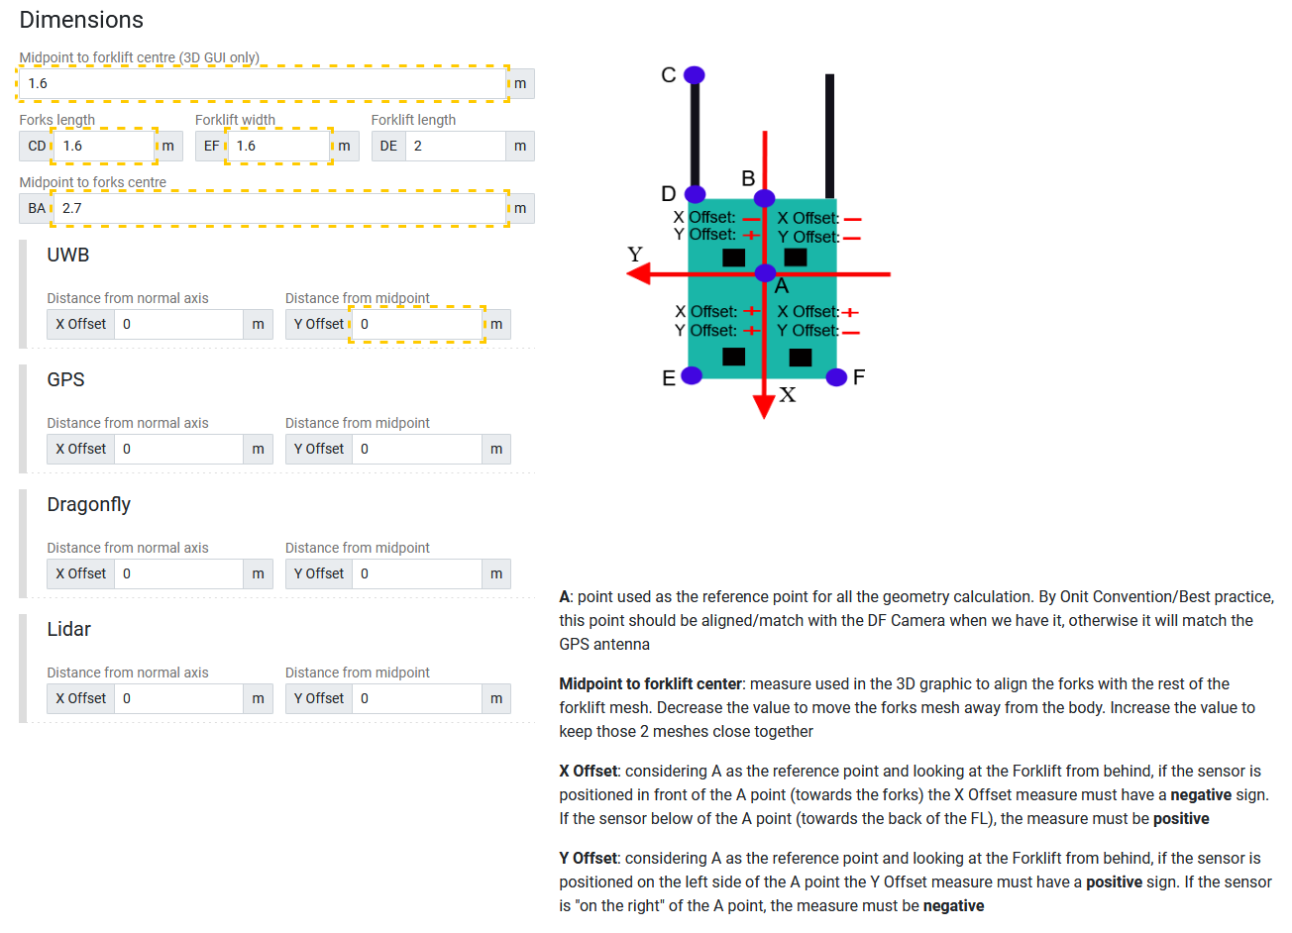

|  |  |
| --- | --- |
| Field | Description |
| Midpoint to forklift Center (3D GUI only) | Defines the visual reference distance between the forklift’s geometric midpoint and the 3D GUI coordinate origin. |
| Forks length (CD) | Sets the total length of the forks in meters. |
| Forklift width (EF) | Defines the width between side boundaries of the forklift. |
| Forklift length (DE) | Specifies the total body length. |
| Midpoint to forks Center (BA) | Determines the distance from forklift center to fork midpoint (for rendering and geometric alignment). |
| X Offset | Distance from the normal axis for UWB, GPS, Dragonfly, and Lidar. |
| Y Offset | Distance from the midpoint for UWB, GPS, Dragonfly, and Lidar. |

* **UWB / GPS Offset Fields**  
  Offsets align localization sensors (UWB or GPS) to the forklift’s reference point **A**, where **A** is the location of the Dragonfly Localization camera, used for most calculations.
  + In *most* cases, the Dragonfly Localization Camera will usually be installed on the rear, midpoint on the top of the forklift/vehicle. This represents **A**.
* **X Offset / Y Offset (from normal axis)** – defines the position of the sensor relative to the **A**, the location of the Dragonfly Localization Camera.

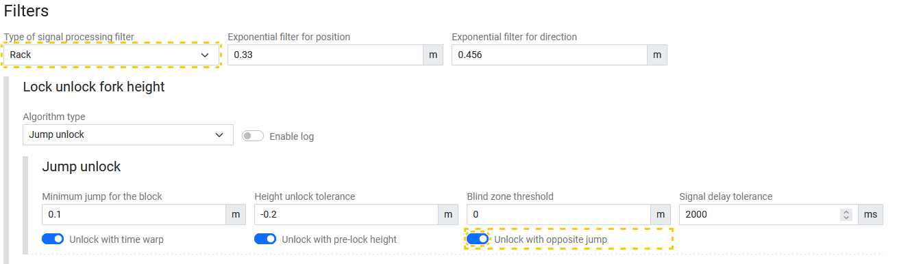

|  |  |
| --- | --- |
| Field | Description |
| Filters / Type of signal processing filter / Exponential filter for position / direction | Selects the filtering algorithm used to smooth position data. Numeric values defining smoothing sensitivity for positional and directional signals. |
| Lock unlock fork height / Algorithm type / Enable log (Toggle) | Defines how the forklift determines locking or unlocking of fork height using height sensors. Method of height lock detection (e.g., *Jump unlock*). Enable/Disable log with toggle. |
| Jump unlock / Minimum jump for the block / Height unlock tolerance / Blind zone threshold / Signal delay tolerance | Thresholds for detecting movement or release. Defines minimum measurable distance and response delay in milliseconds. |
| Unlock options (Toggles) | Toggles for *Unlock with time warp*, *pre-lock height*, or *opposite jump*. |

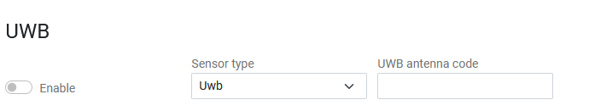

|  |  |
| --- | --- |
| Field | Description |
| Enable (Toggle) | Activates UWB (Ultra-Wideband) localization module. |
| Sensor type | Specifies the antenna type, either Uwb or Simulator. Simulator is used for testing. |
| UWB antenna code | Specifies the antenna code. |

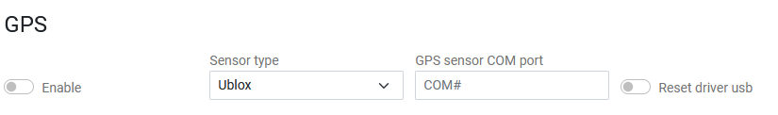

|  |  |
| --- | --- |
| Field | Description |
| Enable | Activates GPS positioning for the forklift. |
| Sensor type | Specifies the GPS’ sensor type, either Ublox or Simulator. Simulator is used for testing. |
| GPS sensor COM port | Defines serial communication port. |
| Reset driver USB | Resets USB interface for GPS devices. |

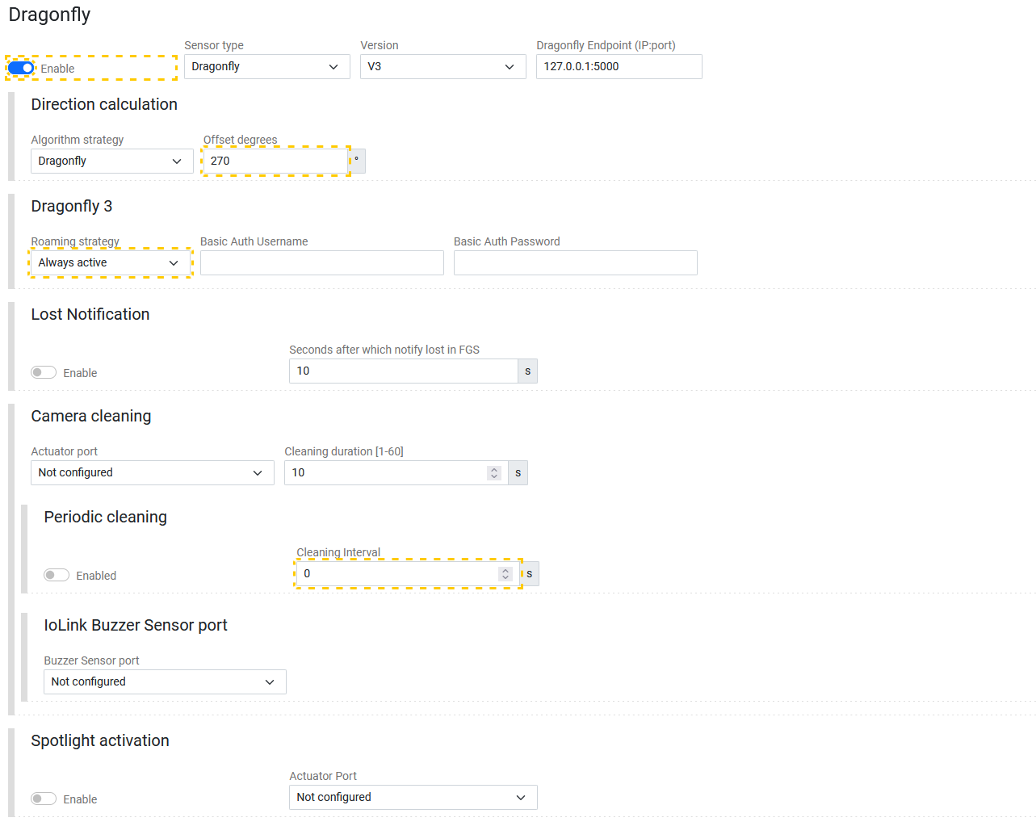

|  |  |
| --- | --- |
| Field | Description |
| Dragonfly / Enable (Toggle) / Sensor type / Version / Endpoint | Selects Dragonfly hardware version and endpoint IP address or port. Sensor type is either Dragonfly or Simulator. Simulator is used for testing. |
| Direction calculation / Algorithm strategy / Offset degrees | Sets direction source for algorithm strategy and offset degrees for direction calibration. |
| Dragonfly 3 / Roaming strategy / Basic Auth Username / Basic Auth Password | Determines roaming behavior between cameras. Optionally create basic authorization for roaming strategy. |
| Lost Notification / Enable (Toggle) / Seconds after which notify lost in FGS | Notifies FGS if Dragonfly signal is lost beyond configured seconds. |
| Camera cleaning / Actuator port / Cleaning duration [1-60] | Defines actuator port and cleaning duration for the lens-cleaning air blower. |
| Periodic cleaning / Enable (Toggle) / Cleaning Interval | Enables scheduled cleaning with defined time interval. |
| IO-Link Buzzer Sensor port / Buzzer Sensor port | Defines buzzer connection port on IO-Link Master. |
| Spotlight activation / Enable (Toggle) / Actuator port | Configures spotlight actuator and duration for camera illumination. Define actuator port utilized on IO-Link. |

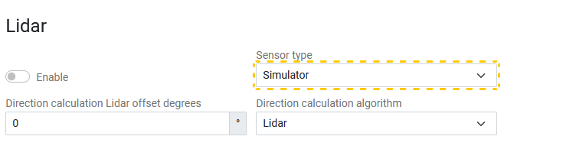

|  |  |
| --- | --- |
| Field | Description |
| Enable (Toggle) | Activates Lidar sensor module. |
| Sensor type | Defines device type, Sick or Simulator. Simulator is used for testing. |
| Direction calculation Lidar offset degrees | Sets sensor offset for orientation calibration. |
| Direction calculation algorithm | Defines algorithm used for motion direction estimation, either Lidar or IMU. |

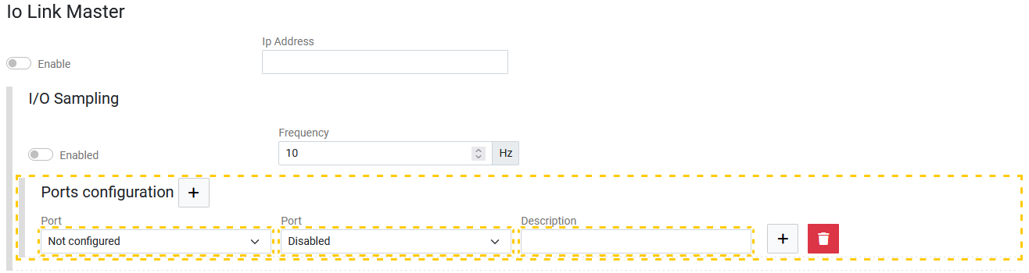

|  |  |
| --- | --- |
| Field | Description |
| Enable (Toggle) | Enables I/O Link Master controller. |
| IP Address | IP of connected master device. |
| I/O Sampling / Frequency | Defines frequency of sensor data polling (Hz). |
| Ports configuration / Port / Port / Description | Optionally opens configuration dialog for each I/O port. |

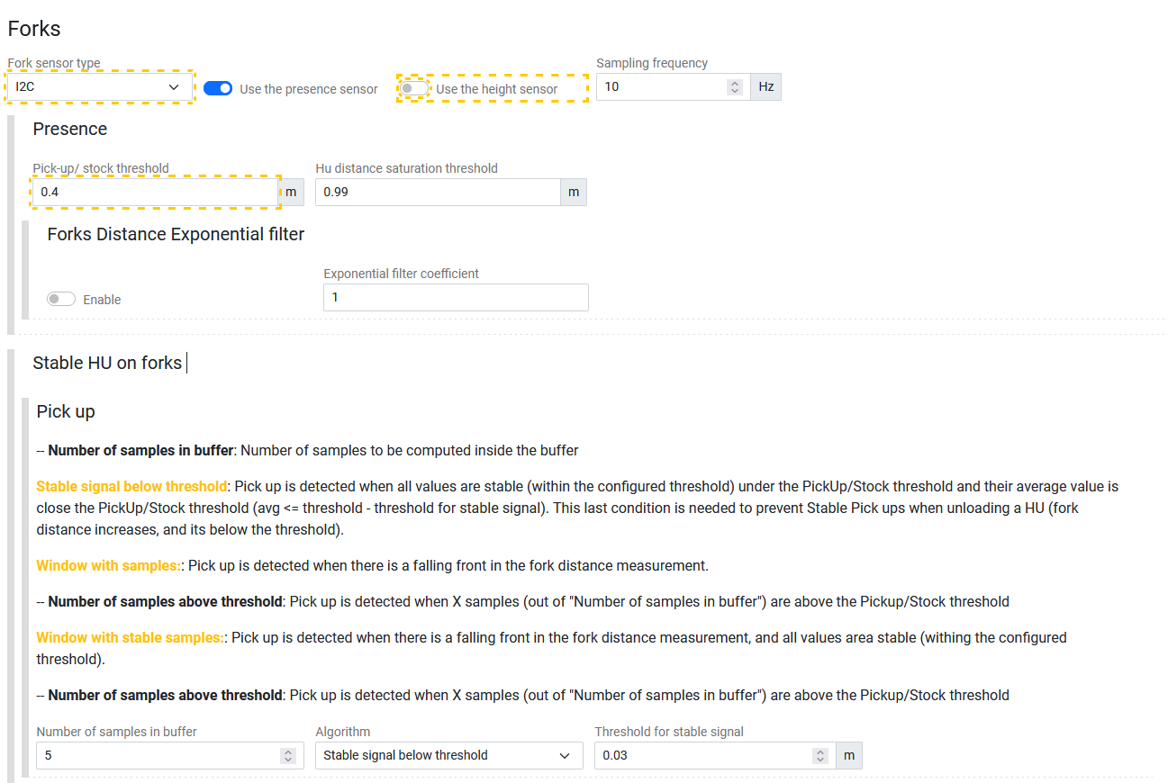

|  |  |
| --- | --- |
| Field | Description |
| Forks / Fork sensor type / Use presence/height sensor (Toggles) / Sampling frequency | Selects hardware interface, such as I2C, IO-Link Master, or Simulator. Simulator is used for testing. Toggles active sensors used for HU detection. Defines data polling frequency for sensors. |
| Presence / Pick-up/stock threshold / HU distance saturation threshold | Distance thresholds used to detect HUs on forks. Defines maximum distance for valid detection. |
| Forks Distance Exponential filter / Enable (Toggle) / Exponential filter coefficient | Applies smoothing filter for distance readings. |
| Stable HU on forks (Pickup) / Number of samples in buffer / Algorithm / Threshold for stable signal | Control logic defining the number of samples or stability conditions to confirm HU pickup or stock detection. |
| I2C (Presence/Height sensor) / PresenzaBudId / AltezzaBusId / Scale factor / Offset | Configures sensor IDs, scale factors, and offset calibration. |
| Available space on forks / Port / Sensor / Buzzer intensity / Calculation Termination timeout / Sensor measurement tolerance / Type of residual space threshold calculation, Warning threshold start, Error threshold start, Depletion threshold start | Defines port, sensor type, tolerance for fork space measurement, and residual thresholds for error detection. |

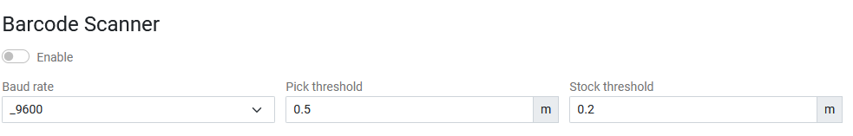

|  |  |
| --- | --- |
| Field | Description |
| Enable (Toggle) | Activates barcode scanner module. |
| Baud rate | Sets communication speed. |
| Pick threshold / Stock threshold | Defines trigger distances for barcode reading events. |

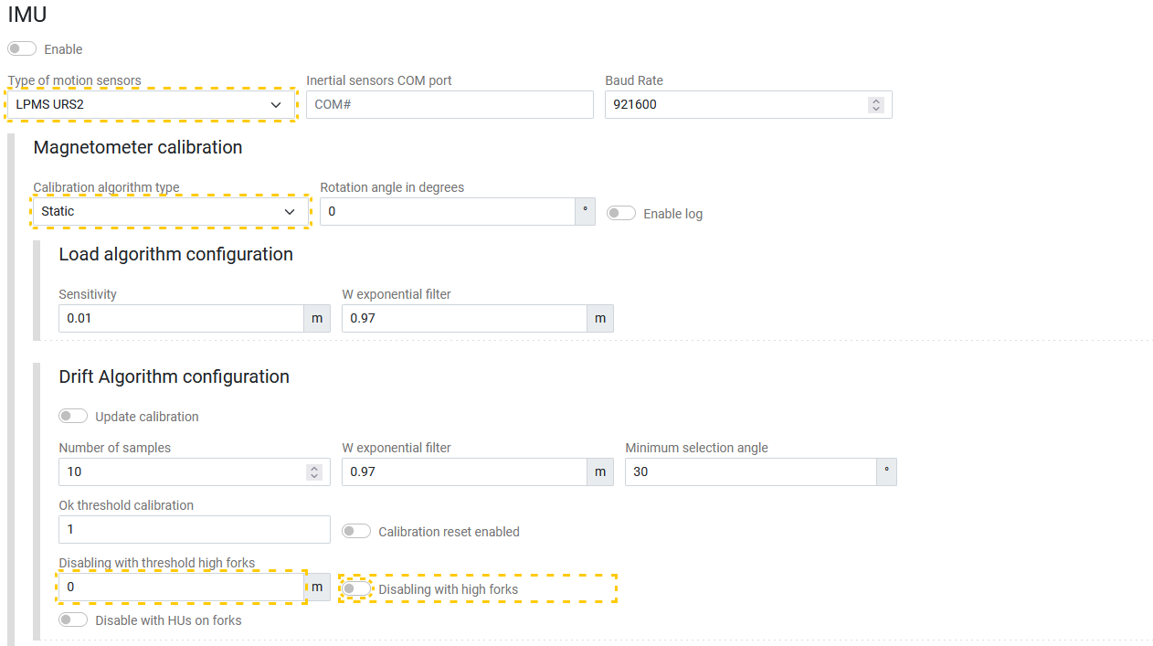

|  |  |
| --- | --- |
| Field | Description |
| IMU / Enable (Toggle) / Type of motion sensors / COM port / Baud rate | Activates IMU sensor suite. Defines hardware interface and communication parameters. |
| Magnetometer calibration / Calibration algorithm type / Rotation angle in degrees / Enable log (Toggle) | Define static type and rotation angle of IMU. Enable/Disable logs. |
| Load algorithm configuration / Sensitivity / W exponential filter | Adjusts sensitivity and exponential filters for load detection. |
| Drift algorithm configuration / Update calibration (Toggle) / Number of samples / W exponential filter / Minimum selection angle / Ok threshold calibration / Calibration reset enabled (Toggle) / Disabling with threshold high forks / Disabling with high forks (Toggle) / Disable with HUs on forks (Toggle) | Manages drift correction, calibration thresholds, and sample sizes. |
| Axes / Axis configuration type / Axis / Scale | Defines X/Y/Z axes of IMU. The IMU must be on a flat surface, with the orientation at 90-degree angles for best calibration. |
| Still forklift calculation / Calculation Source / IMU calculation / Threshold / Accumulator Alpha | Configures parameters for detecting stationary conditions. |
| LPMS URS2 / Transmission frequency / Exponential filter coef / Filter mode / Magnetometer dependency / Linear accel dependency / Orientation offset  Toggles – Euler angles, Quaternion, Linear acceleration, Pressure, Temperature, Altitude, Angular speed | Defines IMU transmission frequency, filter mode, orientation offset, and acceleration dependencies. |
| Gyroscope / Accelerometer / Magnetometer / Enable (Toggles) / Dps / G / Gyroscope self-calibration (Toggle) / Gyro threshold (Toggle) | Toggles sub-sensors and their operating ranges. |

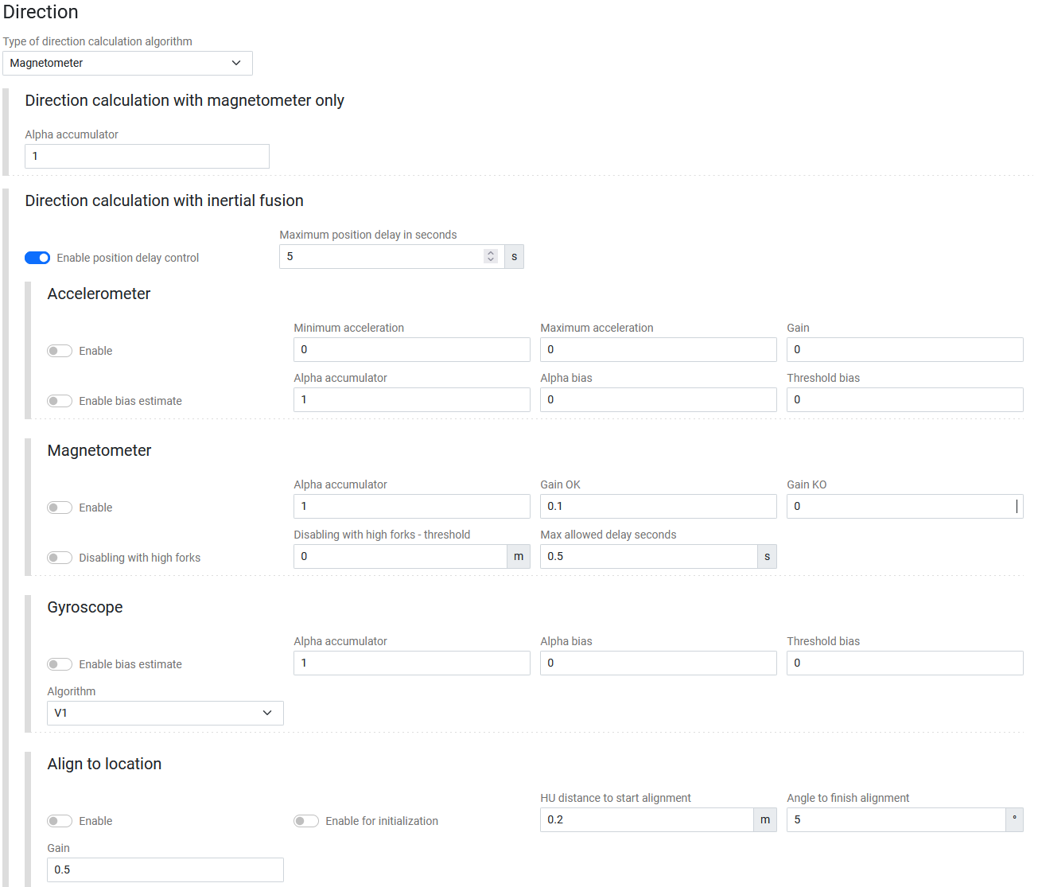

|  |  |
| --- | --- |
| Field | Description |
| Direction / Type of direction calculation algorithm | Chooses method (e.g., *Magnetometer*, *Inertial fusion*). |
| Direction calculation with magnetometer only / Alpha accumulator | Define the alpha accumulator. |
| Direction calculation with inertial fusion / Enable position with delay control (Toggle) / Maximum position delay in seconds | Enables direction correction based on position or speed data with distance and angle limits. |
| Accelerometer / Enable and Enable bias estimate (Toggles) / Minimum and Maximum acceleration / Gain / Alpha accumulator and bias / Threshold bias | Defines how acceleration data is used to stabilize direction. Bias and gain control sensitivity to movement. |
| Magnetometer / Enable and Disabling with high forks (Toggles) / Alpha accumulator / Gain OK / Gain KO / Disabling with high forks – threshold / Max allowed delay seconds | Adjusts how magnetic data affects heading. Can ignore readings when forks are high to avoid interference. |
| Gyroscope / Enable bias estimate (Toggle) / Algorithm / Alpha accumulator and bias / Threshold bias | Uses gyro data to detect rotation and smooth direction. Bias correction reduces sensor drift over time. |
| Align to location / Enable and Enable for initialization (Toggles) / Gain / HU distance to start alignment / Angle to finish alignment | Aligns forklift heading to a fixed location or mission start. Gain sets correction strength; distance and angle set when alignment ends. |

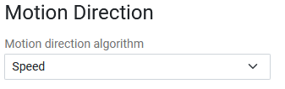

|  |  |
| --- | --- |
| Field | Description |
| Motion Direction / Motion direction algorithm | Selects algorithm type (e.g., *Speed*). |

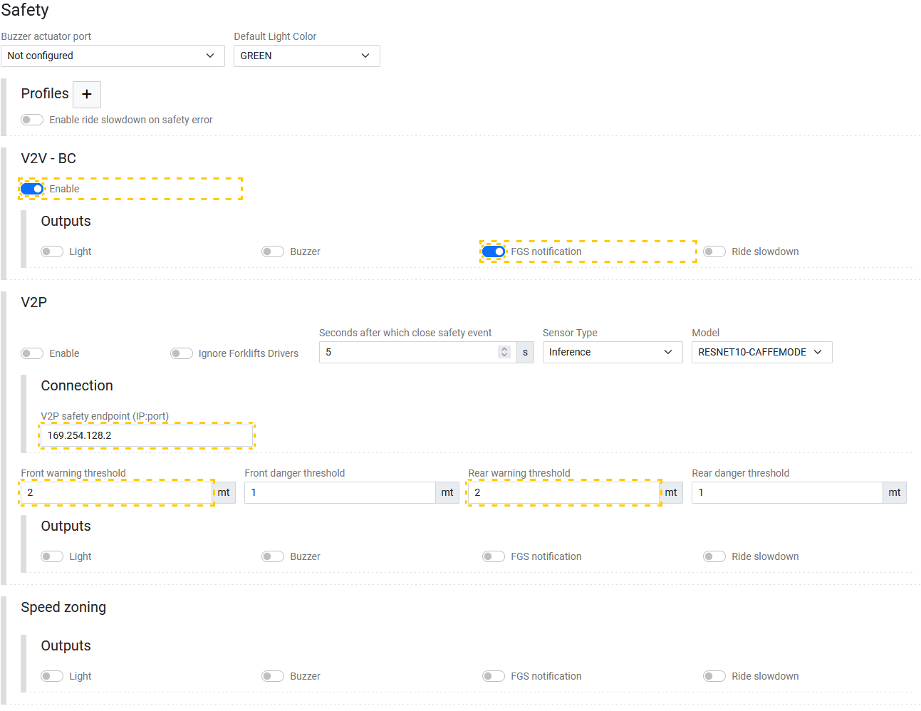

|  |  |
| --- | --- |
| Field | Description |
| Profiles / Enable ride slowdown on safety error (Toggle) | Opens dialog to manage safety behavior profiles. Reduces forklift speed during safety triggers. |
| V2V-BC / Enable (Toggle) / Outputs – Light, Buzzer, FGS notification, Ride slowdown (Toggles) | Enables vehicle-to-vehicle communication with output configuration (light, buzzer, FGS notification). |
| V2P / Enable and Ignore Forklifts Drivers (Toggles) / Seconds after which close safety event / Sensor Type / Model / Connection – V2P safety endpoint (IP:Port) / Front warning threshold / Front danger threshold / Rear warning threshold / Rear danger threshold / Outputs – Light, Buzzer, FGS notification, and Ride slowdown (Toggles) | Configures vehicle-to-pedestrian detection parameters: IP endpoint, thresholds, and outputs. |
| Speed zoning / Outputs – Light, Buzzer, FGS notification, and Ride slowdown (Toggles) | Configures zone-based speed limits and alerts. |

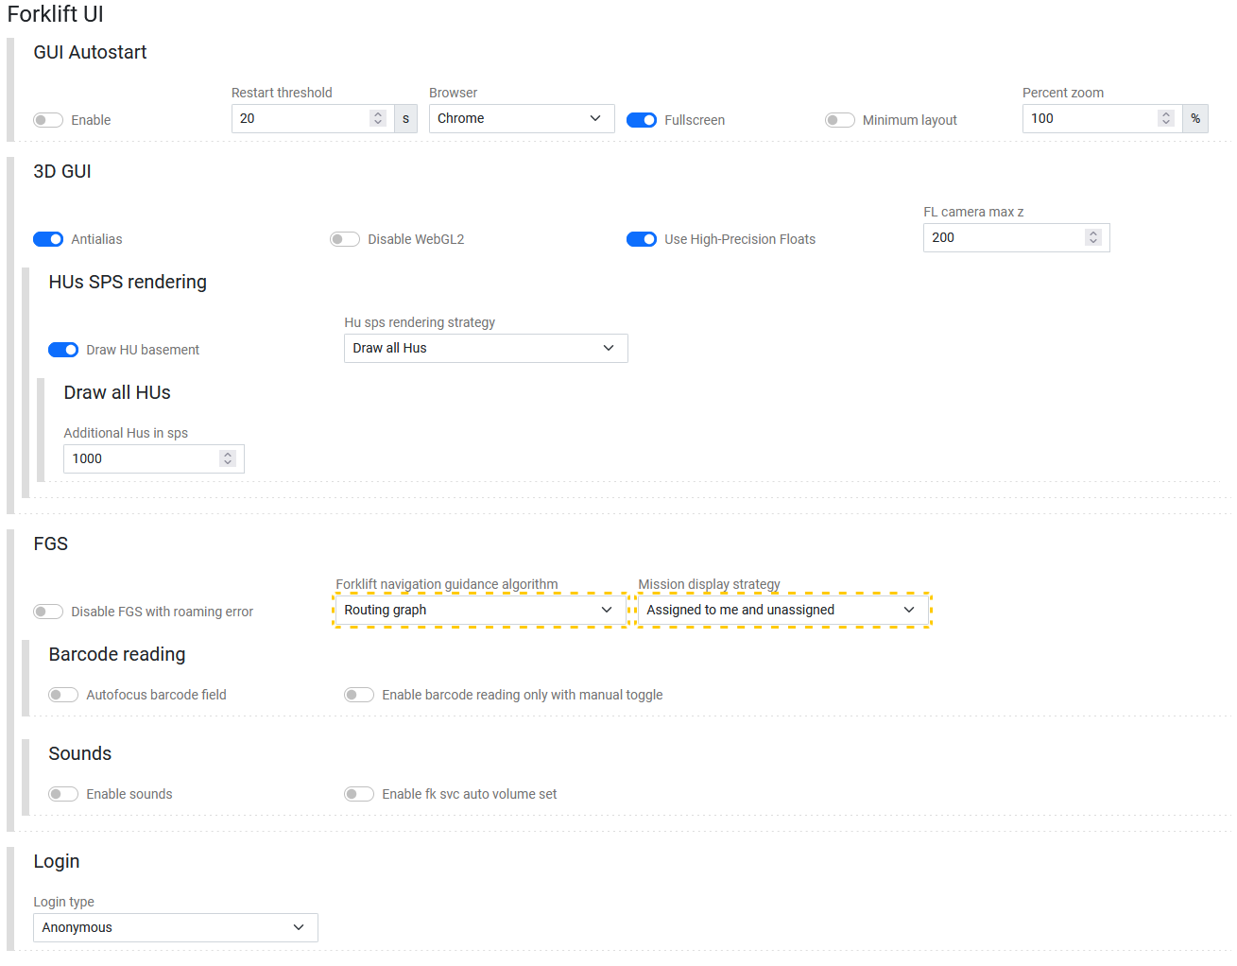

|  |  |
| --- | --- |
| Field | Description |
| GUI Autostart / Enable (Toggle) / Restart threshold / Browser / Fullscreen and Minimum layout (Toggles) / Percent zoom | Controls automated GUI start up performance options. |
| 3D GUI / Antialias, Disable WebGL2, Use High-Precision Floats (Toggles) / FL camera max z | Controls visualization rendering and performance options. |
| HUs SPS rendering / Draw HU basement (Toggle) / Hu sps rendering strategy / Draw all HUs / Additional Hus in sps | Sets how Handling Units appear in SPS maps. Choose to draw all, only active, or simplified HUs. |
| FGS / Disable FGS with roaming error (Toggle) / Forklift navigation guidance algorithm / Mission display strategy | Controls FGS behavior and mission display. Disables FGS if position tracking fails and defines how missions appear on the UI. |
| Barcode reading / Autofocus barcode field and Enable barcode reading only with manual toggle (Toggles) | Enables barcode scanning and autofocus. Manual toggle requires the operator to activate scanning before use. |
| Sounds / Enable sounds and Enable fk svc auto volume set (Toggles) | Enables audio feedback or auto-volume control. |
| Login / Login type | Sets forklift interface authentication (e.g., *Anonymous*). |

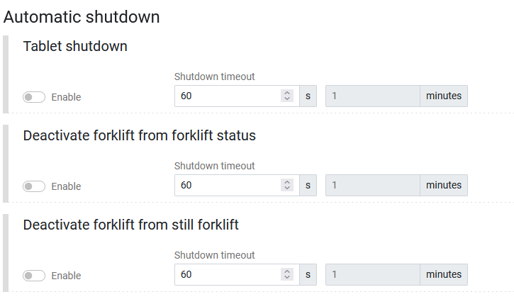

|  |  |
| --- | --- |
| Field | Description |
| Tablet shutdown/Deactivate forklift from forklift status/Deactivate forklift from still forklift / Enable (Toggle) / Shutdown timeout in seconds | Sets timeout for automatic interface shutdown. |

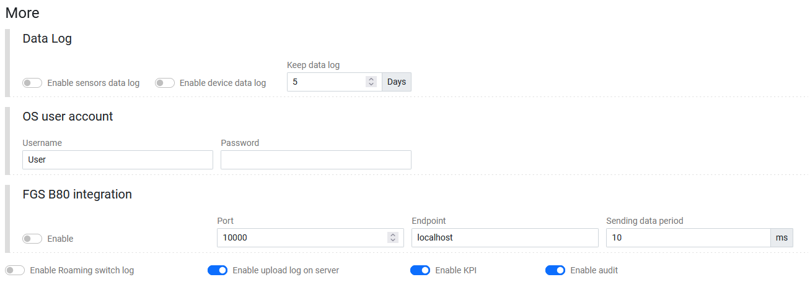

|  |  |
| --- | --- |
| Field | Description |
| Data Log / Enable sensors data log and Enable device data log (Toggles) / Keep data log in Days | Enables logging for sensors or devices and defines retention period. |
| OS user account / Username / Password | Credentials for system-level access to forklift terminals. |
| FGS B80 integration / Enable (Toggle) / Port / Endpoint / Sending data period | Configures communication port, endpoint, and data transmission frequency for external integrations. |
| Toggles | Enable or disable features such as Roaming switch log, upload log, KPI, and Audit. |

**User Actions**

1. **Edit or verify parameters**  
   Adjust specifications, dimensions, filters, or sensor calibrations as needed.
2. **Enable or disable modules**  
   Toggle activation for GPS, UWB, Dragonfly, Lidar, IMU, or barcode sensors.
3. **Update filters and offsets**  
   Calibrate X/Y offsets, exponential filters, and position tolerances according to test results.
4. **Configure safety and UI options**  
   Set up FGS navigation mode, safety thresholds (V2V/V2P), and Forklift UI rendering options.
5. **Save or apply settings**  
   Click **Save** to store configuration, or **Save and restart** to reload forklift services with new parameters.

**Technical Notes**

* All distance units are measured in meters unless stated otherwise.
* IMU, Dragonfly, and Lidar systems use internal calibration algorithms that depend on sensor offsets and filter parameters defined here.
* “Save and restart” restarts the FGS services but does not reboot physical forklift hardware.
* Group configurations apply automatically to all forklifts linked to this group unless overridden individually.

**Troubleshooting**

|  |  |  |
| --- | --- | --- |
| Issue | Description | Action |
| Settings not applied | Parameters saved but not reflected in runtime. | Use **Save and restart** to reload the FGS module. |
| Sensors not responding | Modules like GPS or IMU show inactive. | Verify Enable toggle and COM port assignments. |
| Fork pickup detection unreliable | Fork thresholds too high or low. | Recalibrate Pick-up and Stock thresholds in Forks sensors panel. |
| Camera cleaning not triggered | Air blower actuator misconfigured. | Verify Dragonfly → Camera Cleaning actuator port assignment. |
| Safety alerts not sent | Incorrect IP or threshold in V2V/V2P. | Verify safety endpoint IP and distance values. |

### 4.1.2 Configuration – Forklifts – ⋮ – Zone parameters

The **Zone parameters** page configures how a forklift behaves and interprets positioning, detection, and alignment inside specific zones. These settings define alignment behavior, movement validation, sensor corrections, and stock detection rules for each forklift group or individual forklift.

**Layout Overview**

|  |  |
| --- | --- |
| Area | Description |
| Zone / Zone / Description / Priority | Selects the operational zone and sets general priorities. |
| Alignment / Enable (Toggle) / Location alignment / Location search radius / Maximum location search angle / Rack alignment / Rack search distance for alignment | Defines automatic alignment strategies and search behavior between forklift position and warehouse racks or locations. |
| Magnetometer / Enable and Disabling magnetometer (Toggles) | Enables or disables the magnetometer used for directional calibration. |
| Direction correction / Enable and Enable direction correction (Toggles) | Toggles the automatic correction of the forklift’s direction using additional sensors. |
| Moving HU / Enable (Toggle)  Pick up / Auto-ID enabled, Require Auto-ID confirmation, and Enable pick-up with assisted mode with sensors error (Toggles)  Forklift speed configuration / Enable speed threshold (Toggle) / Threshold after which ignore movement  Stock / Auto-ID enabled, Stock ONLY with assisted mode, Enable stock with assisted mode with sensors error, Require Auto-ID confirmation in location, Stock in free area, and Require Auto-ID confirmation in free area (Toggles)  Forklift speed configuration / Enable speed threshold (Toggle) / Threshold after which ignore movement / Enable check for stock in column at forks height (Toggle)  Location search / Search algorithm / Search distance / Precise search tolerance / HU search algorithm  Pick-up / Stock custom distance / Enable (Toggle) / Pick-Stock HU distance | Enables logic for detecting Handling Units (HUs) in motion for accurate tracking and Auto-ID operations.  Defines Auto-ID behavior and assisted detection rules when forklifts pick up Handling Units, even during sensor faults.  Sets the speed limit above which HU detection is ignored, preventing false readings while the forklift is moving too fast.  Configures automatic HU identification during storage or unloading operations. Includes assisted mode options and confirmation requirements for accurate stock placement.   Enables speed threshold control and height-based stock verification, ensuring accurate detection for stacked storage columns.  Determines the algorithm used to locate positions or HUs relative to forks. Defines search radius, tolerance, and HU detection method.  Overrides default fork detection distance per forklift, allowing fine-tuned HU search distances for specific zones. |
| Dragonfly Roaming Camera Cleaning / Enable (Toggle) | Enables automated air-cleaning of the Dragonfly camera when the forklift transitions between zones, maintaining clear vision for localization. |
| Location Storage Camera on the side / Enable and Enable location storage camera visualization (Toggles) | Activates a secondary camera mounted laterally for detecting HUs in side-storage racks and allows its visualization in diagnostics. |
| Stable Location / Enable (Toggle) / Stable location calculation algorithm / Block 3D position view and Enable log (Toggles) | Activates and configures algorithms that identify when the forklift is stably positioned for missions or stocking. Logs stability events for diagnostics. |
| Location with entrance aligned to forklift direction  Location search / Location search distance / Location search angle offset  Location Lock / Block location strategy / Offset inside location after which block location    Location Unlock / Unlock location strategy / Offset outside location after which unlock stable location / Seconds after which unlock stable location | Defines the distance and angular tolerance used to detect entrances aligned to the forklift’s direction.  Specifies how and when a forklift’s stable location becomes locked once inside a designated area, using offset thresholds for precision.  Determines when and how a locked location is released once the forklift exits a zone, with time delay and offset parameters for controlled unlocking. |

**Field Descriptions**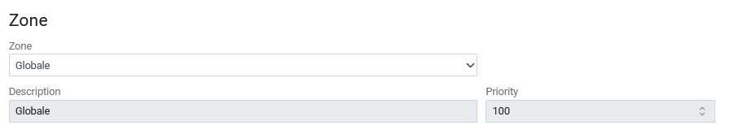

|  |  |
| --- | --- |
| Field | Description |
| Zone | Dropdown to select the target warehouse zone (e.g., *Globale*). |
| Description | Text field describing the purpose or label of the selected zone. |
| Priority | Numerical value defining execution priority for overlapping zones (higher = higher precedence). |

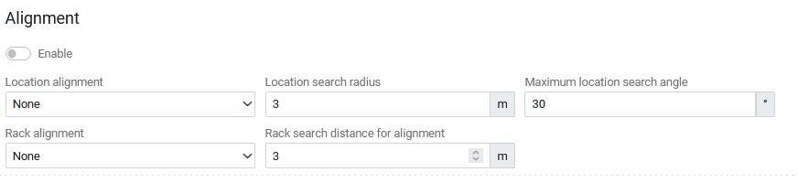

|  |  |
| --- | --- |
| Field | Description |
| Enable | Toggles the alignment feature. |
| Location alignment | Defines how the forklift aligns to a specific location (options: None / Rack / Entrance / Custom). |
| Location search radius | Distance (m) within which the system searches for a matching location. |
| Maximum location search angle | Maximum allowed angular deviation for location search. |
| Rack alignment | Selects rack alignment mode when approaching rack structures. |
| Rack search distance for alignment | Defines distance (m) for detecting and aligning to racks. |

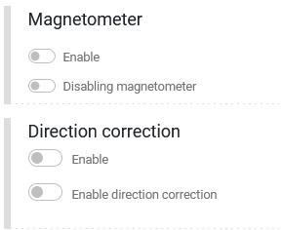

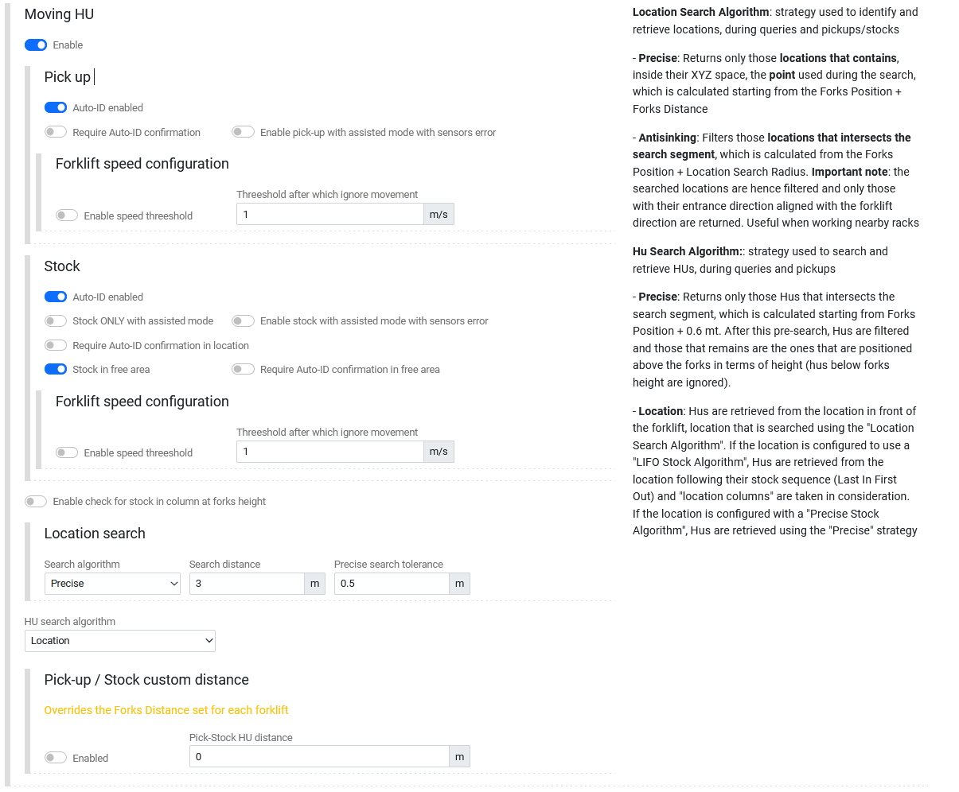

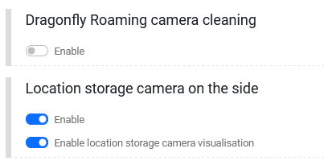

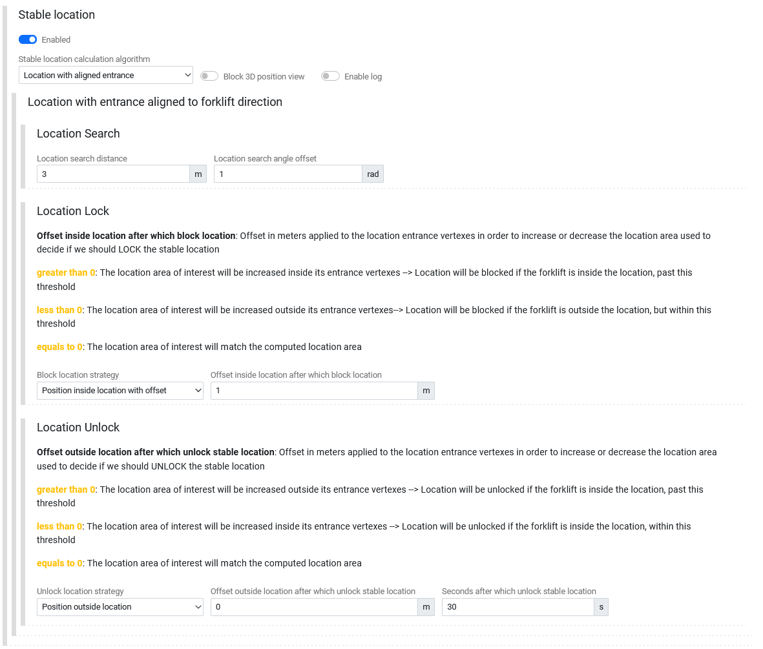

**User Actions**

1. Select a **Zone** and adjust **Priority** as needed. The Globale, top zone should be the only priority at 100.
2. (Optional) Enable **Alignment** and configure search radii and angles.
3. Enable or disable **Magnetometer** and **Direction correction** as required by the forklift sensors.
4. Under **Moving HU**, define pick-up detection logic and motion thresholds.
5. Under Stock, set Auto-ID, assisted mode, and custom search parameters.
6. Optionally configure **Dragonfly cleaning**, **side camera**, and **stable location** settings.
7. Adjust **Lock** and **Unlock** offsets to tune zone engagement behavior.
8. Click **Save** to apply, or **Save and restart** to reload all forklift configuration services.

**Technical Notes**

* All distances are measured in **meters**; angular offsets in **radians**.
* Parameters interact with Dragonfly, UWB, and IMU modules for localization precision.
* “Precise” search algorithms rely on **Forks Position + Forks Distance** to locate valid HU or rack targets.
* **View with reset configurations** restores inherited group defaults and removes individual overrides.
* Changes are stored per forklift group unless overridden at forklift level.

### 4.1.3 Configuration – Forklifts – ⋮ – Safety zones parameters

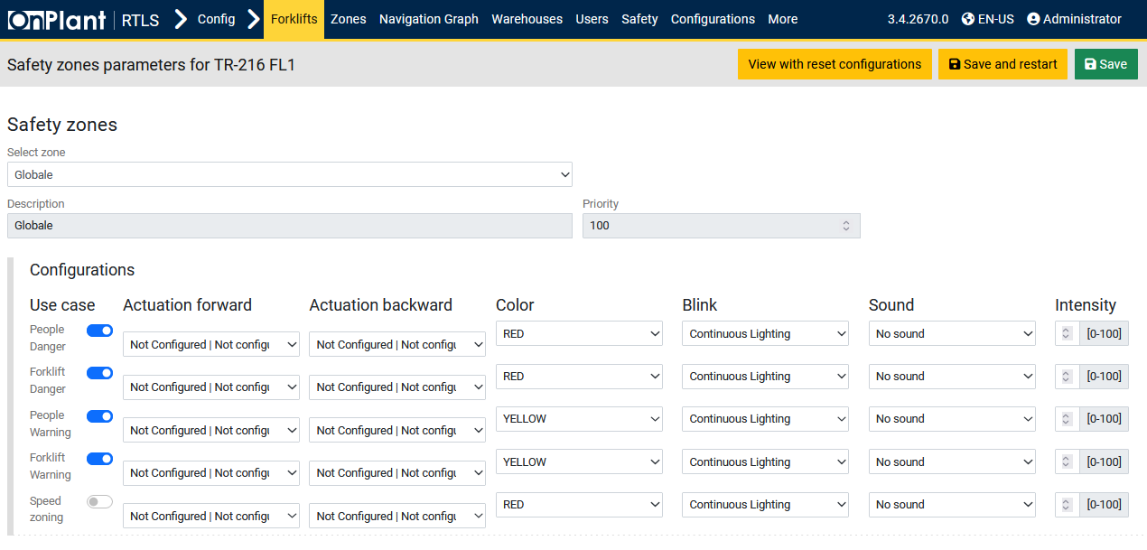

The **Safety zones parameters** page defines forklift behavior when entering or operating within designated safety zones. Administrators use this page to configure visual and auditory alerts, actuation responses, and zone-specific safety priorities for each forklift or forklift group. These parameters determine how the forklift reacts to **proximity events** involving people, other forklifts, or speed zoning restrictions.

**Layout Overview**

|  |  |
| --- | --- |
| Area | Description |
| Safety Zones / Select zone / Description / Priority | Defines the zone scope and general identification fields. |
| Configurations | Table of configurable safety reactions. Each row includes forward/backward actuation, light, blink, sound, and intensity settings. |

**Field Descriptions**

**Safety Zones**

|  |  |
| --- | --- |
| Field | Description |
| Select zone | Dropdown list to select the target operational zone (e.g., *Globale*). |
| Description | Text field describing the selected safety zone. |
| Priority | Numeric field (0–100) defining the execution order for overlapping safety zones. Higher values take precedence. |

**Configurations**

Each configuration defines safety feedback behavior for a specific use case.  
Parameters can be adjusted independently for **forward** and **backward** forklift motion.

|  |  |
| --- | --- |
| Column | Description |
| Use Case | Type of safety event being configured. Options include: • **People Danger** – Human proximity within critical range. • **Forklift Danger** – Collision risk with another forklift. • **People Warning** – Non-critical human proximity warning. • **Forklift Warning** – Non-critical forklift proximity. • **Speed Zoning** – Speed restrictions within controlled zones. |
| Actuation Forward / Actuation Backward | Drop-down lists defining which actuator (light, buzzer, or external output) responds when the forklift moves forward or backward. Displays *Not Configured* if no actuator is assigned. |
| Color | Determines the color of the Safety Alert Lamp. |
| Blink | Controls the blinking or lighting behavior of the beacon. Options include *Continuous Lighting*, *Blinking*, or *Flashing Pattern*. |
| Sound | Selects the audible alert associated with the event. Options include *No sound*, *Beep*, *Warning tone*, or custom-configured sounds. |
| Intensity [0–100] | Adjusts brightness or sound volume intensity as a percentage (0 = off, 100 = maximum). |

**User Actions**

1. **Select the target zone** using the **Select zone** drop-down.
2. Enter a **Description** and adjust **Priority** for this zone.
3. Under **Configurations**, toggle each **Use case** to enable or disable safety management for that type.
4. For each enabled use case, set:
   * **Actuation Forward/Backward** devices to control lights or buzzers.
   * **Color** to define the visual alert color.
   * **Blink** mode for lighting pattern.
   * **Sound** for audible feedback.
   * **Intensity** to set brightness or sound volume.
5. Click **Save** to apply configuration, or **Save and restart** to apply and reload forklift control modules.

**Technical Notes**

* Each safety configuration is tied to the **FGS (Forklift Guidance System)** and executes based on **V2P (Vehicle-to-Pedestrian)** or **V2V (Vehicle-to-Vehicle)** proximity detections.
* Visual actuations typically use connected LED beacon lights, while audio actuations trigger onboard buzzers.
* **Speed Zoning** defines automatic speed reduction zones, even if other warnings are disabled.
* Configuration settings are stored at the forklift level and override inherited group settings.
* The **Priority** parameter ensures the correct safety profile is applied when multiple zones overlap.

**Troubleshooting**

|  |  |  |
| --- | --- | --- |
| Issue | Description | Action |
| Safety lights not activating | Incorrect actuator assignment or disabled toggle | Verify **Use case** is enabled and assign proper actuators in forward/backward fields. |
| No warning when entering zone | Zone not prioritized or disabled | Check **Priority** value and ensure zone toggle is active. |

### 4.1.4 Configuration – Forklifts – ⋮ – Mesh color

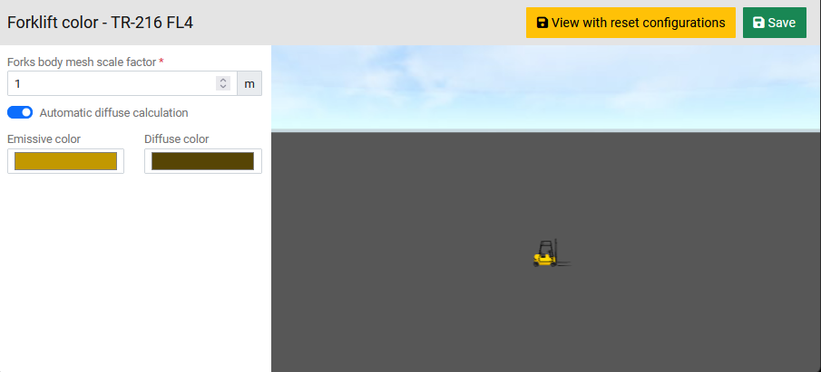

The **Mesh color** page configures the visual representation of forklifts within the OnRTLS 3D environment. Administrators can customize the forklift’s body color, fork scaling, and material rendering parameters for better visual identification on 3D maps and simulation views. This page primarily affects display properties in modules such as **FGS – 3D Live Map**, **Monitoring – Replay**, and **Navigation Graph**.

**Layout Overview**

|  |  |
| --- | --- |
| Area | Description |
| Forks Body Mesh Scale Factor | Numeric input defining the 3D scale multiplier for the forklift’s forks model in meters. Default value: **1**. |
| Automatic Diffuse Calculation (Toggle) | When enabled, the diffuse color automatically adjusts based on the selected emissive color. |
| Emissive Color | Color picker controlling the forklift’s emissive tone. |
| Diffuse Color | Color picker defining how the forklift’s surface reacts to ambient light. It represents the non-glowing component of the forklift model. |
| 3D Preview | Real-time 3D rendering of the forklift model. Displays the active color and scale configuration for immediate visual feedback. Users can rotate, zoom, or inspect the forklift’s color effect in the simulated environment. |

**User Actions**

1. Adjust **Forks body mesh scale factor** to modify the forks’ relative 3D size.
2. Enable or disable **Automatic diffuse calculation** depending on whether you want automatic or manual color matching.
3. Choose desired **Emissive** and **Diffuse** colors to match visual identification or operational group standards.
4. Observe real-time changes in the **3D preview area.**
5. Click **Save** to apply the new visual configuration.
6. If needed, click **View with reset configurations** to revert to default mesh parameters inherited from the group configuration.

### 4.1.5 Configuration – Forklifts – ⋮ – Forks sensors calibration

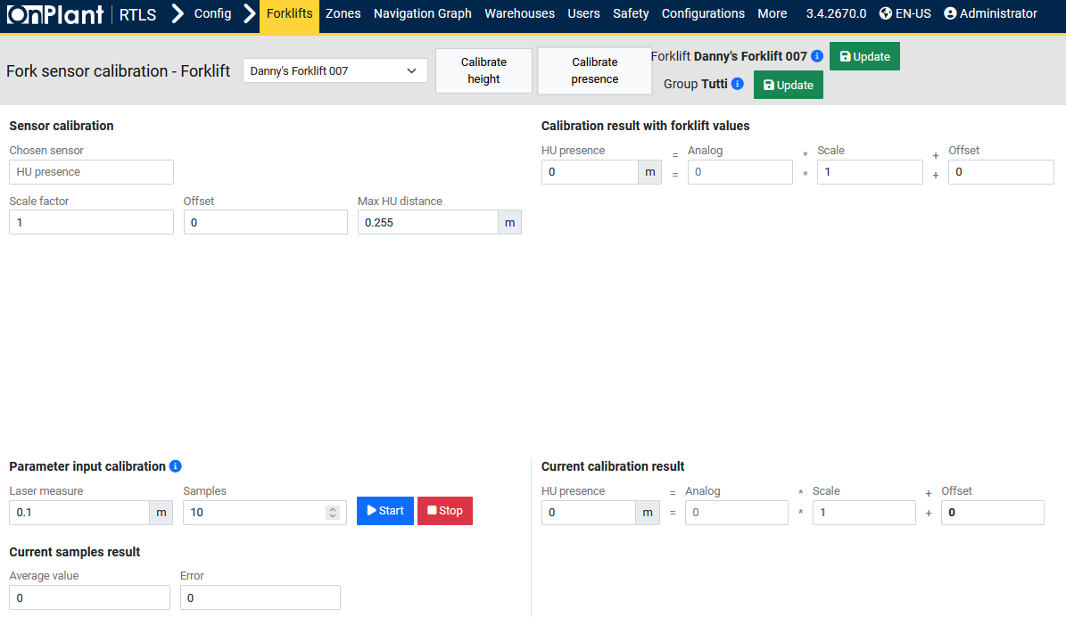

The **Forks sensor calibration** page is used to calibrate the sensors that measure **fork height** and **HU presence** (Handling Unit detection) on a forklift. These sensors are essential for ensuring accurate Handling Unit pick-up and placement detection within the RTLS and FGS environments. Calibration defines scale, offset, and measurement parameters to align sensor readings with actual physical distances measured in meters.

**Layout Overview**

|  |  |
| --- | --- |
| Area | Description |
| Header | Forklift selector (e.g., *Danny’s Forklift 007*). • **Calibrate height** – Opens calibration mode for the fork height sensor. • **Calibrate presence** – Opens calibration mode for the HU presence sensor. • **Update** – Saves calibration data for either the forklift or its assigned group. |
| Sensor Calibration | Panel for defining sensor parameters, including sensor type, scale, and offset. Adjusts how analog sensor signals are translated into metric measurements. |
| Calibration result with forklift values | Displays computed results combining analog input, scale, and offset values to show the derived height or presence distance in meters. |
| Parameter input calibration | Allows manual calibration sampling using real-world laser or measured input. Users define the number of samples and initiate measurement collection. |
| Current Samples Result | Displays ongoing averaged sample data and measurement error from calibration sampling. |
| Current Calibration Result | Shows the live sensor reading converted into real-world units (meters) based on scale and offset. |

**Field Descriptions**

**Sensor Calibration**

|  |  |
| --- | --- |
| Field | Description |
| Chosen sensor | Selects which sensor to calibrate: *Fork height* or *HU presence*. |
| Scale factor | Numerical multiplier converting analog sensor values into real-world distances (m). Adjust this during calibration to align measurements with physical results. |
| Offset | Adds or subtracts a fixed value (in meters) to fine-tune zero-point calibration. |
| Max HU distance *(HU presence mode only)* | Defines the maximum valid distance for Handling Unit presence detection. Readings beyond this threshold are treated as “no HU detected.” |

**Calibration Result with Forklift Values**

|  |  |
| --- | --- |
| Field | Description |
| Fork height / HU presence | Displays computed real-world distance (in meters) based on current analog signal. |
| Analog | Shows the raw analog sensor value received from the forklift. |
| Scale / Offset | Displays active conversion formula values. The result is calculated as: |
| Output (m) = (Analog × Scale) + Offset |  |

**Parameter Input Calibration**

|  |  |
| --- | --- |
| Field | Description |
| Laser measure | Enter the measured real-world distance (m) used for calibration comparison. |
| Samples | Defines how many sensor readings are collected for averaging during the calibration session. |
| Start / Stop buttons | Begins or ends calibration data collection. Once started, the system gathers multiple readings to calculate an average. |

**Current Samples Result**

|  |  |
| --- | --- |
| Field | Description |
| Average value | Displays the average analog value obtained from all samples taken. |
| Error | Shows the deviation between sensor-calculated and actual measured distances. |

**Current Calibration Result**

|  |  |
| --- | --- |
| Field | Description |
| Fork height / HU presence | Displays the latest computed measurement result (in meters). |
| Analog | Current raw sensor value received. |
| Scale | Active multiplier applied to the analog reading. |
| Offset | Constant adjustment applied after scaling. |

**User Actions**

1. **Select a forklift** from the drop-down list.
2. Click **Calibrate height** to calibrate the *fork height sensor* or **Calibrate presence** to calibrate the *HU presence sensor*.
3. Under **Sensor calibration**, verify or adjust **Scale factor** and **Offset** values.
4. (For HU presence calibration) Set the **Max HU distance** according to expected maximum detection range.
5. Under **Parameter input calibration**, enter the **Laser measure** value (the true measured distance) and set the desired **Samples** count.
6. Click **Start** to begin calibration sampling. The system records sensor readings and computes average and error values.
7. Observe the **Current calibration result** and adjust the scale or offset until the **Error** approaches zero.
8. Click **Stop** to end sampling.
9. Click **Update** (for the forklift or group) to save the calibration values.

### 4.1.6 Configuration – Forklifts – +New

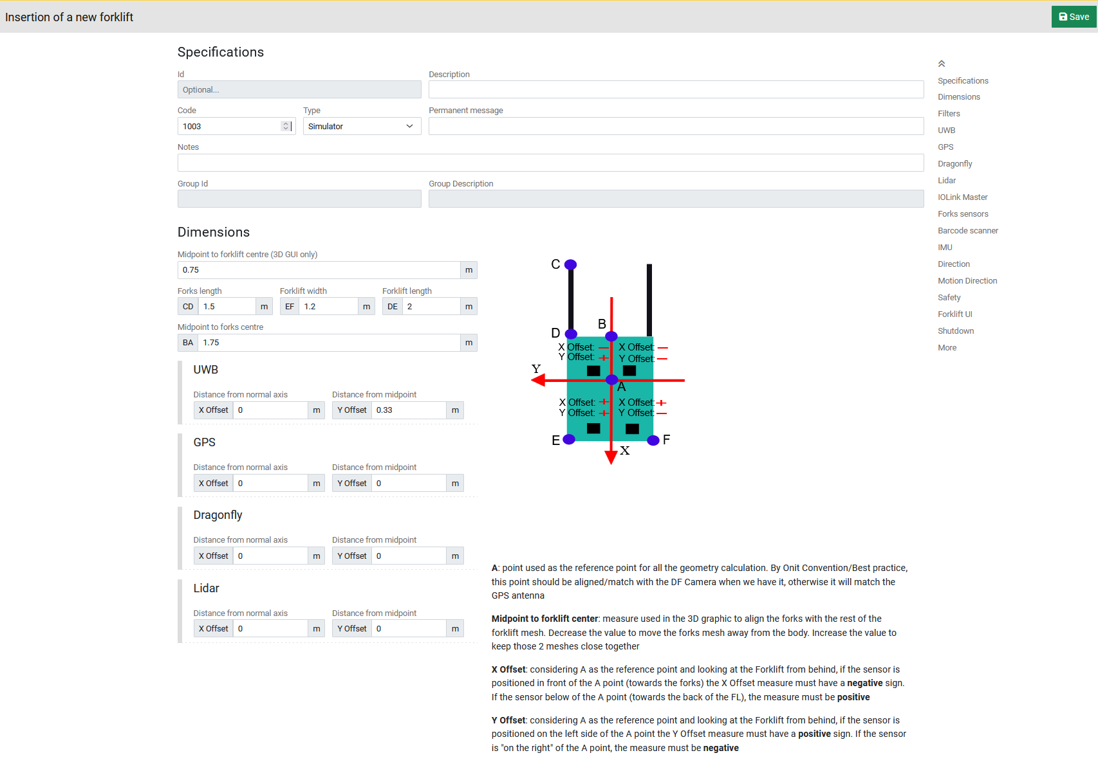

The Insertion of a new forklift page allows administrators to create and register a new forklift or simulator within the OnRTLS system. This page defines the forklift’s physical dimensions, geometric offsets, and sensor alignment parameters that will be used for localization, visualization, and mission tracking. It is almost identical to the Modify group configuration page but applies to initial forklift registration rather than editing existing configurations. (See: 4.1.1 Configuration – Forklifts – ⋮ – Modify group)

### 4.1.7 Configuration – Forklifts – Forklift groups

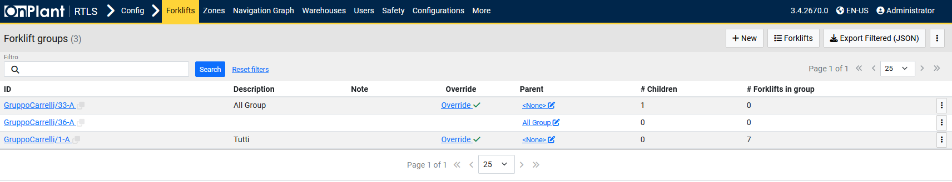

The **Forklift groups** page allows administrators to manage forklift grouping structures used for shared configurations. Groups provide a hierarchical organization system where multiple forklifts can inherit identical parameters for geometry, sensors, safety zones, and performance behavior. Using groups minimizes repetitive configuration by allowing bulk adjustments at the parent level.

**Layout Overview**

|  |  |
| --- | --- |
| Area | Description |
| Header | • **+ New** – Creates a new forklift group. • **Forklifts** – Returns to the forklift list page. • **Export Filtered (JSON)** – Exports the currently visible list of groups in JSON format. • **⋮ (Three-dot menu)** – Import/Export, All groups override, and Fork sensor calibration options. |
| Search Bar (Filtro) | Text search field for filtering forklift groups by ID, description, or note. Includes Search and Reset search buttons. |
| Table | Displays all existing forklift groups with their properties, parent-child relationships, and group membership statistics. |

**Table Columns**

|  |  |
| --- | --- |
| Column | Description |
| ID | Unique identifier for the forklift group. Each ID is a clickable link that opens the group’s configuration page (see 4.1.1 Configuration – Forklifts – ⋮ – Modify group). |
| Description | Descriptive label of the group (e.g., *All Group*, *Tutti*). |
| Note | Optional field used for administrative comments or documentation. |
| Override | Indicates whether the group contains configuration overrides compared to its parent. Displays *Override ✓* when differences are present. |
| Parent | Identifies the parent group (if applicable). Groups may inherit configurations from parent groups to maintain consistency. |
| # Children | Displays the number of subgroups nested under the current group. |
| # Forklifts in group | Shows how many forklifts are currently assigned to this group. |

**User Actions**

1. **Create a new group:**
   * Click **+ New** to open the *Insertion of a new forklift group* page.
   * Enter group details such as Description, Notes, and optionally assign a Parent group.
   * Click **Save** to create the group.
2. **Filter existing groups:**
   * Use the Filtro field to search for groups by ID or name.
   * Click Search to apply the filter or Reset search to return to the full list.
3. **View or edit a group configuration:**
   * Click a group’s ID link (e.g., GruppoCarrelli/33-A).
   * The group’s configuration page (see 4.1.8 and 4.1.9) will open for detailed modification.

### 4.1.8 Configuration – Forklifts – Forklift groups – ⋮ – Zones parameters

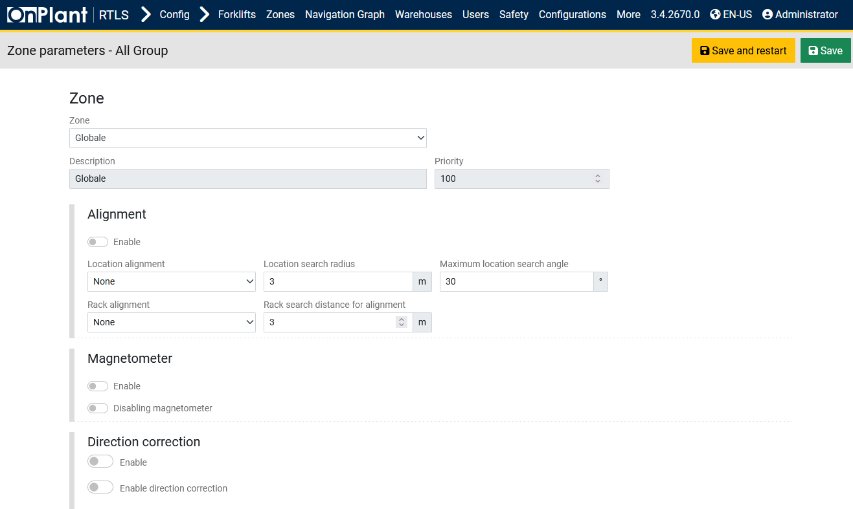

The Zones parameters page for forklift groups defines the default zone configuration inherited by all forklifts within that group. These parameters determine how forklifts behave, align, and detect Handling Units (HUs) or storage locations when operating in defined warehouse zones. Any values configured here apply to every forklift in the group unless individually overridden. 4.1.8 Configuration – Forklifts – Forklift groups – ⋮ – Zones parameters page is functionally identical to 4.1.2 Configuration – Forklifts – ⋮ – Zone parameters, but it operates at the group level rather than for individual forklifts. (See: 4.1.2 Configuration – Forklifts – ⋮ – Zone parameters).

### 4.1.9 Configuration – Forklifts – Forklift groups – ⋮ – Safety zones parameters

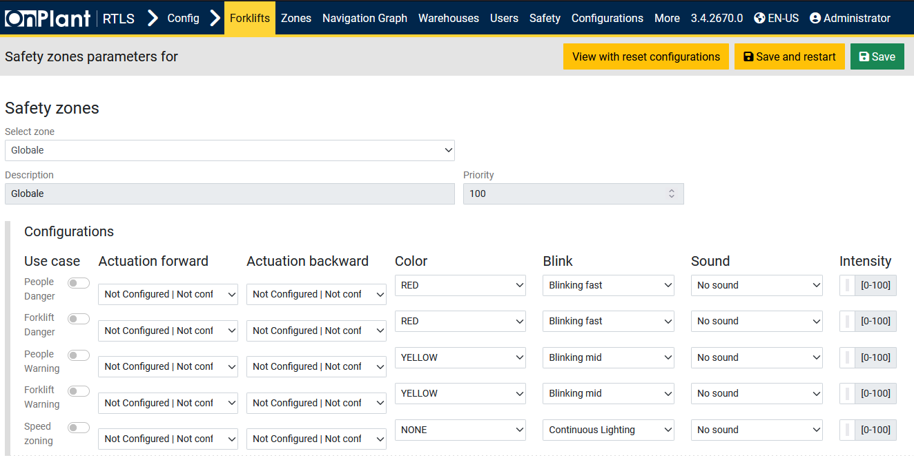

The Safety zones parameters page for forklift groups defines default safety responses inherited by all forklifts within that group. These parameters govern visual alerts, audible warnings, and actuation behaviors when forklifts enter specific safety zones. By configuring safety logic at the group level, administrators ensure consistent safety reactions across multiple forklifts, reducing the need for repetitive individual configuration. 4.1.9 Configuration – Forklifts – Forklift groups – ⋮ – Safety zones parameters page is identical in structure and function to 4.1.3 Configuration – Forklifts – ⋮ – Safety zones parameters, with the only distinction being its group-level application. (See: 4.1.3 Configuration – Forklifts – ⋮ – Safety zones parameters).

### 4.1.10 Configuration – Forklifts – Forklift groups – ⋮ – Mesh color

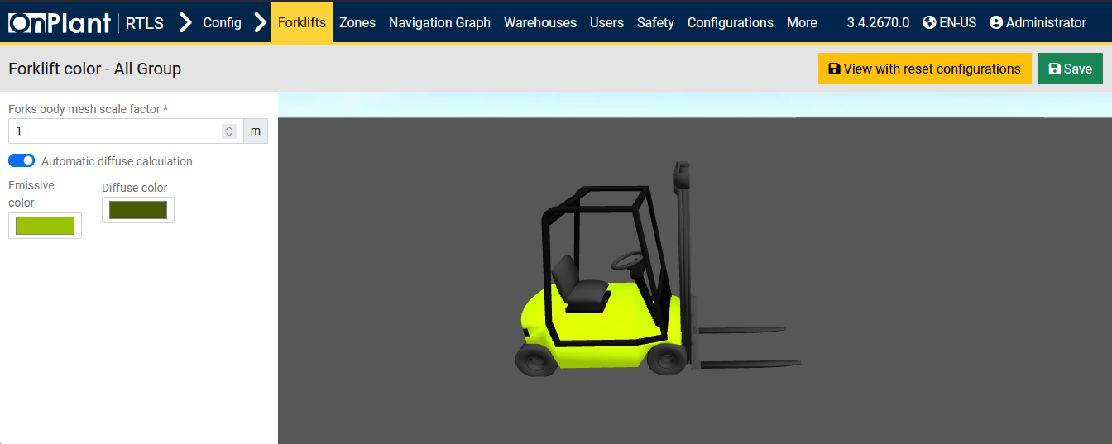

The **Mesh color** page for forklift groups defines the visual color and scale settings applied to all forklifts within that group. These parameters control how forklifts appear in 3D visualization modules, such as the **FGS 3D Live Map**, **Replay**, and **Navigation Graph**.  
Group-level color configuration ensures a consistent visual identity across all forklifts sharing the same operational role or type. This page is visually and functionally **identical** to the forklift-level **5.1.4 Configuration – Forklifts – ⋮ – Mesh color**, except it applies at the **group level**. (See: 5.1.4 Configuration – Forklifts – ⋮ – Mesh color).

## 4.2 Configuration – Zone

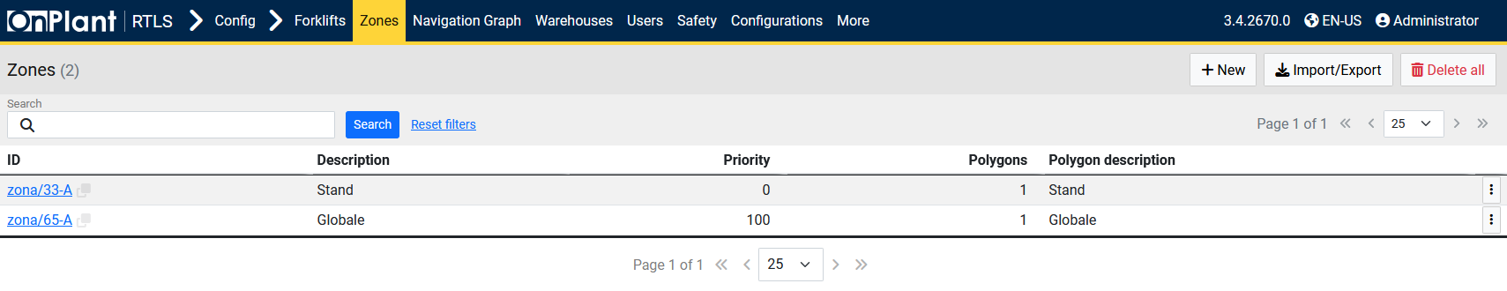  
The *Configuration – Zone* page manages warehouse or operational zones used across the OnRTLS system. Each zone defines spatial boundaries and priorities used by forklifts, navigation graphs, and safety mechanisms. Administrators can add, edit, import/export, or delete zones to structure the working environment within the RTLS.

**Layout Overview**

|  |  |
| --- | --- |
| Area | Description |
| Toolbar | • **+ New** – Opens the form to create a new zone. • **Import/Export** – Opens dialog for importing or exporting zone definitions. • **Delete all** – Removes all zone records from the database. |
| Search Bar | Text field with Search and Reset search buttons to locate zones by ID or description. |
| Table | Lists all configured zones with identifiers, descriptions, priorities, and polygon details. |

**Table Columns**

|  |  |
| --- | --- |
| Column | Description |
| ID | Unique identifier of the zone (e.g., zona/33-A). Clicking opens detailed zone configuration. |
| Description | Text label describing the zone’s purpose (e.g., *Stand*, *Globale*). |
| Priority | Numeric value that determines execution precedence when multiple zones overlap. Higher numbers (e.g., 100) take precedence. |
| Polygons | Number of geometric shapes defining the zone’s area within the RTLS map. |
| Polygon Description | Optional description or label for each polygon. |
| ⋮ (Row Menu) | Contains zone-specific actions such as *Clone* or *Delete*. |

**User Actions**

1. Click **+ New** to create a new zone and define its boundaries, priority, and polygons.
2. Use **Import/Export** to exchange zone configurations between systems (JSON format).
3. Use **Delete all** with caution—this permanently removes all zones from the database.
4. Click an ID link to open and edit an existing zone’s configuration.
5. Use **⋮** menu beside each row for quick management actions.
6. Apply filters in the Search field to locate specific zones; click Reset search to clear results.

**Technical Notes**

* Zone polygons define geometric boundaries used by the RTLS engine for forklift positioning, safety zoning, and navigation mapping.
* The *Globale* zone typically acts as the default system-wide zone with highest priority (100).
* Data updates are written directly to the system configuration database and take effect immediately after saving.

### 4.2.1 Configuration – Zone – +New

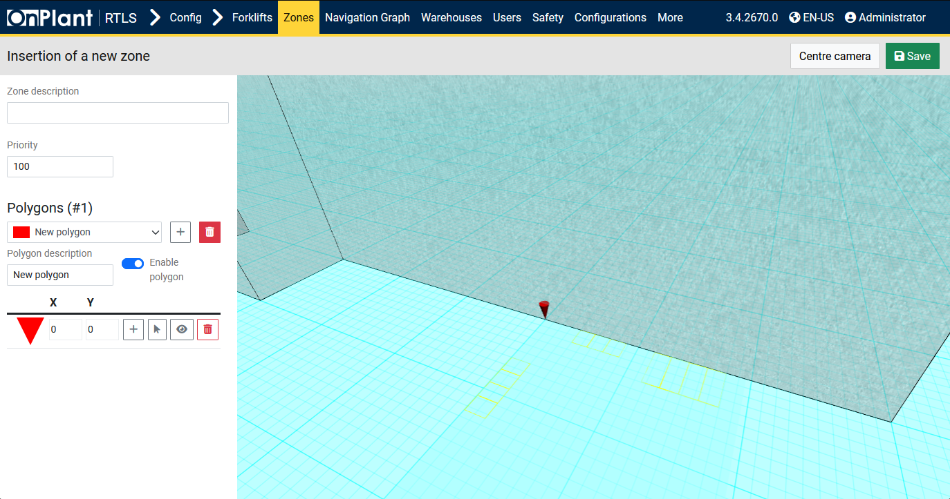  
The *Insertion of a new zone* page allows administrators to create new spatial zones used by the OnRTLS system for positioning, safety, and navigation. Each zone is composed of one or more polygons defining its physical boundaries on the warehouse map. Zones can represent work areas, restricted areas, global regions, or task-specific boundaries for forklifts and missions.

**Layout Overview**

|  |  |
| --- | --- |
| Area | Description |
| Header | • Center camera – Repositions the 3D view to the default focus point. • Save – Saves the newly created zone to the configuration database. |
| Zone Description Field | Text box to name or describe the zone (e.g., “Loading Bay”, “Restricted Area”). |
| Priority | Numeric input determining the zone’s precedence when overlapping with others. The system typically reserves 100 for *Globale* (global zone). Lower values (e.g., 0–99) represent local or specialized areas. |
| Polygons Panel | Manages geometric areas that compose the zone. A zone can have multiple polygons. Each polygon is defined by X/Y coordinates and color-coded for visual reference. |
| 3D Map Area | Displays the spatial grid and active polygons. Users can visually define the zone’s position and boundaries within the environment using interactive tools. |

**Field Descriptions**

|  |  |
| --- | --- |
| Field | Description |
| Zone description | Text field to assign a human-readable name or label for the zone. |
| Priority | Numeric field to set the zone’s precedence level. Higher numbers override lower ones in overlapping areas. |
| Polygon Dropdown | Allows selecting which polygon is currently being edited. Each polygon can be renamed or color-coded. |
| Polygon Description | Text field labeling the polygon. |
| Enable Polygon (Toggle) | Activates or deactivates the polygon’s inclusion in the zone geometry. |
| Coordinates (X / Y) | Numeric input boxes to set the polygon’s vertex coordinates. Each represents a point on the RTLS grid. |
| Polygon Tools | Buttons beside coordinate fields: • **Add (+)** – Adds a new vertex to the polygon. • **Cursor icon** – Shows the polygon in the 3D scene. • **Eye icon** – Toggles visibility of the polygon in the 3D map. • **Trash icon** – Deletes the current vertex or polygon. |

**User Actions**

**To create a new zone:**

1. Enter a **Zone description** (e.g., *Stand Area*, *Docking Zone*).
2. Define the **Priority** number. Use 100 only for the *Globale* zone; all others should have lower priorities.
3. In **Polygons**, keep the default or add more using the **+** button.
4. Provide a **Polygon description** and enable the toggle.
5. Define the zone’s shape using coordinate values or by clicking/dragging in the **3D map area**.
6. Use Center camera to reset view if the map drifts.
7. Click **Save** to confirm and register the zone.

**Editing Tips**

* Use color coding to distinguish zones visually.
* Maintain consistent naming conventions (e.g., “Zone_Receiving_01”).
* Use small polygons for precise boundaries; larger ones for general areas.

**Technical Notes**

* All coordinates use the RTLS warehouse coordinate system (X/Y plane).
* Each polygon represents a flat 2D shape defining part of a zone boundary.
* Multiple polygons can form complex zones or disjoint areas.
* Priority defines zone overlap handling — higher-priority zones (e.g., *Globale = 100*) take precedence in sensor interpretation.
* Zones are referenced by Forklift Zone Parameters (4.1.2) and Safety Zones (4.1.3).

## 4.3 Configuration – Navigation Graph

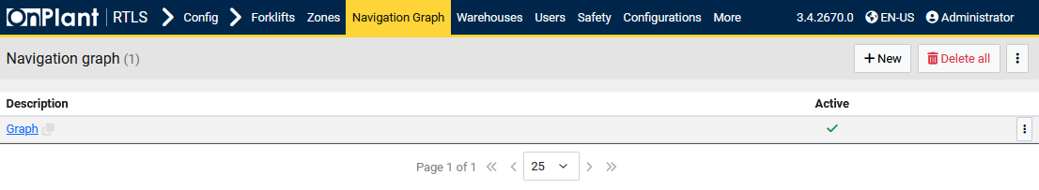  
The *Navigation Graph* page manages the spatial routing maps used by forklifts and other autonomous vehicles within the OnRTLS environment. Each navigation graph defines a connected network of nodes and paths that guide forklifts through designated areas, ensuring accurate and optimized route planning for missions and movement control.

**Layout Overview**

|  |  |
| --- | --- |
| Area | Description |
| Toolbar | • **+ New** – Opens the *Insertion of a new navigation graph* page. • **Delete all** – Permanently removes all navigation graphs from the database. • **⋮ (Three-dot menu)** – Opens additional options such as *Import/Export* or *Set active*. |
| Table | Lists all navigation graphs configured in the system with their descriptions and active status. |

**Table Columns**

|  |  |
| --- | --- |
| Column | Description |
| Description | Displays the name or label of the navigation graph. Clicking the name (e.g., Graph) opens the graph editor interface where nodes, connections, and routes can be configured (see 4.3.1 Configuration – Navigation Graph – +New). |
| Active | Shows whether the navigation graph is currently active in the system (✓ = active). Only one navigation graph can be active at a time. |
| ⋮ (Row Menu) | Contains contextual options for managing the selected graph, such as *Edit*, *Clone*, *Export*, *Deactivate*, or *Delete*. |

**User Actions**

1. Click **+ New** to create a new navigation graph and define its nodes and routes.
2. Click the **Description link** (e.g., *Graph*) to open and edit an existing graph.
3. Use the **⋮** menu for specific actions like exporting or cloning the selected graph.
4. Use **Delete all** to remove all navigation graphs.

### 4.3.1 Configuration – Navigation Graph – +New

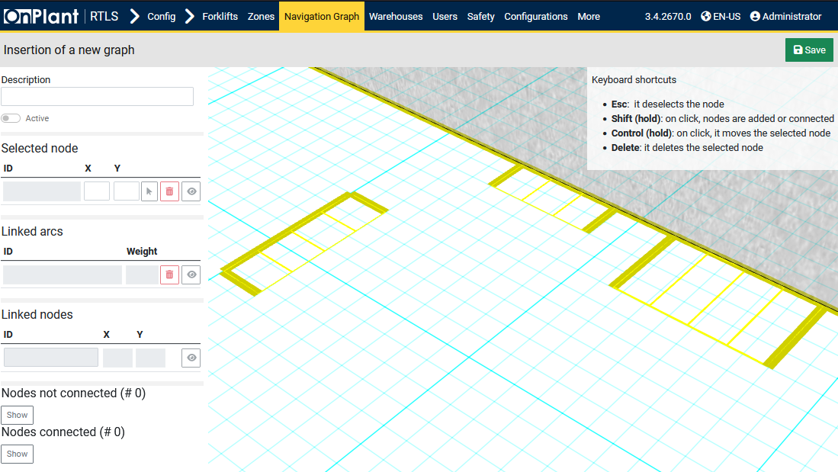  
The *Insertion of a new graph* page is used to create and configure navigation graphs that define forklift routing paths within the warehouse environment. Each graph consists of nodes and arcs representing possible forklift movements. This structure enables the Forklift Guidance System (FGS) to calculate optimal routes for missions and movement tasks based on real-world map coordinates.

**Layout Overview**

|  |  |
| --- | --- |
| Area | Description |
| Header | **Save** button to store the configuration. |
| 3D Grid View | Interactive area where users create and link nodes to build the navigation graph. The 3D grid visually represents the warehouse floor plan. |
| Keyboard Shortcuts | • **Esc** – Deselects the active node. • **Shift (hold)** – Adds or connects nodes when clicked. • **Control (hold)** – Moves the selected node. • **Delete** – Deletes the selected node. |
| Panel | Contains configuration and data fields for the selected node and its linked connections. |

**Panel Fields and Controls**

|  |  |  |
| --- | --- | --- |
| Section | Field / Control | Description |
| Description | Text field | Enter a unique name for the navigation graph. |
| Active Toggle | Switch | Enables the navigation graph as active once saved. Only one active graph can exist at a time. |
| Selected Node | ID / X / Y fields | Displays ID and coordinates of the selected node within the graph. • Arrow icon – Centers the 3D view on the node. • Trash icon – Deletes the node from the graph. |
| Linked Arcs | ID / Weight fields | Lists and defines the arcs (connections) between nodes. • **Weight** determines connection cost or distance used for pathfinding algorithms. • **Trash icon** – Removes the arc connection. |
| Linked Nodes | ID / X / Y fields | Displays connected nodes’ coordinates to visualize relationships between points. |
| Nodes not connected (#) | Show button | Displays all unlinked nodes within the graph to identify missing connections. |
| Nodes connected (#) | Show button | Displays all nodes that are currently connected through one or more arcs. |

**User Actions**

**To create a navigation graph:**

1. Enter a **Description** for the graph.
2. (Optional) Enable the **Active** toggle if this graph should be used immediately.
3. Click on the **3D grid view** to start creating nodes:
   * **Shift + Click** to place nodes or connect them.
   * **Control + Click** to move an existing node.
   * **Delete** to remove a node.
4. Adjust node coordinates (X, Y) manually in the **Selected node** panel if precise positioning is required.
5. Review **Linked arcs** and **Linked nodes** to confirm route structure.
6. Use **Show** buttons to visualize connected or unconnected nodes for verification.
7. Click **Save** to register the new navigation graph.

## 4.4 Configuration – Warehouses

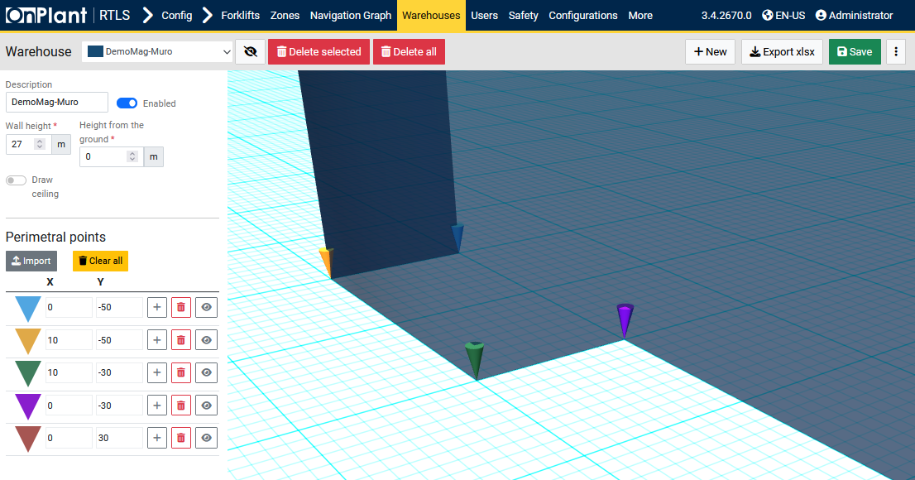  
The *Warehouse* configuration page defines the physical layout of warehouses within the OnRTLS system. Each warehouse is represented as a 3D structure composed of perimeter points that determine its walls, height, and position relative to the ground plane. These warehouse models are used by other system components (Navigation Graphs, Zones, and 3D Live Maps) to simulate and visualize forklift operations in realistic environments.

**Layout Overview**

|  |  |
| --- | --- |
| Area | Description |
| Header | • **Delete selected** – Removes selected perimeter points. • **Delete all** – Clears all perimeter points and warehouse data.  • **+ New** – Creates another warehouse on the same page. • **Export XLSX** – Exports warehouse configuration data to an Excel file. • **Save** – Saves the current warehouse geometry and parameters. • **⋮ (Three-dot menu)** – Import/Export |
| Warehouse Selection | Drop-down list to select an existing warehouse (e.g., *DemoMag-Muro*). |
| Description | Text field to label or rename the selected warehouse. |
| Enabled (Toggle) | Enables or disables the visibility and activation of the warehouse in the 3D environment. |
| Wall Height / Height from Ground | Numeric fields defining the vertical dimensions of the warehouse: • **Wall height (m)** – Sets the total wall height. • **Height from the ground (m)** – Defines the base elevation relative to the ground plane. |
| Draw Ceiling (Toggle) | When enabled, renders a closed ceiling over the warehouse structure for full enclosure visualization. |
| Perimetral Points Section (perimeter points) | Lists all coordinate points (X/Y) forming the warehouse’s perimeter polygon. Each point is color-coded for easy identification in the 3D view. |
| 3D View Area | Displays the warehouse perimeter and vertical structure in a 3D coordinate grid. The colored markers represent the perimeter vertices. Users can zoom, pan, and rotate to inspect or edit geometry. |

**Field Descriptions**

|  |  |
| --- | --- |
| Field / Control | Description |
| Import | Import warehouse vertexes with X;Y \n. |
| Clear all | Deletes all perimeter points, resetting the geometry definition. |
| X / Y | Coordinates for each perimeter point in meters, defining the warehouse base polygon. |
| + Button | Adds a new perimeter point entry. |
| Trash Icon | Deletes the associated point. |
| Eye Icon | Centers the perimetral point on the 3D live map. |

**User Actions**

**To create or modify a warehouse:**

1. Select an existing warehouse or click **+ New** to create one.
2. Enter a **Description** (e.g., “DemoMag-Muro”).
3. Enable the **Enabled** toggle to activate visibility.
4. Define **Wall height** and **Height from the ground** in meters.
5. Add perimeter points manually using the **+** button, or click **Import** to load them from a file.
6. Adjust **X** and **Y** values to set the correct layout on the 3D grid.
7. (Optional) Enable **Draw ceiling** to close the roof.
8. Click **Save** to confirm all changes.

**Technical Notes**

* The perimeter defines the warehouse’s 2D base polygon; wall height extends this polygon vertically.
* Coordinates follow the same RTLS spatial reference as zones, navigation graphs, and forklifts.
* Multiple warehouses can coexist in the system, but only enabled ones are rendered in the 3D view.
* The *Export XLSX* option is typically used for documentation or backup of structural configurations.
* The warehouse model directly affects visibility, zone alignment, and navigation graph boundaries in the FGS.

## 4.5 Configuration – Users – FGS Users

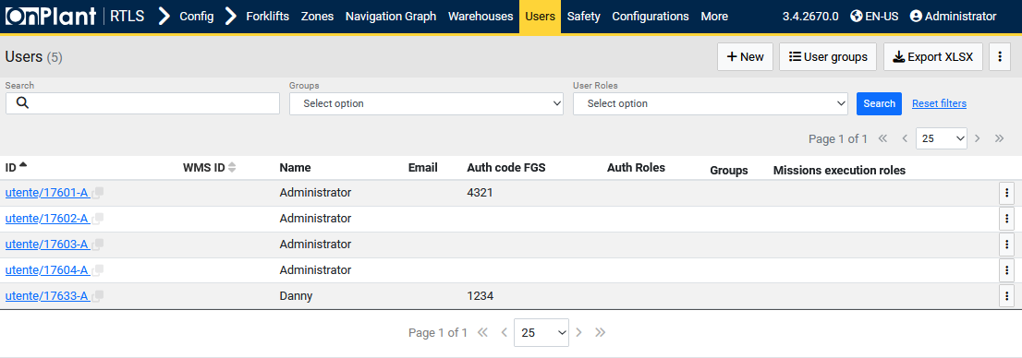

The **FGS Users** page manages user accounts that can access the OnRTLS Forklift Guidance System (FGS) and web interface. Administrators use this page to create, assign, and manage user credentials, group memberships, and operational roles used for mission execution and forklift authorization.

**Layout Overview**

|  |  |
| --- | --- |
| Area | Description |
| Header | • **+ New** – Opens the user creation form (see 5.5.1 Configuration – Users – FGS Users – +New). • **User groups** – Opens the User Groups configuration page (see 5.6). • **Export XLSX** – Exports the current user list in Excel format. |
| Filter Bar | Provides dropdown filters to locate users by Groups or User Roles. A Search box allows keyword lookup by name, ID, or email. Includes Search and Reset search buttons. |
| Table | Displays all registered FGS user accounts with details such as identifiers, authentication codes, and assigned roles. Each row corresponds to one user account. |

**Table Columns**

|  |  |
| --- | --- |
| Column | Description |
| ID | Unique user identifier. Clicking the ID (e.g., utente/17601-A) opens the user configuration page. |
| WMS ID | Identifier linked to the Warehouse Management System, if integrated. |
| Name | Display name of the user. |
| Email | Email address associated with the account (blank if not configured). |
| Auth code FGS | Numeric authentication code used to log in to forklift-mounted FGS terminals. |
| Auth Roles | Lists assigned authentication roles, defining access rights in the system. |
| Groups | Displays user group memberships, inherited from the *User Groups* page. |
| Missions execution roles | Defines the mission types or forklift tasks this user can perform. |
| ⋮ (Row Menu) | Option to *Delete*. |

**User Actions**

|  |  |
| --- | --- |
| Action | Description |
| Add a new user | Click **+ New**, fill in user details, and assign roles and groups. (See 5.5.1.) |
| Filter users | Use the Search, Groups, or User Roles filters to narrow results. Click Search to apply or Reset search to clear. |
| Edit an existing user | Click the user’s ID link to open their detailed configuration. |
| Export user list | Click **Export XLSX** to download all visible users as an Excel file. |
| Access user groups | Click **User groups** to manage shared access roles and permissions. |

**Technical Notes**

* The **Auth code FGS** is required for forklift terminal logins and is typically numeric.
* User roles determine access to FGS modules, missions, and configuration tools.
* Data synchronization with the **WMS** (Warehouse Management System) occurs automatically if enabled.
* System updates refresh the user list upon each search or after creating a new user.

### 4.5.1 Configuration – Users – FGS Users – +New

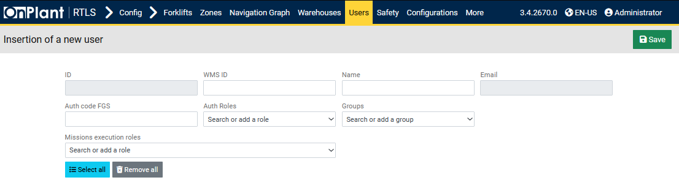

The **Insertion of a new user** page allows administrators to create and register a new user for the Forklift Guidance System (FGS) and OnRTLS web interface. Each user record defines authentication credentials, assigned roles, and group memberships that determine access permissions and operational privileges.  
  
**Layout Overview**

|  |  |
| --- | --- |
| Area | Description |
| Header | **Save** button (top-right corner) to store the new user’s configuration. |
| Form Fields | Organized into two rows for identification, authentication, and authorization settings. |

**Field Descriptions**

|  |  |
| --- | --- |
| Field | Description |
| ID | Unique system identifier automatically assigned upon saving. Used internally to reference the user (e.g., *utente/17601-A*). |
| WMS ID | Optional identifier used when integrating with a Warehouse Management System (WMS). Ensures cross-platform user mapping. |
| Name | Full display name of the user as shown in the system (e.g., *Danny* or *Administrator*). |
| Email | User’s email address for administrative or notification purposes. Optional field. |
| Auth code FGS | Numeric or alphanumeric code used for forklift terminal login. This field is **required** for users who operate forklifts. |
| Auth Roles | Drop-down list to assign predefined authorization roles (e.g., *Administrator*, *Operator*, *Viewer*). Roles define web and FGS interface permissions. Multiple roles may be assigned. |
| Groups | Assigns the user to one or more groups. Groups define shared configuration and permission templates. See section **5.6 Configuration – Users – User Groups**. |
| Missions execution roles | Specifies which mission types or actions the user can execute within the FGS. Multiple roles can be assigned. |
| Select all / Remove all | Buttons for bulk selection or removal of all mission execution roles. Useful when granting or revoking multiple permissions at once. |

**User Actions**

|  |  |
| --- | --- |
| Action | Description |
| Create a new user | Fill in **Name**, **Auth code FGS**, and assign **Auth Roles** and **Groups** as required. |
| Assign mission permissions | In the *Missions execution roles* field, select roles that determine which tasks the user can perform. Use **Select all** to grant all available roles or **Remove all** to clear them. |
| Save user | Click **Save** to register the new user. The new entry appears in the FGS Users table. |
| Cancel creation | Navigate back to the **Users** page without saving if no changes are desired. |

## 4.6 Configuration – Users – User Groups

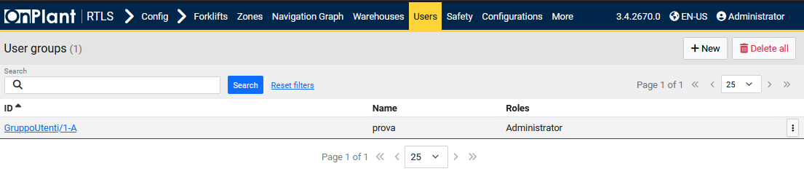

The **User Groups** page manages collections of users who share the same authorization roles and access privileges within the OnRTLS system. Groups simplify permission management by allowing administrators to assign roles once at the group level rather than individually to each user.

**Layout Overview**

|  |  |
| --- | --- |
| Area | Description |
| Header | • **+ New** – Opens the *Insertion of a new user group* page (see 5.6.1). • **Delete all** – Permanently removes all existing user groups from the database. Use with caution. |
| Search Bar | A text field for filtering user groups by ID or name. Includes Search and Reset search buttons. |
| Table | Displays all existing user groups with their identifiers, names, and assigned roles. |

**Table Columns**

|  |  |
| --- | --- |
| Column | Description |
| ID | Unique identifier of the user group (e.g., *GruppoUtenti/1-A*). Clicking this link opens the group configuration editor. |
| Name | Descriptive name of the user group (e.g., *prova*). |
| Roles | Lists the roles or permissions associated with the group (e.g., *Administrator*). |
| ⋮ (Row Menu) | Option to *Delete*. |

**User Actions**

|  |  |
| --- | --- |
| Action | Description |
| Create new group | Click **+ New**, enter a group name, and assign one or more roles. (See 5.6.1 Configuration – Users – User Groups – +New.) |
| Edit or view group details | Click the ID link (e.g., GruppoUtenti/1-A) to open its configuration page. |
| Delete groups | Use **Delete all** to remove all groups or the **⋮** menu to delete individual ones. |
| Search groups | Enter a keyword in the search field and click Search. Use Reset search to clear results. |

### 4.6.1 Configuration – Users – User Groups – +New

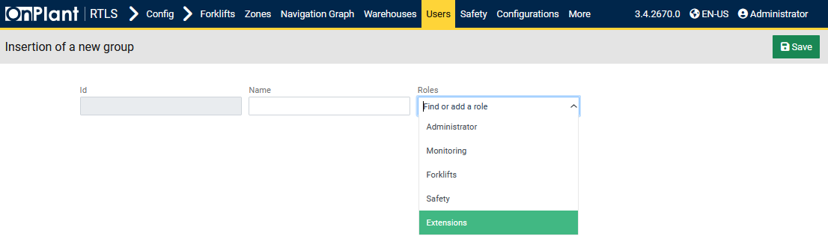

The **Insertion of a new group** page allows administrators to create user groups that share the same access roles and permissions within the OnRTLS system. These groups simplify permission management by defining access once and applying it to all users assigned to the group.

**Layout Overview**

|  |  |
| --- | --- |
| Area | Description |
| Header | **Save** button (top-right) to confirm creation. |
| Form Fields | Contains fields for defining the group’s identifier, name, and associated roles. |

**Field Descriptions**

|  |  |
| --- | --- |
| Field | Description |
| ID | Automatically generated unique group identifier once the group is saved (e.g., *GruppoUtenti/1-A*). Used internally by the system. |
| Name | User-defined name of the group (e.g., *Administrators*, *Operators*, *Maintenance Team*). This label appears in the Users → FGS Users page when assigning users to groups. |
| Roles | • **Administrator** – Grants full access to all modules and configurations. • **Monitoring** – Provides access to real-time dashboards and event tracking. • **Forklifts** – Enables forklift management and configuration privileges. • **Safety** – Grants permissions to review and configure safety parameters. • **Extensions** – Allows interaction with additional or custom modules. |

**User Actions**

|  |  |
| --- | --- |
| Action | Description |
| Create a new group | Enter a **Name** and select one or more **Roles** from the dropdown list. |
| Save group | Click **Save** to create and store the group in the system. It will immediately appear in the **User Groups** list (5.6). |
| Assign users to group | After saving, go to **Users → FGS Users** and select this group for the desired users. |

**Technical Notes**

* User groups act as **permission templates** for multiple users.
* A single user can belong to multiple groups, inheriting the union of all assigned permissions.
* Roles listed in this page are predefined under **User Roles** (see section 5.7).
* Changes to a group’s roles automatically propagate to all users associated with that group.
* The ID field remains read-only and is auto-assigned upon saving.

## 4.7 Configuration – Users – User Roles

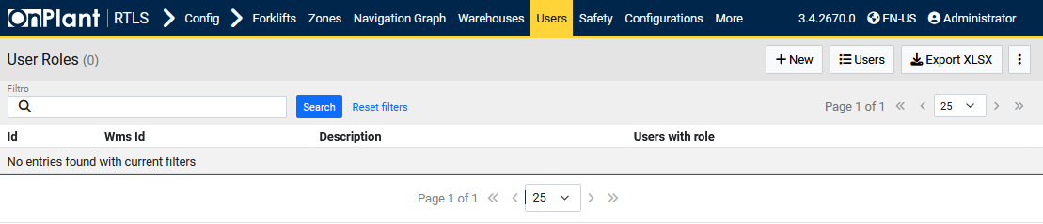

The **User Roles** page defines the permission sets that control user access to specific modules and actions within the OnRTLS system. Each role represents a collection of rights that can be assigned to individual users or entire user groups to manage access consistency and security.

**Layout Overview**

|  |  |
| --- | --- |
| Area | Description |
| Toolbar | • **+ New** – Opens the *Insertion of a new role* page (see 5.7.1). • **Users** – Redirects to the **FGS Users** list (5.5). • **Export XLSX** – Exports all visible roles and related data to an Excel file. |
| Filter Bar | Contains a search box labeled Filtro, used to filter roles by ID, name, or description. Includes Search and Reset search buttons to apply or clear filters. |
| Table | Displays all roles defined in the system, along with their associated WMS identifiers, descriptions, and the number of users assigned to each role. |

**Table Columns**

|  |  |
| --- | --- |
| Column | Description |
| ID | Unique system identifier for the role (e.g., *role/1-A*). Clicking the link opens the detailed configuration page for the selected role. |
| WMS ID | Optional field used to map roles with an external Warehouse Management System (WMS). |
| Description | Descriptive label of the role (e.g., *Administrator*, *Safety Monitor*). |
| Users with role | Indicates how many users are currently assigned to this role. |

**User Actions**

|  |  |
| --- | --- |
| Action | Description |
| Create new role | Click **+ New** to define a new role (see 5.7.1 Configuration – Users – User Roles – +New). |
| Edit or view role details | Click a role ID link to open its detailed configuration. |
| Export roles | Click **Export XLSX** to download the list of roles and user associations in spreadsheet format. |
| Search roles | Use the Filtro field to find roles by name or ID. Click Reset search to restore the full list. |

### 4.7.1 Configuration – Users – User Roles – +New

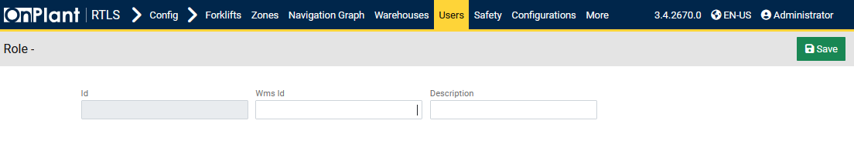

The **Insertion of a new role** page allows administrators to define new permission roles used across the OnRTLS system. Roles determine which pages, modules, and actions users or groups can access. Once created, roles can be assigned under **Users (5.5)** or **User Groups (5.6)** to apply consistent access control.

**Layout Overview**

|  |  |
| --- | --- |
| Area | Description |
| Header | **Save** button (top-right corner) to confirm creation of the new role. |
| Form Fields | Simple input form containing three fields for role identification and description. |

**Field Descriptions**

|  |  |
| --- | --- |
| Field | Description |
| ID | System-generated unique identifier automatically assigned after saving the role (e.g., *role/1-A*). This field is read-only. |
| WMS ID | Optional identifier used for synchronization with external Warehouse Management Systems (WMS). Enables seamless integration between OnRTLS and enterprise systems. |
| Description | User-defined text label describing the purpose or scope of the role (e.g., *Administrator*, *Monitoring*, *Safety Operator*). This label is displayed in all role selection dropdowns throughout the application. |

**User Actions**

|  |  |
| --- | --- |
| Action | Description |
| Create a new role | Enter a Description (and optionally a WMS ID) to define the new role. |
| Save role | Click **Save** to register the role in the system. The newly created role will appear in the **User Roles** list (5.7). |
| Assign role to users or groups | After saving, return to **Users** or **User Groups** to link the new role. |

## 4.8 Configuration – Configuration – System

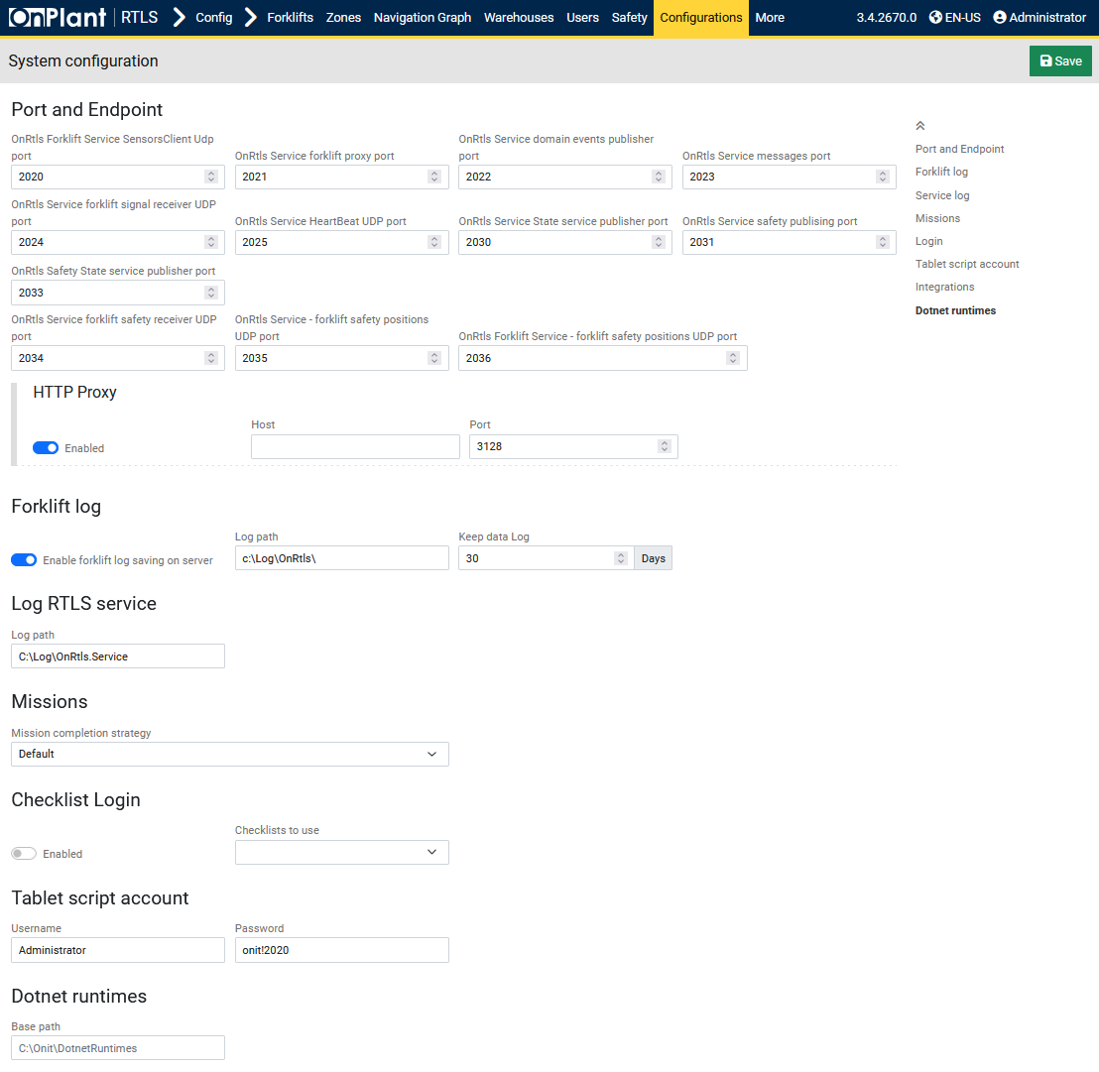

The **System Configuration** page defines communication ports, log paths, mission handling behavior, and service credentials used by the OnRTLS platform. Administrators use this page to configure how the system exchanges data between services, manages forklift and RTLS logs, and controls proxy and script authentication settings.

**Layout Overview**

|  |  |
| --- | --- |
| Area | Description |
| Toolbar | **Save** button to store all modified configuration parameters. |
| Main Panels | The page is organized into multiple configuration sections:  • Port and Endpoint  • HTTP Proxy  • Forklift log  • Log RTLS service  • Missions  • Checklist Login  • Tablet script account  • .NET runtimes |

**Panels and Field Descriptions**

**Port and Endpoint**

This section defines the UDP and TCP ports used by OnRTLS internal services to exchange forklift, safety, and event data.

|  |  |
| --- | --- |
| Field | Description |
| OnRtls Forklift Service Sensors/Client UDP port | Port used for forklift sensor data communication. Default: 2020. |
| OnRtls Service forklift proxy port | Defines the proxy communication port between forklift and central service. Default: 2022. |
| OnRtls Service domain events publisher port | Used for publishing internal domain events. Default: 2022. |
| OnRtls Service messages port | Handles forklift message traffic. Default: 2023. |
| OnRtls Service forklift signal receiver UDP port | UDP port receiving signal data from forklifts. Default: 2024. |
| OnRtls Service HeartBeat UDP port | Monitors heartbeat signals from forklifts for connection verification. Default: 2025. |
| OnRtls Service State service publisher port | Publishes forklift state updates to the system. Default: 2030. |
| OnRtls Service safety publishing port | Publishes safety-related messages and events. Default: 2031. |
| OnRtls Safety State service publisher port | Transmits safety state information from forklifts. Default: 2034. |
| OnRtls Service forklift safety receiver UDP port | Receives forklift safety status updates. Default: 2035. |
| OnRtls Forklift Service – forklift safety positions UDP port | Publishes forklift safety positions for RTLS tracking. Default: 2036. |

**HTTP Proxy**

Defines proxy configuration for outbound communication to external services or APIs.

|  |  |
| --- | --- |
| Field | Description |
| Enabled (Toggle) | Activates or deactivates proxy usage for HTTP traffic. |
| Host | IP address or hostname of the proxy server. |
| Port | Communication port for the proxy (default example: 3128). |

**Forklift Log**

Controls server-side forklift log collection and retention.

|  |  |
| --- | --- |
| Field | Description |
| Enable forklift log saving on server (Toggle) | When enabled, forklift log files are stored centrally on the OnRTLS server. |
| Log path | File system directory where forklift logs are saved (default: C:\Log\OnRtls\). |
| Keep data log | Defines the log retention period before automatic cleanup. Default: 30 days. |

**Log RTLS Service**

Specifies the storage path for RTLS service logs.

|  |  |
| --- | --- |
| Field | Description |
| Log path | Path where the RTLS service writes system and telemetry logs. Default: C:\Log\OnRtls.Service. |

**Missions**

Configures how forklift missions are handled within the system.

|  |  |
| --- | --- |
| Field | Description |
| Mission completion strategy | Determines how missions are marked as complete. Default option: **Default**. Other strategies may be available based on system integrations. |

**Checklist Login**

Controls whether checklists are required during forklift login.

|  |  |
| --- | --- |
| Field | Description |
| Enabled (Toggle) | Enables the checklist prompt when operators log into forklifts. |
| Checklists to use | Specifies which checklist template is applied during login. (Field visible only when Enabled.) |

**Tablet Script Account**

Stores authentication credentials for the tablet or forklift-mounted terminal.

|  |  |
| --- | --- |
| Field | Description |
| Username | Account name used by forklift terminals or scripts to authenticate. Default: Administrator. |
| Password | Password for the tablet or forklift script account. Default example: onit!2020. |

**.NET Runtimes**

Defines the base path for installed .NET runtimes used by OnRTLS applications.

|  |  |
| --- | --- |
| Field | Description |
| Base path | File system location where .NET runtimes are stored. Default: C:\onit\DotnetRuntimes. |

**User Actions**

* **Enable or disable HTTP proxy** – Use when the system requires a proxy to access external endpoints.
* **Set log paths and retention** – Confirm directories exist and have sufficient disk space for continuous logging.
* **Configure mission strategy** – Select the mission completion logic suitable for your site’s workflow.
* **Enable checklist login** – Activate when forklifts require operator validation during startup.

**Technical Notes**

* All port changes require corresponding updates in connected forklift and FGS configurations.
* Log and path fields accept both local and network UNC paths (e.g., \\Server\Logs\OnRtls).
* Default paths are created automatically during system installation.
* The **Mission completion strategy** may interact with the **Monitoring → Missions** module for automated status changes.
* Use administrator privileges to modify system paths or authentication fields.

## 4.9 Configuration – Configuration – Reference System

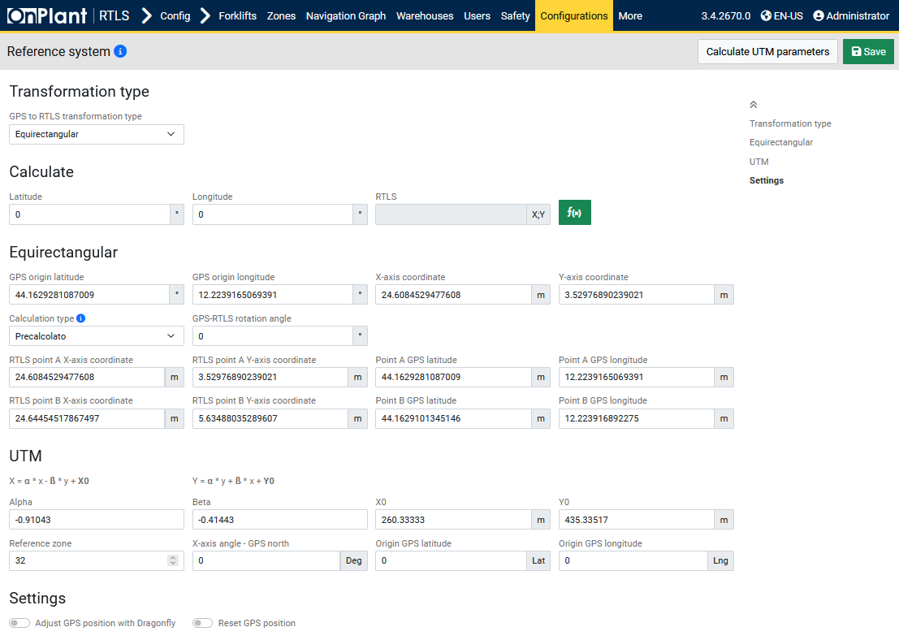

The **Reference System** page defines how GPS coordinates are transformed into the RTLS (Real-Time Location System) coordinate space used by OnRTLS. This configuration ensures alignment between global GPS data and the local coordinate system displayed in the 3D environment. Administrators use it to calibrate, verify, and calculate transformation parameters between GPS and RTLS points.

**Layout Overview**

|  |  |
| --- | --- |
| Area | Description |
| Header | Contains **Calculate UTM parameters** and **Save** buttons. |
| Transformation type | Allows selecting between **Equirectangular** and **UTM** transformation methods. |
| Calculate | Provides quick coordinate conversion between GPS and RTLS systems. |
| Equirectangular | Section for defining GPS and RTLS alignment parameters using latitude/longitude origins and rotation values. |
| UTM | Section for defining conversion coefficients for Universal Transverse Mercator (UTM) projection. |
| Settings | Optional toggles for GPS position adjustment. |

**Panels and Field Descriptions**

**Transformation type**

|  |  |
| --- | --- |
| Field | Description |
| GPS to RTLS transformation type | Dropdown selection to choose the transformation model used by the system. Options:  • **Equirectangular** – Uses latitude and longitude offsets for smaller areas. • **UTM** – Uses standard map projection for larger or geographically wide environments. |

**Calculate**

Allows conversion between known coordinate pairs.

|  |  |
| --- | --- |
| Field | Description |
| Latitude / Longitude | Input fields for GPS coordinates. |
| RTLS (X;Y) | Input field for local RTLS coordinate. |
| f(x) | Converts between coordinate systems using the selected transformation type. |

**Equirectangular**

Defines parameters for aligning GPS and RTLS coordinates using a simple plane-based projection.

|  |  |
| --- | --- |
| Field | Description |
| GPS origin latitude / longitude | Establishes the geographic starting point (origin) for the RTLS coordinate system. |
| X-axis coordinate / Y-axis coordinate | Corresponding RTLS coordinates for the GPS origin. |
| Calculation type | Defines how transformation is computed. |
| GPS–RTLS rotation angle | Rotation (in degrees) applied to align the GPS north axis with RTLS X/Y axes. |
| RTLS point A / B X-axis coordinate | Local X coordinates of two known RTLS points used for calibration. |
| RTLS point A / B Y-axis coordinate | Local Y coordinates of two known RTLS points. |
| Point A / B GPS latitude / longitude | GPS coordinates corresponding to each RTLS point. |

**UTM**

Defines the mathematical coefficients for UTM coordinate transformation.

|  |  |
| --- | --- |
| Field | Description |
| Alpha / Beta | Transformation coefficients defining axis scaling and rotation between UTM and RTLS coordinates. |
| X0 / Y0 | Offset values (in meters) applied to align the RTLS coordinate origin with UTM origin. |
| Reference zone | UTM zone number that identifies the geographic projection zone (e.g., 32). |
| X-axis angle – GPS north | Defines the angular offset (in degrees) between RTLS X-axis and true GPS north. |
| Origin GPS latitude / longitude | Reference GPS coordinate representing the RTLS origin for UTM calculations. |
| X = α * x – β * y + X₀  Y = α * y + β * x + Y₀ | Formulas that define the linear transformation between UTM and RTLS coordinates. |

**Settings**

|  |  |
| --- | --- |
| Field | Description |
| Adjust GPS position with Dragonfly | When enabled, adjusts GPS position data using Dragonfly visual localization for higher precision. |
| Reset GPS position | Resets transformation parameters to their initial default state. |

**User Actions**

|  |  |
| --- | --- |
| Action | Description |
| Select transformation type | Choose **Equirectangular** for smaller, localized setups or **UTM** for wide-area outdoor environments. |
| Enter GPS and RTLS coordinates | Input known pairs of GPS and local RTLS coordinates for calibration. |

### 4.9.1 Configuration – Configuration – Reference System – Calculate UTM parameters

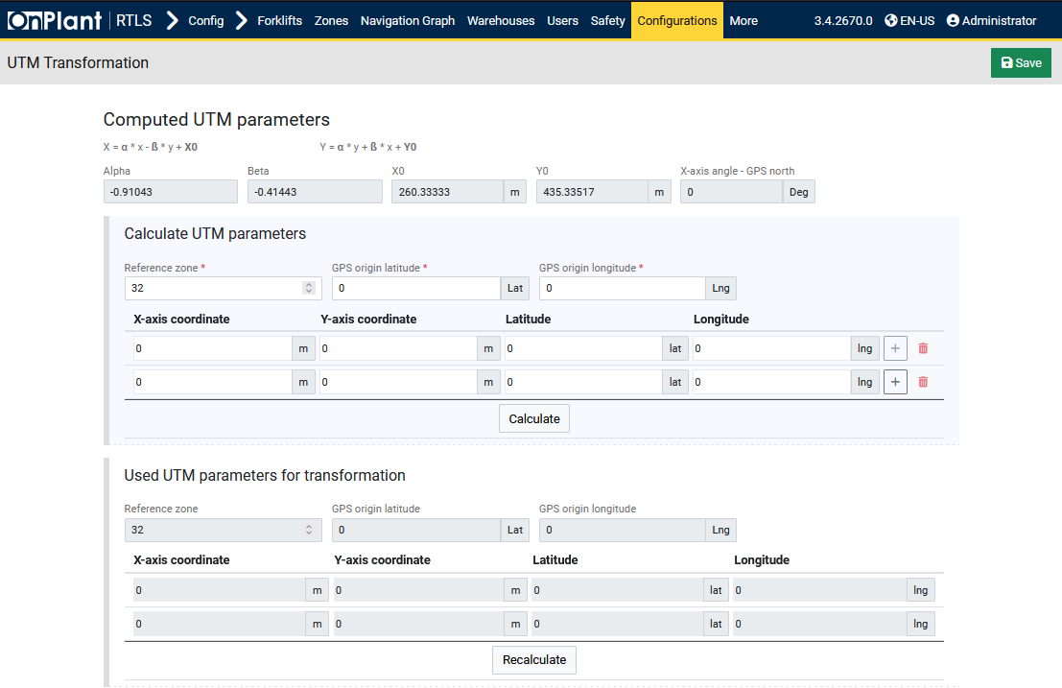

The **Calculate UTM Parameters** page provides an interface to automatically compute the transformation coefficients (Alpha, Beta, X₀, Y₀) used in the **UTM conversion model** of the Reference System. Administrators use this page after entering reference GPS and RTLS coordinates to align global (UTM) and local (RTLS) coordinate systems accurately. This calculation ensures that forklift and mission locations derived from GPS sources are correctly positioned in the OnRTLS 3D environment.

**Layout Overview**

|  |  |
| --- | --- |
| Area | Description |
| Header | **Save** buttons for performing the coefficient calculation and saving results to the system. |
| Input Panels | Divided into two main sections:  • **Reference points (A & B)**  • **Computed coefficients** |
| Result Table | Displays automatically calculated values for Alpha, Beta, X₀, Y₀, and the resulting UTM–RTLS conversion parameters. |
| Calculate / Recalculate | Buttons for computing, clearing, or applying the calculated parameters. |

**Panels and Field Descriptions**

**Reference Points**

Defines the known GPS and RTLS coordinate pairs used for computing UTM coefficients.

|  |  |
| --- | --- |
| Field | Description |
| Point A – GPS Latitude / Longitude | Geographic coordinates of the first known reference point. |
| Point A – RTLS (X;Y) | Local RTLS coordinates (in meters) corresponding to Point A. |
| Point B – GPS Latitude / Longitude | Geographic coordinates of the second known reference point. |
| Point B – RTLS (X;Y) | Local RTLS coordinates corresponding to Point B. |

**Calculated Parameters**

Displays automatically generated transformation coefficients for the **UTM to RTLS** conversion formula.

|  |  |
| --- | --- |
| Field | Description |
| Alpha | Scale coefficient for X-axis alignment between UTM and RTLS coordinates. |
| Beta | Scale coefficient for Y-axis alignment and rotation correction. |
| X₀ (X0) | Offset value aligning UTM X-origin to the RTLS X-origin. |
| Y₀ (Y0) | Offset value aligning UTM Y-origin to the RTLS Y-origin. |
| Reference Zone | Displays the detected UTM zone number based on GPS input. |
| X-axis angle – GPS north | Computed angular difference (degrees) between RTLS X-axis and true geographic north. |

**User Actions**

|  |  |
| --- | --- |
| Action | Description |
| Enter reference coordinates | Input GPS and RTLS values for points A and B under the Reference System page. |
| Review results | The computed coefficients are displayed in the Calculated Parameters section. |
| Click “Save” | Saves all computed parameters to the UTM configuration model. These values update the Reference System transformation immediately. |

**Technical Notes**

* The computation follows the transformation equations:
  + X = α * x – β * y + X₀
  + Y = α * y + β * x + Y₀
* Alpha and Beta encode both scale and rotation between the GPS and RTLS systems.
* UTM Zone automatically adjusts based on GPS coordinates; ensure both reference points lie within the same zone.
* Incorrect or near-identical coordinates for points A and B can cause inaccurate or zeroed coefficient results.
* Once saved, these parameters are used globally by all modules relying on UTM coordinate transformation (e.g., GNSS and Dragonfly integration).

## 4.10 Configuration – Configuration – RTCM

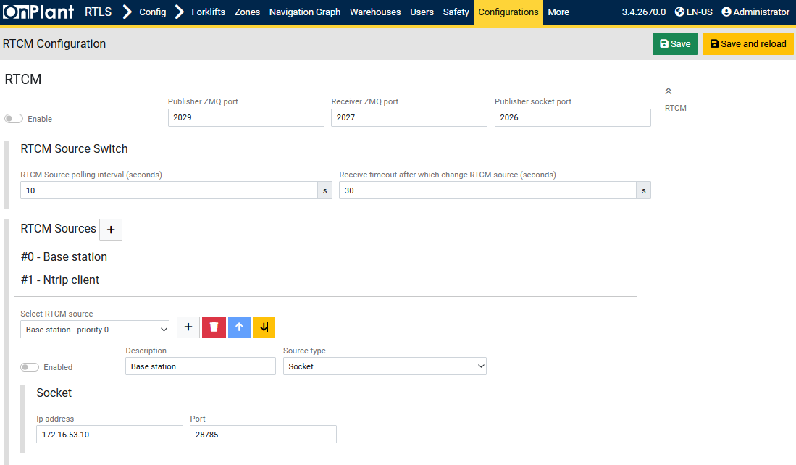

The **RTCM Configuration** page defines the communication parameters and data sources used for receiving and distributing **RTCM (Radio Technical Commission for Maritime Services)** correction messages. These correction messages are used to improve GPS accuracy for the RTLS system and are typically obtained from a **Base Station** or **NTRIP client**. Administrators use this page to configure how the OnRTLS system connects to one or multiple RTCM sources and to manage automatic source switching based on availability.

**Layout Overview**

|  |  |
| --- | --- |
| Area | Description |
| Header | Contains **Save** and **Save and reload** buttons to apply or restart configuration changes. |
| Enable (Toggle) | Activates or deactivates the entire RTCM correction system. |
| Ports Configuration | Defines the internal communication ports used for RTCM message publishing and receiving. |
| RTCM Source Switch | Controls polling intervals and timeouts for switching between active RTCM sources. |
| RTCM Sources | Lists and configures available RTCM data sources, such as Base Station or NTRIP Client connections. |
| Source Editor | Displays connection parameters for the selected RTCM source. |

**Panels and Field Descriptions**

**RTCM**

|  |  |
| --- | --- |
| Field | Description |
| Enable (Toggle) | Turns RTCM correction service on or off. When disabled, the system will not request or distribute correction data. |
| Publisher ZMQ port | Port used by the system to publish RTCM correction data via ZeroMQ (ZMQ) protocol. Default: 2029. |
| Receiver ZMQ port | Port used to receive incoming RTCM data via ZMQ. Default: 2027. |
| Publisher socket port | Port used for TCP socket transmission of RTCM data to other services or forklifts. Default: 2026. |

**RTCM Source Switch**

Defines polling intervals and timeouts for managing multiple RTCM sources.

|  |  |
| --- | --- |
| Field | Description |
| RTCM Source polling interval (seconds) | Interval (in seconds) for checking the availability of configured RTCM sources. Default: 10 s. |
| Receive timeout after which change RTCM source (seconds) | Duration (in seconds) after which the system automatically switches to the next available source if no data is received. Default: 30 s. |

**RTCM Sources**

This section lists all configured RTCM data sources. Each source provides GPS correction data for localization accuracy.

|  |  |
| --- | --- |
| Element | Description |
| + Button | Adds a new RTCM source configuration. |
| Trash icon | Deletes the selected RTCM source. |
| Up / Down arrows | Adjust source priority. The system will use sources in descending order of priority (0 = highest). |
| Double-arrow icon | Reorders or resets source priority levels. |
| Select RTCM source | Drop-down list to select and edit an existing source by name and priority. Example: Base station - priority 0, Ntrip client - priority 1. |

**Source Configuration Fields**

Each RTCM source can be enabled or disabled individually and configured with the following parameters:

|  |  |
| --- | --- |
| Field | Description |
| Enabled (Toggle) | Activates or deactivates this specific RTCM source. Only enabled sources participate in the automatic switch cycle. |
| Description | User-defined label for identifying the RTCM source (e.g., *Base station*, *Ntrip client*). |
| Source type | Determines the communication protocol for the source. Options:  • **Socket** – Direct TCP/IP socket connection to a base station.  • **NTRIP Client** – Connects to an NTRIP server for internet-based corrections. |
| IP address | The network IP of the RTCM server. Example: 172.16.53.10. |
| Port | Network port used by the RTCM data stream. Example: 28785. |

**User Actions**

|  |  |
| --- | --- |
| Action | Description |
| Enable RTCM system | Toggle the **Enable** switch at the top to activate RTCM processing. |
| Configure ports | Verify that Publisher and Receiver ports do not conflict with other services on the server. |
| Set polling interval and timeout | Adjust the frequency of source checks and failover timing to ensure continuity of corrections. |
| Add new source | Click **+** under RTCM Sources to add a new Base Station or NTRIP client. |
| Edit existing source | Select a source from the drop-down list to modify its connection type, IP, or port. |
| Reorder priorities | Use **Up / Down** arrows to prioritize preferred correction sources. The system will automatically switch to backup sources in lower order if the primary fails. |

## 4.11 Configuration – Configuration – Roaming Areas

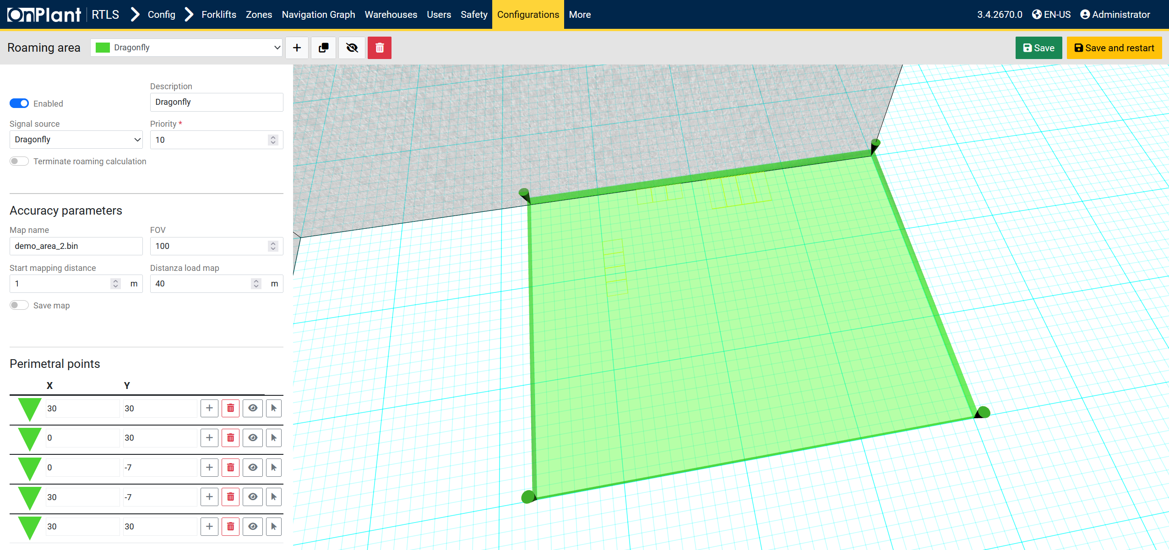

The **Roaming Areas** page defines the physical regions where localization systems (e.g., *Dragonfly*, *UWB*, *GPS*) provide coverage for forklifts or mobile devices. These areas are critical for ensuring continuous positioning as forklifts transition between mapping regions. Administrators use this page to configure, visualize, and adjust roaming zones for each localization source.

**Layout Overview**

|  |  |
| --- | --- |
| Area | Description |
| Toolbar | • **+ (Add new)** – Creates a new roaming area. • **Duplicate** – Clones the currently selected area. • **Visibility toggle (eye icon)** – Shows or hides the area in the 3D view. • **Delete (trash icon)** – Removes the selected roaming area. • **Save** and **Save and restart** buttons (top-right) store or reload configurations. |
| Roaming Area Selector | Drop-down list to select an existing roaming area (e.g., *Dragonfly*). |
| Enabled Toggle | Activates or deactivates the roaming area for system use. Disabled areas are ignored by localization calculations. |
| Description | Text field naming or labeling the roaming area. |
| Signal Source | Defines which localization system this area is linked to. Options include: *Dragonfly*, *UWB*, *GPS*, etc. |
| Priority | Numeric input determining the execution order of overlapping roaming areas. Higher numbers take precedence. |
| Terminate Roaming Calculation (Toggle) | When enabled, prevents further roaming handoff calculations beyond this region. Useful for isolating localization domains. |
| Accuracy Parameters Section | Configures performance and mapping characteristics:  • Map name – The reference mapping file used by the localization system. • FOV (Field of View) – Defines the angular coverage (degrees) of the localization sensor. • Start mapping distance – Minimum distance (in meters) from the forklift before mapping begins. • Distanza load map (distance at which the map starts to load) – Maximum range (in meters) for loading or using this map. • Save map (Toggle) – When enabled, the generated mapping data is stored for reuse. |
| Perimetral Points Section (perimeter points) | Defines the 2D perimeter of the roaming area in the RTLS coordinate system. Each entry includes: • **X / Y coordinates (m)** – Vertices of the polygon defining area boundaries. • **+ (Add)** – Adds a new vertex. • **Trash icon** – Deletes the vertex. • **Arrow icon** – Focuses or centers the 3D camera on that point. • **Eye icon** – Toggles point visibility on the map. |
| 3D Map | Displays the current roaming area polygon (highlighted in green). Users can pan, zoom, and rotate to visualize alignment with warehouse structures or other localization regions. |

**User Actions**

1. **Create or Edit a Roaming Area**
   * Select an existing roaming area from the top drop-down or click **+** to create a new one.
   * Enable the toggle if the area should be active.
   * Enter a **Description** (e.g., “Dragonfly”).
   * Choose the appropriate **Signal Source** (e.g., Dragonfly localization).
   * Assign a **Priority** (e.g., 10). Higher priority takes precedence during overlapping zone calculations.
2. **Configure Accuracy Parameters**
   * Enter a **Map name**.
   * Set FOV.
   * Define Start mapping distance and Distanza load map (distance at which the map starts to load) values in meters.
   * Enable **Save map** if you want the system to store generated mapping data for reuse.
3. **Define Area Perimeter**
   * Add or modify **X/Y** coordinate pairs to shape the roaming area polygon.
   * Use the **+** icon to add vertices.
   * Use the **trash** icon to remove points.
   * The 3D view updates automatically with each change.
4. **Save Configuration**
   * Click **Save** to store changes.
   * Click **Save and restart** to reload the configuration service (required if changes affect active localization modules).

**Technical Notes**

* Roaming areas determine **where forklifts can switch between localization maps or cameras** (e.g., Dragonfly to UWB).
* The **priority** ensures correct map transition hierarchy during overlapping coverage.
* Each area polygon is stored as a 2D boundary in the RTLS coordinate space.
* The **FOV** and **distance parameters** are used by Dragonfly and RTLS systems to calculate visibility and map load thresholds.
* **Save and restart** reinitializes the roaming module—recommended after altering geometry or signal source.

## 4.12 Configuration – Configuration – 3D Graphics

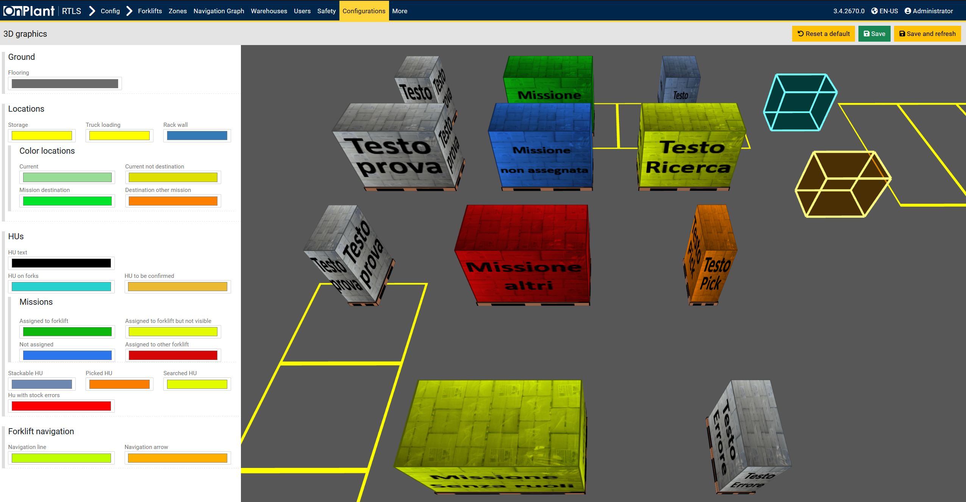

The **3D Graphics** page allows administrators to configure color schemes and visual themes used in all 3D visualizations within the OnRTLS Web Application, including **FGS 3D Live Map**, **Monitoring – Replay**, and **Navigation Graph**. This configuration defines how different objects (such as Handling Units, missions, and navigation lines) are displayed, ensuring visual clarity and operational consistency for users.

**Layout Overview**

|  |  |
| --- | --- |
| Area | Description |
| Toolbar | Controls for configuration management:  • Reset to default – Restores all color settings to factory defaults. • Save – Saves the current color configuration. • Save and refresh – Saves and immediately reloads all 3D scenes with the new settings. |
| Ground | • **Flooring** – Defines the base ground color of 3D environments. Typically dark gray for visual contrast. |
| Locations | Configures colors for warehouse areas and specific location types: • **Storage** – Zones where Handling Units are stored. • **Truck loading** – Loading/unloading bay areas. • **Rack wall** – Structural walls or storage racks. |
| Color Locations | Defines colors representing current and destination statuses in the map: • **Current** – Current forklift or Handling Unit position. • **Current not destination** – Forklift position not linked to a destination. • **Mission destination** – Target location for an active mission. • **Destination other mission** – Destination of another mission (used to visualize overlaps). |
| HUs | Determines color rules for Handling Units (HUs): • **HU text** – Color of HU labels/text displayed on objects. • **HU on forks** – Color applied when a HU is detected on forklift forks. • **HU to be confirmed** – Color for newly detected or unvalidated HUs. |
| Missions | Defines colors for mission-related visual states: • **Assigned to forklift** – Missions actively assigned to the selected forklift. • **Assigned to forklift but not visible** – Missions linked to forklift but currently outside visible range. • **Not assigned** – Missions pending assignment. • **Assigned to other forklift** – Missions linked to another forklift. • **Stackable HU** – Handling Units that can be stacked. • **Picked HU** – Handling Unit currently picked up by a forklift. • **Searched HU** – HU currently being searched or targeted. • **HU with stock errors** – Displays red to indicate anomalies in HU stock data. |
| Forklift Navigation | Configures path and direction indicators: • **Navigation line** – Color of path lines showing the forklift’s planned trajectory. • **Navigation arrow** – Color of directional arrows used for navigation visualization. |
| 3D Map | Displays all configured objects (Handling Units, missions, zones, etc.) in a live preview of the 3D scene. The preview updates instantly when colors are changed, providing real-time visual feedback. |

**User Actions**

1. **Customize 3D Colors**
   * Click on a color box beside each label to open the color picker.
   * Adjust hues, saturation, and brightness to align with the site’s visualization preferences.
2. **Preview in Real Time**
   * Observe changes in the 3D preview on the right.
   * The preview displays Handling Units, missions, and storage zones with the active color scheme.
3. **Save or Restore Defaults**
   * Click **Save** to apply color changes.
   * Click **Save and refresh** to reload all 3D views across the application immediately.
   * Use Reset to default to revert to system default colors.

**Technical Notes**

* The configured colors apply globally across all modules that use 3D visualization.
* Settings are stored per system configuration and persist through service restarts.
* Adjustments to HU or mission colors can help distinguish concurrent operations in shared areas.
* The preview scene uses simplified models for Handling Units and zones purely for visual validation.
* Changes take effect in **3D Live Map**, **Replay**, **Navigation Graph**, and **FGS Forklift UI** modules after saving.

**Troubleshooting**

|  |  |  |
| --- | --- | --- |
| Issue | Possible Cause | Action |
| Colors not updated in live map | Changes saved but scene not reloaded | Click **Save and refresh** instead of **Save**. |
| Colors appear too dark or blended | Low lighting contrast in 3D environment | Use lighter tones for zones and stronger hues for missions. |
| HU colors overlap with mission indicators | Same color value assigned | Use distinct colors for mission destinations and HU on forks. |
| Reset didn’t work | Cached configuration loaded | Clear browser cache or click Reset to default then Save and refresh. |

## 4.13 Configuration – Configuration – FGS Personalizations

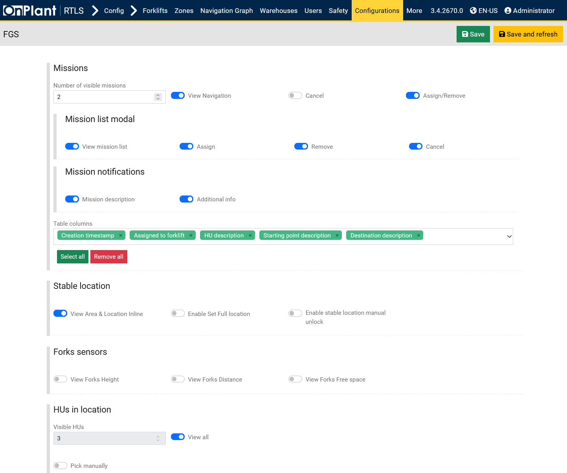

The **FGS Personalizations** page customizes the appearance, controls, and user-level functionalities for the **Forklift Guidance System (FGS)** interface. Administrators use this page to configure how missions, Handling Units (HUs), and system data are displayed and managed in the forklift UI. These personalizations affect both the **operator tablet interface** and the **web application’s FGS view**.

**Layout Overview**

|  |  |
| --- | --- |
| Section | Description |
| Toolbar | • **Save** – Stores all modified personalization settings. • **Save and refresh** – Saves and immediately reloads the interface to apply new preferences. |
| Missions | Configures how missions are displayed and managed in the FGS UI. |
| Stable location | Defines how the system manages location stability during forklift operations. |
| Forks sensors | Toggles sensor visualizations for height, distance, and available space. |
| HUs in location | Controls Handling Unit (HU) visibility, fields, and display options for locations. |
| HUs on forks | Controls visibility and interaction for HUs currently on forklift forks. |
| Advanced functionalities | Enables or disables advanced operational options like mission requests, HU creation, or swaps. |
| User personalizations | Defines safety, visualization, and interface behaviors for the forklift view. |

**Missions Section**

|  |  |
| --- | --- |
| Field / Toggle | Description |
| Number of visible missions | Sets how many missions appear simultaneously in the FGS mission list (e.g., 2). |
| View Navigation | Displays navigation guidance lines for missions. |
| Assign/Remove | Enables manual mission assignment or removal from the forklift. |
| Mission list modal | Controls modal behaviors when viewing or managing missions: • **View mission list** – Displays mission list popup. • **Assign / Remove / Cancel** – Enables management buttons for mission control. |
| Mission notifications | Enables mission detail popups or real-time notifications: • **Mission description** – Displays basic mission info. • **Additional info** – Adds extended mission details. |
| Table columns | Defines which mission columns appear in the forklift mission list (e.g., *Creation timestamp*, *Assigned to forklift*, *HU description*, *Starting point description*, *Destination description*). Use **Select all** or **Remove all** for bulk configuration. |

**Stable Location**

|  |  |
| --- | --- |
| Field / Toggle | Description |
| View Area & Location Inline | Displays area and location information directly in the interface. |
| Enable Set Full Location | Allows the operator to manually define full location coordinates. |
| Enable stable location manual unlock | Enables manual override to unlock a stable location if auto-lock conditions persist. |

**Forks Sensors**

|  |  |
| --- | --- |
| Field / Toggle | Description |
| View Forks Height | Displays the real-time fork height in meters. |
| View Forks Distance | Shows the distance measured by the fork sensors. |
| View Forks Free Space | Displays remaining available fork space, if applicable. |

**HUs in Location**

|  |  |
| --- | --- |
| Field / Toggle | Description |
| Visible HUs | Sets how many Handling Units (HUs) to display for each location (e.g., 3). |
| View all | Displays all HUs present at a location regardless of limit. |
| Pick manually | Allows manual selection of an HU from the location list. |
| Visible fields | Defines which HU details are shown (e.g., HU ID, HU description, Item description, Lot, Quantity). |
| Select all / Remove all | Quickly add or clear visible HU fields. |

**HUs on Forks**

|  |  |
| --- | --- |
| Field / Toggle | Description |
| Visible HUs | Sets how many HUs are shown when detected on the forklift forks. |
| View all | Displays all detected HUs regardless of number limit. |
| Rotate HU | Enables visual rotation of the HU in 3D view for alignment validation. |
| Remove HU | Allows operators to manually remove an HU from the current fork list. |
| Stock manually | Enables manual stock confirmation of the HU. |
| HU weight history update | Toggles automatic HU weight history recording. |
| Visible fields | Defines displayed HU attributes, such as HU ID, HU description, Item description, Lot, Quantity, Work order description, Item ID. |

**Advanced Functionalities**

|  |  |
| --- | --- |
| Field / Toggle | Description |
| Search a HU | Enables HU search functionality within the FGS. |
| Show compatible location for current mission | Displays recommended storage or destination locations compatible with the current mission. |
| Create new HU | Allows operators to generate new Handling Units from the FGS interface. |
| Automatic modal opening on new SSCC | Automatically opens the HU creation dialog when a new SSCC is detected. |
| Request mission enabled | Allows the operator to request a mission manually. |
| Automatic modal opening | Automatically opens the mission request form when applicable. |
| Manual proposal selection | Lets operators manually select proposals from the mission list instead of automatic assignment. |
| Swap HU enabled | Enables HU swap functionality, allowing exchange between current and target HUs. |

**User Personalizations**

|  |  |  |
| --- | --- | --- |
| Category | Toggle | Description |
| Safety | Safety events camera | Displays camera feed during detected safety events. |
|  | Forklift safety areas | Highlights safety zones surrounding the forklift. |
|  | Safety V2V BC Events | Enables Vehicle-to-Vehicle broadcast visualization for safety alerts. |
| Miscellaneous | Forklift backward camera | Displays the forklift’s rear camera feed in the interface. |
|  | Compatible HU visualization | Highlights Handling Units compatible with current mission tasks. |
|  | Warehouse structure visualization | Renders warehouse walls and layouts in 3D view. |
|  | Fullscreen Browser | Enables fullscreen mode for tablet or desktop visualization. |
|  | Zones visualization | Displays warehouse zones on the 3D map. |
|  | Safety Zones visualization | Overlays defined safety zones in 3D mode. |
|  | Roaming areas visualization | Displays configured roaming areas from section 4.11. |
|  | Forklift motion filter | Smooths forklift movement in 3D to reduce jitter or noise. |
|  | 3D Engine inspector | Enables developer-level diagnostics for the 3D rendering engine. |
|  | 3D Grid visualization | Shows the spatial coordinate grid in the 3D scene. |

**User Actions**

1. Adjust toggles to enable or disable the desired FGS functionalities.
2. Use **Select all** / **Remove all** to manage visible fields efficiently.
3. Review mission and HU parameters for proper field visibility.
4. Click **Save** to apply changes, or **Save and refresh** to immediately load new configurations.

## 4.14 Configuration – Configuration – Data Pages Config

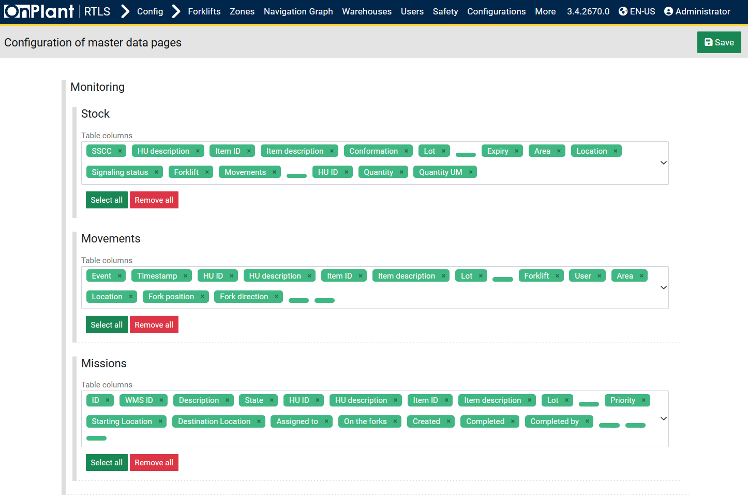

The **Data Pages Configuration** page defines which data fields are visible in the main Monitoring tables of the OnRTLS web application. Administrators use this section to customize the display of columns for **Stock**, **Movements**, and **Missions** pages, ensuring that each monitoring view shows only the most relevant information for their workflow.

**Layout Overview**

|  |  |
| --- | --- |
| Area | Description |
| Toolbar | • **Save** – Applies all visibility changes across the configured data tables. |
| Stock | Controls the visible columns for the *Monitoring → Stock* page. Used to configure which Handling Unit (HU) and inventory details appear in the stock list. |
| Movements | Defines visible fields in the *Monitoring → Movements* page. Used to show or hide event-related data such as forklift activity, Handling Unit movement, and area tracking. |
| Missions | Configures visible columns for the *Monitoring → Missions* page. Determines which mission details—such as state, location, forklift, or operator—are displayed. |

**User Actions**

1. Open **Configuration → Configuration → Data Pages Config**.
2. Under each section (Stock, Movements, Missions), use **Select all** or **Remove all** to toggle visibility for all columns at once.
3. Optionally, choose specific columns from the dropdown list.
4. Click **Save** to apply and update all table views in the Monitoring module.

**Technical Notes**

* Changes here affect the **display only**—they do not modify the stored data.
* The configuration applies globally for all users.
* Reducing the number of visible columns can improve page performance.
* New data fields introduced by system updates will appear automatically in the lists

## 4.15 Configuration – More – Ublox ZED

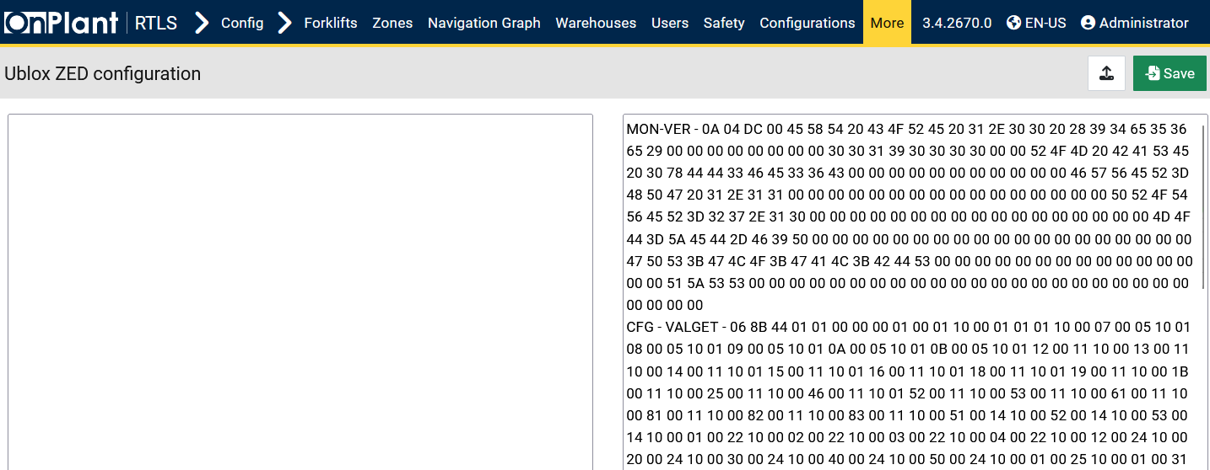

The **Ublox ZED Configuration** page provides direct access to configuration data from **Ublox ZED GNSS receivers** used by the OnRTLS system for precise GPS-based localization. Administrators use this interface to **view, edit, or upload binary configuration data** that defines the behavior of the Ublox ZED module.

**Layout Overview**

|  |  |
| --- | --- |
| Area | Description |
| Configuration Editor (Left Panel) | Editable text area for pasting or editing Ublox ZED configuration data. The data is typically expressed in binary or hexadecimal format. |
| Device Output Viewer (Right Panel) | Displays the current configuration response or status data from the Ublox ZED device. Each section (e.g., MON-VER, CFG-VALGET) shows system version details, firmware parameters, and configuration blocks read from the module. |
| Upload Button | Allows administrators to import a configuration file (.bin or .txt) for applying new GPS module settings. |
| Save Button | Saves the current configuration data to the system. Updated data will be sent to the Ublox ZED receiver during the next initialization cycle. |

**User Actions**

1. **View Existing Configuration**
   * The right panel displays real-time data from the Ublox ZED receiver.
   * Review fields like MON-VER (monitoring version info) and CFG-VALGET (configuration values) for verification.
2. **Edit or Replace Configuration**
   * Paste or edit data in the left panel using the Ublox standard configuration format.
   * Alternatively, click the **Upload** button to import a configuration file.

## 4.16 Configuration – More – Migrations

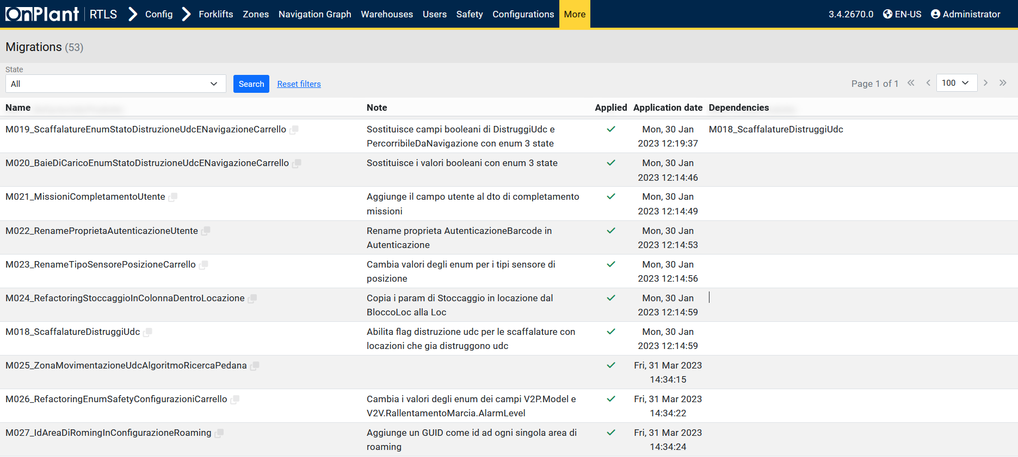

The **Migrations** page displays a complete list of database and configuration migrations applied within the OnRTLS platform. Each migration represents a versioned update or change to the system’s structure, such as modifications to tables, fields, enums, or stored configurations. Administrators use this page to verify that all database updates have been correctly executed following software upgrades or maintenance releases.

**Layout Overview**

|  |  |
| --- | --- |
| Area | Description |
| Toolbar | Contains filter controls and search functionality.  • State dropdown – Filters migrations by status (All, Applied, or Pending). • Search – Executes the selected filter. • Reset search – Clears filters and shows all migrations. |
| Table | • **Name** – Unique migration identifier. • **Note** – Describes the change implemented by the migration. • **Applied** – Checkmark indicates successful application. • **Application date** – Shows when the migration was executed. • **Dependencies** – Lists prerequisite migrations that must be completed first. |

**User Actions**

1. **Filter by Status**
   * Select *All*, *Applied*, or *Pending* from the **State** dropdown.
   * Click **Search** to filter migrations accordingly.
2. **Review Migration Details**
   * Check the **Note** column for a description of what each migration changes.
   * Verify the **Applied** column for a checkmark (✓) indicating success.
   * Review **Dependencies** to confirm update sequence integrity.
3. **Reset or Refresh View**
   * Click Reset search to show all migration entries again.

## 4.17.1 Configuration – More – Checklist Login

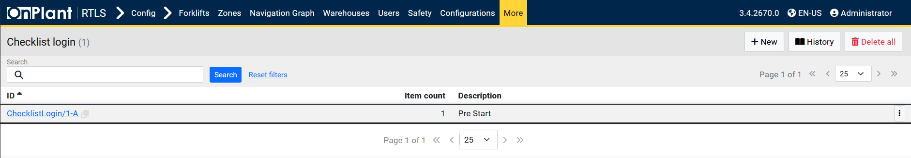

The **Checklist Login** page allows administrators to manage the configuration and templates of checklists required during forklift login. These checklists ensure that operators perform essential safety or operational verifications before starting their shifts or using forklifts. The page lists all available checklists, their associated forklifts or groups, and provides tools to create, edit, or delete checklist templates.

**Layout Overview**

|  |  |
| --- | --- |
| Area | Description |
| Toolbar | • **+ New** – Opens the form to create a new checklist template.  • **Delete Filtered** – Deletes all checklists currently visible under active filters.  • **Export XLSX** – Exports the checklist list to an Excel file. |
| Search Bar | Provides a text field for keyword-based search and filter options. Includes Search and Reset search buttons. |
| Table | Displays all configured checklists. Each row represents a single checklist template, including metadata and associated configuration. |

**Table Columns**

|  |  |
| --- | --- |
| Column | Description |
| ID | Unique identifier for each checklist (e.g., checklistlogin/1-A). Clicking the ID opens the detailed configuration or edit page. |
| Description | Short name or title of the checklist (e.g., “Daily Safety Inspection”). |
| Item count | Number of items to check. |
| ⋮ (Row Menu) | Option to ***Delete***. |

**User Actions**

|  |  |
| --- | --- |
| Action | Description |
| Add a new checklist | Click **+ New** to create a new checklist template. Fill in checklist items, associate them with forklifts or groups, and save. (See section 4.17.1.1 Configuration – More – Checklist Login – +New.) |
| Edit existing checklist | Click the ID link or select Edit from the row menu to modify checklist details or item order. |
| Search / Filter | Enter text or keywords and click Search. Use Reset search to clear filters and reload all entries. |
| Delete filtered checklists | Removes all visible records after applying search filters. |
| Export XLSX | Exports the currently displayed checklist list to Excel for reporting or backup. |

### 4.17.2 Configuration – More – Checklist Login – +New

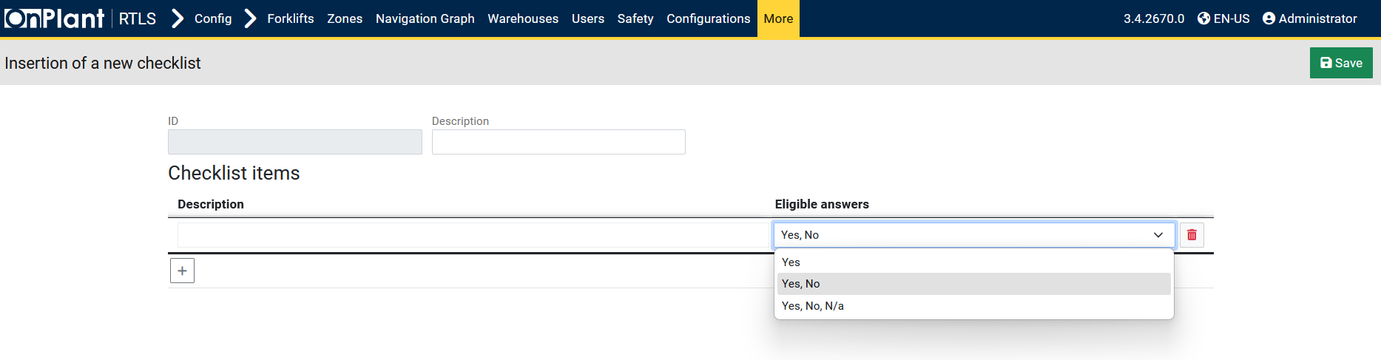

The **Insertion of a new checklist** page allows administrators to create customized checklists that appear when forklift operators log into the system. These checklists are used to verify operational and safety conditions before forklifts are activated, ensuring compliance with internal procedures and regulatory standards.

**Layout Overview**

|  |  |
| --- | --- |
| Area | Description |
| ID | Automatically generated unique identifier for the checklist after saving (e.g., ChecklistLogin/1-A). This field is read-only. |
| Description | Text field where administrators enter the checklist title or purpose (e.g., “Daily Forklift Pre-Start Inspection”). |
| Checklist Items Section | Allows defining one or more checklist questions or verifications. Each checklist item represents a question the operator must answer before login is completed. |
| Add Item Button (+) | Adds a new checklist item row. Each row includes a description and eligible answers. |
| Delete Item (Trash Icon) | Removes the selected checklist item from the list. |

**Checklist Item Fields**

|  |  |
| --- | --- |
| Field | Description |
| Description | Text field describing the specific verification step or question (e.g., “Check tire condition”, “Ensure horn is operational”). |
| Eligible Answers | Drop-down menu for selecting the permitted response options for that item. Options include:  • **Yes** – Single affirmative response.  • **Yes, No** – Binary response type.  • **Yes, No, N/A** – Ternary response type, used when some questions may not apply. |

**User Actions**

|  |  |
| --- | --- |
| Action | Description |
| Add checklist items | Click the **+** button to add a new row. Enter a **Description** for each item and select suitable **Eligible answers**. |
| Remove checklist items | Click the **Trash icon** beside a row to delete it. |
| Save checklist | After defining all checklist items, click **Save** to register the checklist in the system. The checklist will now appear in the main **Checklist Login** table. |

### 4.17.3 Configuration – More – Checklist Login – History

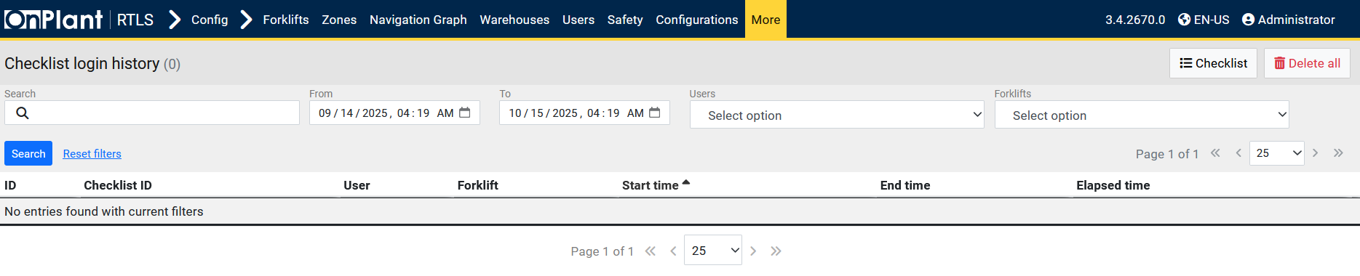

The **Checklist Login History** page records all completed checklist sessions performed during forklift logins. It provides a detailed log of when each operator filled out a checklist, which forklift was used, and how long the checklist process took. This data is useful for compliance auditing, verifying that safety checks are consistently executed, and reviewing user accountability over time.

**Layout Overview**

|  |  |
| --- | --- |
| Area | Description |
| Toolbar | • **Checklist** – Opens the main **Checklist Login** configuration page.  • **Delete all** – Permanently deletes all checklist history records from the database. Use with caution, as this action cannot be undone. |
| Filter Bar | Used to search and filter checklist history records. Includes:  • Search – Text field for keywords or ID lookup.  • From / To – Date and time range filters for recorded checklist sessions.  • Users – Drop-down list to filter by specific operator.  • Forklifts – Drop-down list to filter by forklift ID.  Buttons: Search to apply filters, Reset search to clear them. |
| Table | Displays a list of recorded checklist sessions that meet the selected criteria. Each record corresponds to a completed checklist during forklift login. |

**Table Columns**

|  |  |
| --- | --- |
| Column | Description |
| ID | Unique identifier for the checklist history entry. |
| Checklist ID | Identifier of the checklist template used (e.g., ChecklistLogin/1-A). |
| User | The operator or system user who completed the checklist. |
| Forklift | The forklift associated with the login session. |
| Start time | Timestamp indicating when the checklist began. |
| End time | Timestamp indicating when the checklist was completed. |
| Elapsed time | Duration of the checklist session, calculated as the difference between the start and end times. |

**User Actions**

|  |  |
| --- | --- |
| Action | Description |
| View historical records | Use the **From / To** fields to specify a date range, or filter by **User** or **Forklift** to view relevant sessions. Click **Search** to apply filters. |
| Reset search | Clears all filters and reloads the full history. |
| Return to checklist configuration | Click **Checklist** to navigate back to the **Checklist Login** setup page. |
| Delete all history | Click **Delete all** to permanently remove all entries. Recommended only during system resets or maintenance. |

## 4.18 Configuration – More – Tablet Script

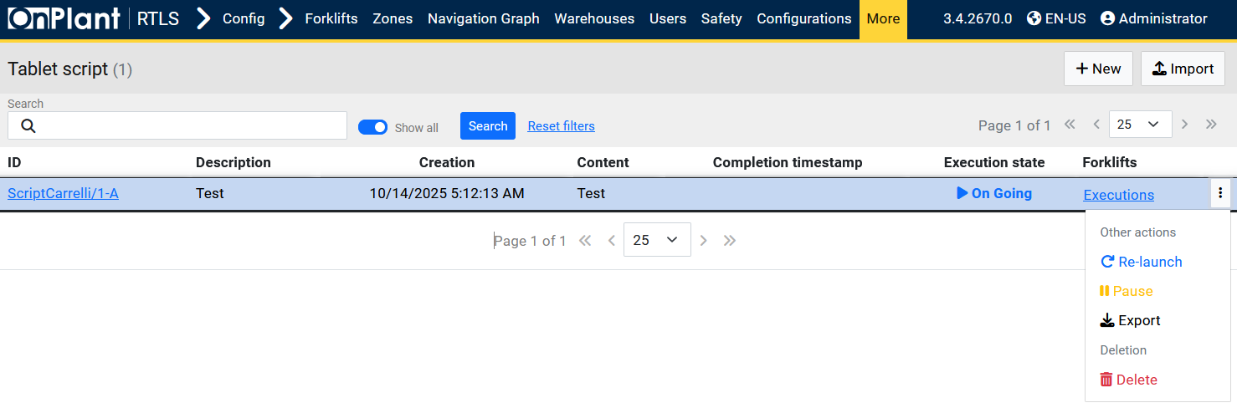  
Manage tablet automation scripts used by the OnRTLS Forklift Guidance System (FGS). It allows administrators to view, edit, import, or delete tablet scripts that control behavior or settings on forklift-mounted tablets.

**Layout Overview**

|  |  |
| --- | --- |
| Area | Description |
| Toolbar | • **+New** – Create a new tablet script. • **Import** – Opens the import dialog to upload a JSON script file. |
| Table | Lists existing tablet scripts. Columns visible in the screenshot:  • ID – Unique identifier (e.g., tabletscript/2-A). • Description – Short descriptive name of the script. • Last Modified – Date/time of the latest update. • User – Account that last modified the script. • ⋮ (Row menu) – Provides per-script actions such as Edit or Delete. |

**Field and Control Descriptions**

|  |  |
| --- | --- |
| Control / Field | Function |
| +New | Opens the creation form where a new tablet script can be written or pasted manually. |
| Import | Uploads an existing .json configuration file to add or update a tablet script. |
| Search bar | Filters scripts by name, ID, or description keyword. |
| Search / Reset search | Executes or clears the filter criteria. |
| ⋮ (Row menu) | Options for *Re-launch, Pause, Export, or Delete*. |

**User Actions**

1. **View existing scripts**  
   Scroll through the table to review available tablet scripts and their last modification dates.
2. **Search for a script  
   Type part of the ID or description into the Filtro box and click Search.  
   Use Reset search to clear the results.**
3. **Create a new script**  
   Click **+New** to open the creation form (see *4.18.1 Tablet Script – +New*).
4. **Import from file**  
   Click **Import** to load a JSON configuration file exported from another system.
5. **Delete entries**  
   Use **Delete filtered** for bulk removal or open the row menu (⋮) to delete an individual script.

**Technical Notes**

* Tablet scripts are stored as JSON configuration blocks executed by forklift-mounted tablets at startup or during synchronization.
* Each record includes metadata such as creator and last modification time for audit tracking.
* Imported scripts overwrite existing ones if IDs match.
* Changes take effect the next time a tablet reconnects to the OnRTLS service.

**Troubleshooting**

|  |  |  |
| --- | --- | --- |
| Issue | Possible Cause | Solution |
| Script not listed | Filter applied or search term mismatch. | Click Reset search. |
| Import fails | File format invalid or missing required fields. | Validate JSON structure before importing. |
| Delete filtered removes nothing | No active filters or user lacks permission. | Ensure filters are applied and user has Admin role. |

### 4.18.1 Configuration – More – Tablet Script – +New

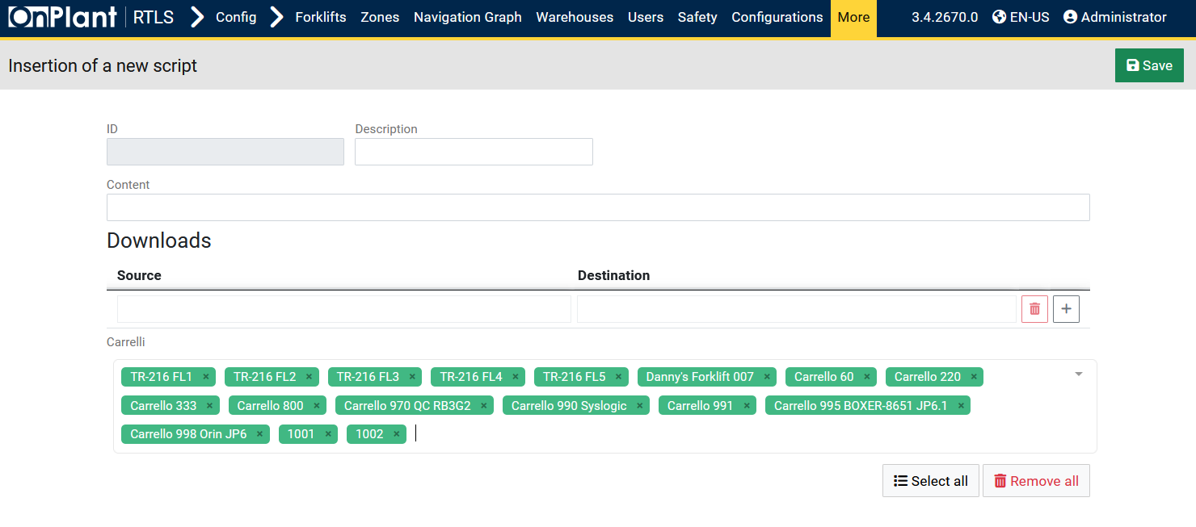

The **Insertion of a new script** page allows administrators to create and distribute a new tablet automation script for forklifts. This page defines the script’s identification, content, and destination forklifts where the script will be deployed.

**Layout Overview**

|  |  |
| --- | --- |
| Area | Description |
| Header | Displays the title *Insertion of a new script* and a **Save** button (top-right) to store the new script. |
| ID / Description Fields | Text fields for entering a unique script ID and a brief description of its purpose. |
| Content Field | A single-line input area for the script body or execution command. This typically contains a command, configuration string, or JSON-based directive. |
| Downloads Section | Defines file transfer or deployment settings for the script. Divided into **Source** and **Destination** input fields. |
| Source / Destination Fields | Used to define where the script originates and where it will be deployed. Administrators can manually specify or browse system paths. |
| Add/Delete Buttons | • **+** – Adds a new Source–Destination mapping row.  • **Trash icon (🗑)** – Deletes the selected mapping row. |
| Carrelli Section (Forklifts List) | Displays a list of forklifts to which the script can be applied. Each forklift is represented as a green tag (e.g., *TR-216 FL1*, *Carrello 333*, *Danny’s Forklift 007*). |
| Forklift Controls | Buttons below the list:  • **Select all** – Highlights or enables all forklifts.  • **Remove all** – Clears all selected forklifts. |

**Field Descriptions**

|  |  |
| --- | --- |
| Field | Description |
| ID | Unique identifier for the tablet script (e.g., ScriptCarrelli/1-A). Assigned automatically or manually. |
| Description | Short name describing the script’s purpose (e.g., “FGS Tablet Initialization”). |
| Content | Script command or text content executed by the tablet client. Example: JSON or shell-like commands used for configuration updates. |
| Downloads – Source | Path or reference to the original script file stored on the server. |
| Downloads – Destination | Path on the forklift tablet where the script should be saved or executed. |
| Carrelli Tags | Represents forklifts (by ID or name) assigned to receive the script. Each can be individually added or removed using the “×” symbol. |
| Select all / Remove all | Quick actions to bulk-assign or clear forklift selections. |

**User Actions**

1. **Define Script Details**
   * Enter an ID and Description.
   * Input the script **Content**.
2. **Configure File Transfers (optional)**
   * Under **Downloads**, specify the **Source** and **Destination** paths.
   * Use **+** to add additional path pairs if needed.
   * Use **🗑** to remove unused entries.
3. **Assign Forklifts**
   * Select which forklifts will receive the script using the **Carrelli** tag list.
   * Click **Select all** to target all forklifts or **Remove all** to clear the list.
4. **Save Script**
   * Click **Save** (top-right) to store and deploy the new tablet script to the selected forklifts.

### 4.18.2 Configuration – More – Tablet Script – Import

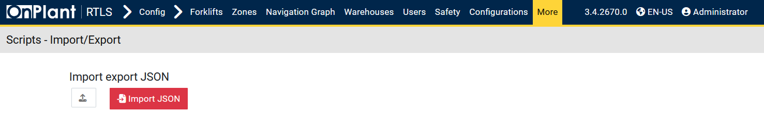

The **Scripts – Import/Export** page allows administrators to import tablet automation scripts from a JSON file into the OnRTLS system. This feature is primarily used to restore previously exported scripts or migrate configurations between installations.

**Layout Overview**

|  |  |
| --- | --- |
| Area | Description |
| Upload Button | Opens a file browser to select a .json file for upload. |
| Import JSON Button | Executes the import process for the selected file. Once clicked, the system reads and registers the scripts from the file. |

**User Actions**

1. **Import scripts**  
   Click **Import JSON** to upload and apply the configuration.  
   A confirmation message will appear once the import completes successfully.
2. **Verify import**  
   Return to **Configuration → More → Tablet Script** to confirm that all scripts were added or updated.

## 4.19 Configuration – More – Dotnet Runtimes

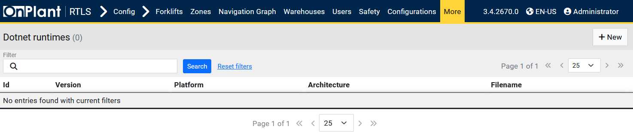

The .NET Runtimes page allows administrators to manage all installed and available .NET runtime versions used by OnRTLS backend services. These runtimes are required to execute OnRTLS applications and forklift-related services correctly. Administrators use this page to verify runtime paths, add or remove runtime versions, and ensure compatibility with installed software modules.

**Layout Overview**

|  |  |
| --- | --- |
| Area | Description |
| Toolbar | • **+New** – Opens a form to register a new .NET runtime path. |
| Search Bar | Allows filtering by ID. Includes Search and Reset search buttons. |
| Table | Displays the list of registered .NET runtimes and their configurations. Each row represents one runtime installation. |

**Table Columns**

|  |  |
| --- | --- |
| Column | Description |
| ID | Unique identifier for the runtime record (e.g., dotnetruntime/1-A). |
| Version | Displays the runtime’s version number as detected by the system. |
| Platform | Platform specification. |
| Architecture | Indicates the CPU architecture (e.g., x64, x86, ARM). |
| Filename | Name of file. |

**User Actions**

* **Add new runtime:**Click **+New**, to upload a .NET file.
* **Filter runtimes:**Use the Search bar to locate a runtime by version or description. Click Search to apply filters or Reset search to clear them.
* **Export runtime list:**Click **Export XLSX** to download the current runtime list in spreadsheet format.

### 4.19.1 Configuration – More – Dotnet Runtimes – +New

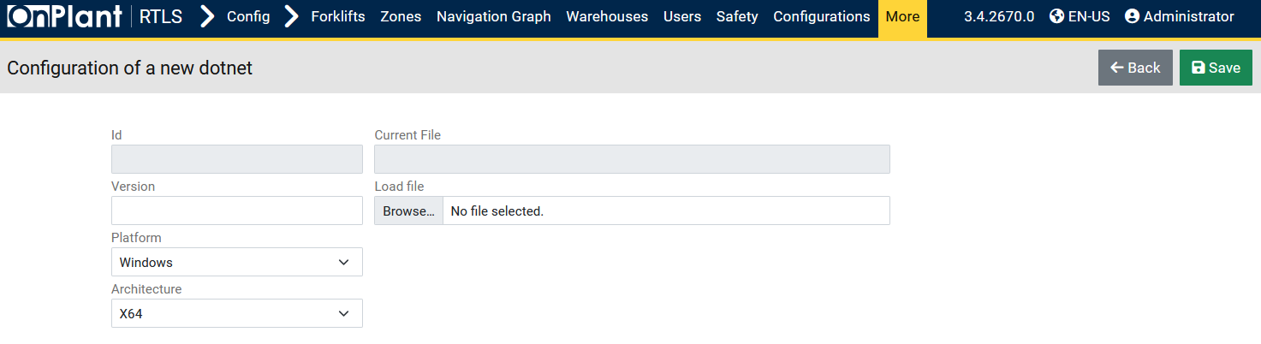

The Configuration of a new .NET page allows administrators to register and upload new .NET runtime files to the OnRTLS system. Each runtime entry defines a specific version, platform, and architecture used by OnRTLS services and forklift applications. This ensures compatibility and consistency between deployed software modules and the available .NET environments.

**Layout Overview**

|  |  |
| --- | --- |
| Area | Description |
| ID | Automatically generated field that uniquely identifies the runtime entry (read-only). |
| Version | Text field to enter the runtime version. |
| Platform | Dropdown menu to select the target operating system. Available options: **Windows**, **Linux**. |
| Architecture | Dropdown menu to select the CPU type supported by the runtime. Available options: **x64**, **x86**, **ARM**. |
| Current File | Displays the currently assigned runtime file (empty if creating a new entry). |
| Load File | Field with **Browse…** button to upload the runtime package file (e.g., .zip or .tar.gz). |
| Buttons | • Back – Returns to the previous page (.NET Runtimes list). • Save – Confirms the new runtime configuration and uploads the selected file to the server. |

**User Actions**

* **Add a new .NET runtime:**Click +New from the .NET Runtimes page to open the creation form.
* **Save configuration:**Click Save to register and upload the runtime. The entry will then appear in the .NET Runtimes table.

## 4.20 Configuration – More – HU Containers

Note. HU Containers define Width / Length / Height (mm). In Monitoring → Stock → +New, HU Dimensions are recorded as Width / Depth / Height for the placed HU.

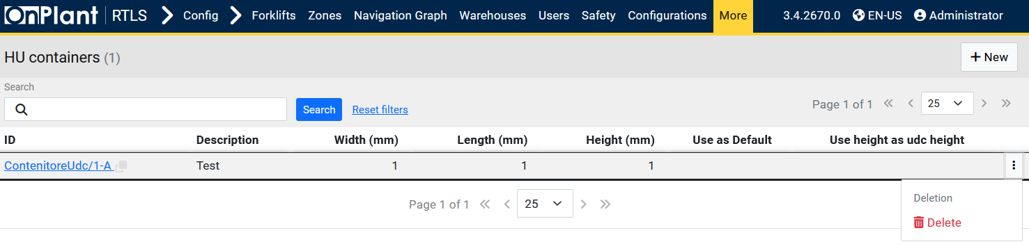

The **HU Containers** page allows administrators to manage container templates used for Handling Units (HUs). These templates define standard dimensions (width, length, height) for packaging or storage containers used within the OnRTLS system. Container definitions ensure that all Handling Units maintain consistent dimensional data for tracking, visualization, and stacking purposes.

**Layout Overview**

|  |  |
| --- | --- |
| Area | Description |
| Toolbar | • **+New** – Opens the form to add a new HU container. |
| Search Bar | Allows filtering of HU containers by ID or Description. Includes Search and Reset search buttons. |
| Table | Displays all configured HU container templates and their attributes. Each row represents one container configuration. |

**Table Columns**

|  |  |
| --- | --- |
| Column | Description |
| ID | Unique identifier for the HU container (e.g., ContenitoreUdc/1-A). Clicking the link opens the container configuration page. |
| Description | Descriptive name or label for the container type (e.g., “Test”, “EU Pallet Box”). |
| Width (mm) | Container width in millimeters. |
| Length (mm) | Container length in millimeters. |
| Height (mm) | Container height in millimeters. |
| Use as Default | Indicates whether this container template is set as the default model for new HUs. |
| Use height as UDC height | When enabled, automatically applies the container height as the HU height during HU creation. |
| ⋮ (Row Menu) | Option to *Delete*. |

**User Actions**

* **Add a new HU container:**  
  Click **+New** to create a new HU container template. Fill in container dimensions and configuration fields, then click **Save**.
* **Search for a container:**Use the Search bar to find containers by Description or ID. Click Search to filter results or Reset search to show all containers.
* **Set default container:**  
  Enable **Use as Default** for the container that should automatically apply to new Handling Units.
* **Apply container height to HU height:**  
  Enable **Use height as UDC height** to ensure the HU inherits the container’s defined height.
* **Edit container details:**Click the container ID link to open and edit its dimensions or settings.
* **Delete container:**  
  Open the **row menu (⋮)** and click **Delete** to permanently remove a container record.

### 4.20.1 Configuration – More – HU Containers – +New

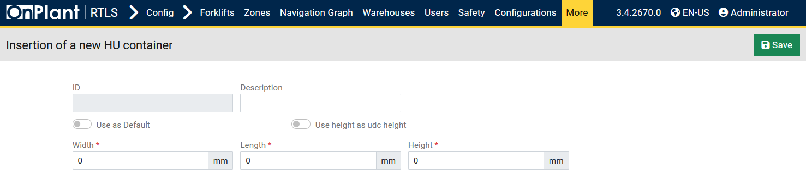

The **Insertion of a new HU container** page allows administrators to create and register new Handling Unit (HU) container templates. These templates define standardized physical dimensions for Handling Units and can be designated as the default model for future HU creations.

**Layout Overview**

|  |  |
| --- | --- |
| Area | Description |
| ID | Automatically generated identifier assigned after saving the container (read-only). |
| Description | Text field for entering a label or name for the container (e.g., “Standard Box”, “Pallet 1200x800”). |
| Use as Default | Toggle switch to designate this container as the default template for new Handling Units. Only one container can be default at a time. |
| Use height as UDC height | Toggle switch that applies the container height as the HU height automatically during Handling Unit creation. |
| Width / Length / Height | Numeric input fields (in millimeters) defining the physical dimensions of the container. All fields are required. |
| Save Button | Saves and registers the container template into the system database. |

**User Actions**

* **Create a new container:**  
  Click **+New** on the HU Containers page to open the insertion form.
* **Enter a description:**  
  Type a short name or description in the **Description** field.
* **Define dimensions:**  
  Enter **Width**, **Length**, and **Height** in millimeters. These are required values.
* **Set as default (optional):**  
  Toggle **Use as Default** if this container should automatically apply to all new Handling Units.
* **Enable automatic height (optional):**  
  Toggle **Use height as UDC height** to apply the container’s height directly to the HU height field during HU creation.
* **Save the container:**  
  Click **Save** (top-right) to confirm and register the new HU container.

## 5.1 Locations

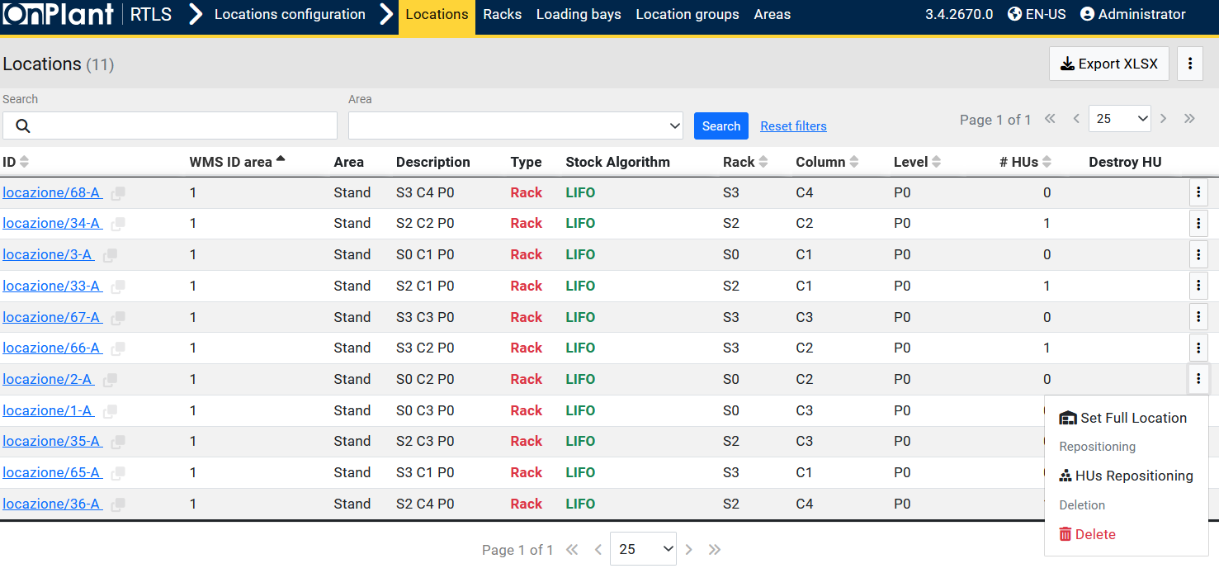

The **Locations** page displays all defined warehouse locations registered in the OnRTLS system. Each location represents a physical or logical position where Handling Units (HUs) can be stored, stacked, or moved. Administrators use this page to review, organize, and maintain warehouse layout consistency, including racks, stands, and columns used in RTLS and FGS operations.

**Layout Overview**

|  |  |
| --- | --- |
| Area | Description |
| Toolbar | • **Export XLSX** – Exports the currently visible locations to an Excel file. • **⋮ (Three-dot menu)** – Options to Import, Export, or download descriptions. |
| Search Filters | Two filter fields at the top:  • Search – Searches by location ID or description. • Area – Dropdown to filter by defined warehouse area.  Buttons: Search to execute and Reset search to clear. |
| Table | Displays all locations configured in the system. Each row represents a unique warehouse location with properties such as rack, column, level, and assigned stock algorithm. |
| Row Menu (⋮) | Provides per-location actions such as **Set Full Location**, **HUs Repositioning**, and **Delete**. |

**Table Columns**

|  |  |
| --- | --- |
| Column | Description |
| ID | Unique identifier for the location (e.g., locazione/68-A). Clicking opens detailed configuration for that location. |
| WMS ID area | Reference ID linking the location to the Warehouse Management System (WMS) integration area. |
| Area | Defines the zone or warehouse area to which this location belongs (e.g., Stand, Dock, Rack Area). |
| Description | Label or description of the location (e.g., “S3 C4 P0” = Shelf 3, Column 4, Position 0). |
| Type | Defines the structure type of the location (e.g., **Rack**, **Stand**, **Floor**). |
| Stock Algorithm | Specifies the algorithm used for Handling Unit placement, such as **LIFO** (Last-In, First-Out) or **FIFO** (First-In, First-Out). |
| Rack | Indicates the rack code or section associated with this location. |
| Column | Column identifier within the rack. |
| Level | Vertical position (e.g., P0, P1). |
| # HUs | Displays the number of Handling Units currently stored in that location. |
| Destroy HU | Indicates if the HU can be automatically destroyed when removed (for testing or simulation environments). |
| ⋮ (Row Menu) | Provides access to per-location management tools. |

**Row Menu Options (⋮)**

|  |  |
| --- | --- |
| Option | Description |
| Set Full Location | Marks the selected location as full, preventing further Handling Unit placement. |
| HUs Repositioning | Opens repositioning tools to move or reassign Handling Units within the same area or to another location. |
| Delete | Permanently deletes the selected location from the system. This action cannot be undone. |

**User Actions**

* **Search for locations:**Enter part of a location ID or description and click Search to filter results. Use Reset search to clear the search.
* **Review warehouse layout:**  
  Examine columns such as **Rack**, **Column**, and **Level** to understand physical structure and HU distribution.
* **Export location data:**  
  Click **Export XLSX** to download the list of all displayed locations for documentation or offline review.
* **Manage individual locations:**  
  Use the **Row Menu (⋮)** to perform actions such as **Set Full Location**, **HUs Repositioning**, or **Delete**.

## 5.2 Locations – Racks

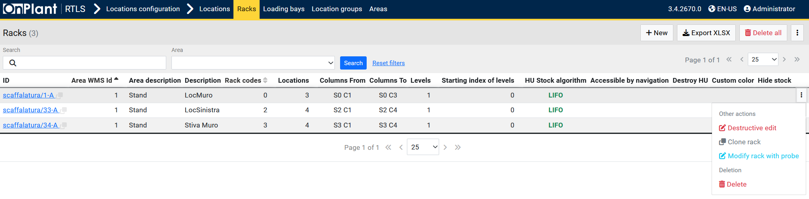

The **Racks** page manages warehouse rack structures used for Handling Unit (HU) storage within the OnRTLS system. Each rack defines a set of columns, levels, and positional ranges where HUs can be automatically or manually placed. Administrators use this page to create, organize, or edit rack configurations that represent the physical shelving structures in the warehouse.

**Layout Overview**

|  |  |
| --- | --- |
| Area | Description |
| Toolbar | • **+New** – Opens the form to create a new rack. • **Export XLSX** – Exports the list of racks to an Excel file. • **Delete all** – Removes all rack entries from the system (use with caution). • **⋮ (Three-dot menu)** – Displays additional options such as import/export or advanced rack tools. |
| Search Bar | Provides filters for finding racks by ID or Area.  Includes Search and Reset search buttons. |
| Table | Displays all configured racks, including their physical dimensions, levels, and column ranges. Each row represents one rack configuration. |
| Row Menu (⋮) | Provides actions for modifying, duplicating, or deleting individual racks. |

**Table Columns**

|  |  |
| --- | --- |
| Column | Description |
| ID | Unique rack identifier (e.g., scaffalatura/1-A). Clicking the link opens the rack configuration page. |
| Area WMS ID | Links the rack to its associated WMS (Warehouse Management System) area. |
| Area Description | Descriptive label of the area or zone where the rack is located (e.g., “Stand”). |
| Description | Custom label describing the rack’s purpose or position (e.g., “LocMuro”, “Stiva Muro”). |
| Rack Codes | Internal numeric code used to index or group racks. |
| Locations | Displays how many distinct locations are associated with this rack. |
| Columns From / To | Defines the range of columns in the rack (e.g., from S0 C1 to S0 C3). |
| Levels | Indicates the number of vertical levels in the rack (e.g., 1, 2, 3). |
| Starting Index of Levels | Shows the index offset used when numbering rack levels (default: 0). |
| HU Stock Algorithm | Defines how Handling Units are stocked or retrieved from the rack: **LIFO** (Last-In, First-Out) or **FIFO** (First-In, First-Out). |
| Accessible by Navigation | Indicates whether the rack is available for forklift navigation or automated routing. |
| Destroy HU | Marks whether Handling Units can be automatically removed when cleared from this rack (simulation/testing). |
| Custom Color | Defines the rack’s visual color in 3D maps or the Navigation Graph (if customized). |
| Hide Stock | Determines whether stock visibility is hidden for this rack in monitoring views. |

**Row Menu (⋮) Options**

|  |  |
| --- | --- |
| Option | Description |
| Destructive Edit | Opens the rack editor in overwrite mode, allowing full redefinition of structure and parameters. |
| Clone Rack | Creates a duplicate rack with identical parameters and layout. Useful for replicating multi-zone shelving configurations. |
| Modify Rack with Probe | Opens a configuration interface that allows users to adjust rack dimensions or alignment interactively using a probe (manual measurement or calibration feature). |
| Delete | Permanently removes the selected rack from the system. |

**User Actions**

* **Search for racks:**Enter part of the rack ID or area name in the Search field, then click Search.  
  Click Reset search to show all racks again.
* **Create a new rack:**  
  Click **+New** to define a new rack, specify columns, levels, and stock algorithms, then click **Save** (see section **5.2.1 Racks – +New**).
* **Export rack list:**  
  Click **Export XLSX** to download the current list of racks for documentation or audit use.
* **Edit or duplicate a rack:**  
  Open the **Row Menu (⋮)** and select **Destructive Edit** or **Clone Rack** to modify or replicate the structure.
* **Modify rack geometry with probe:**  
  Select **Modify Rack with Probe** to adjust rack measurements or alignment interactively.
* **Delete a rack:**  
  Use **Row Menu (⋮ → Delete)** to permanently remove an individual rack or **Delete all** from the toolbar to remove every entry.

**Technical Notes**

* Racks define structural hierarchy for HU placement and retrieval within areas and zones.
* **Columns** and **Levels** determine the geometric layout of storage points used in RTLS visualization.
* The **Stock Algorithm (LIFO/FIFO)** controls the logical order for storage and retrieval in forklift missions.
* **Destructive Edit** should only be used by administrators, as it overwrites all linked location data.
* Visual attributes such as **Custom Color** appear in **3D Live Map**, **Replay**, and **Navigation Graph** modules.

### 5.2.1 Locations – Racks – +New

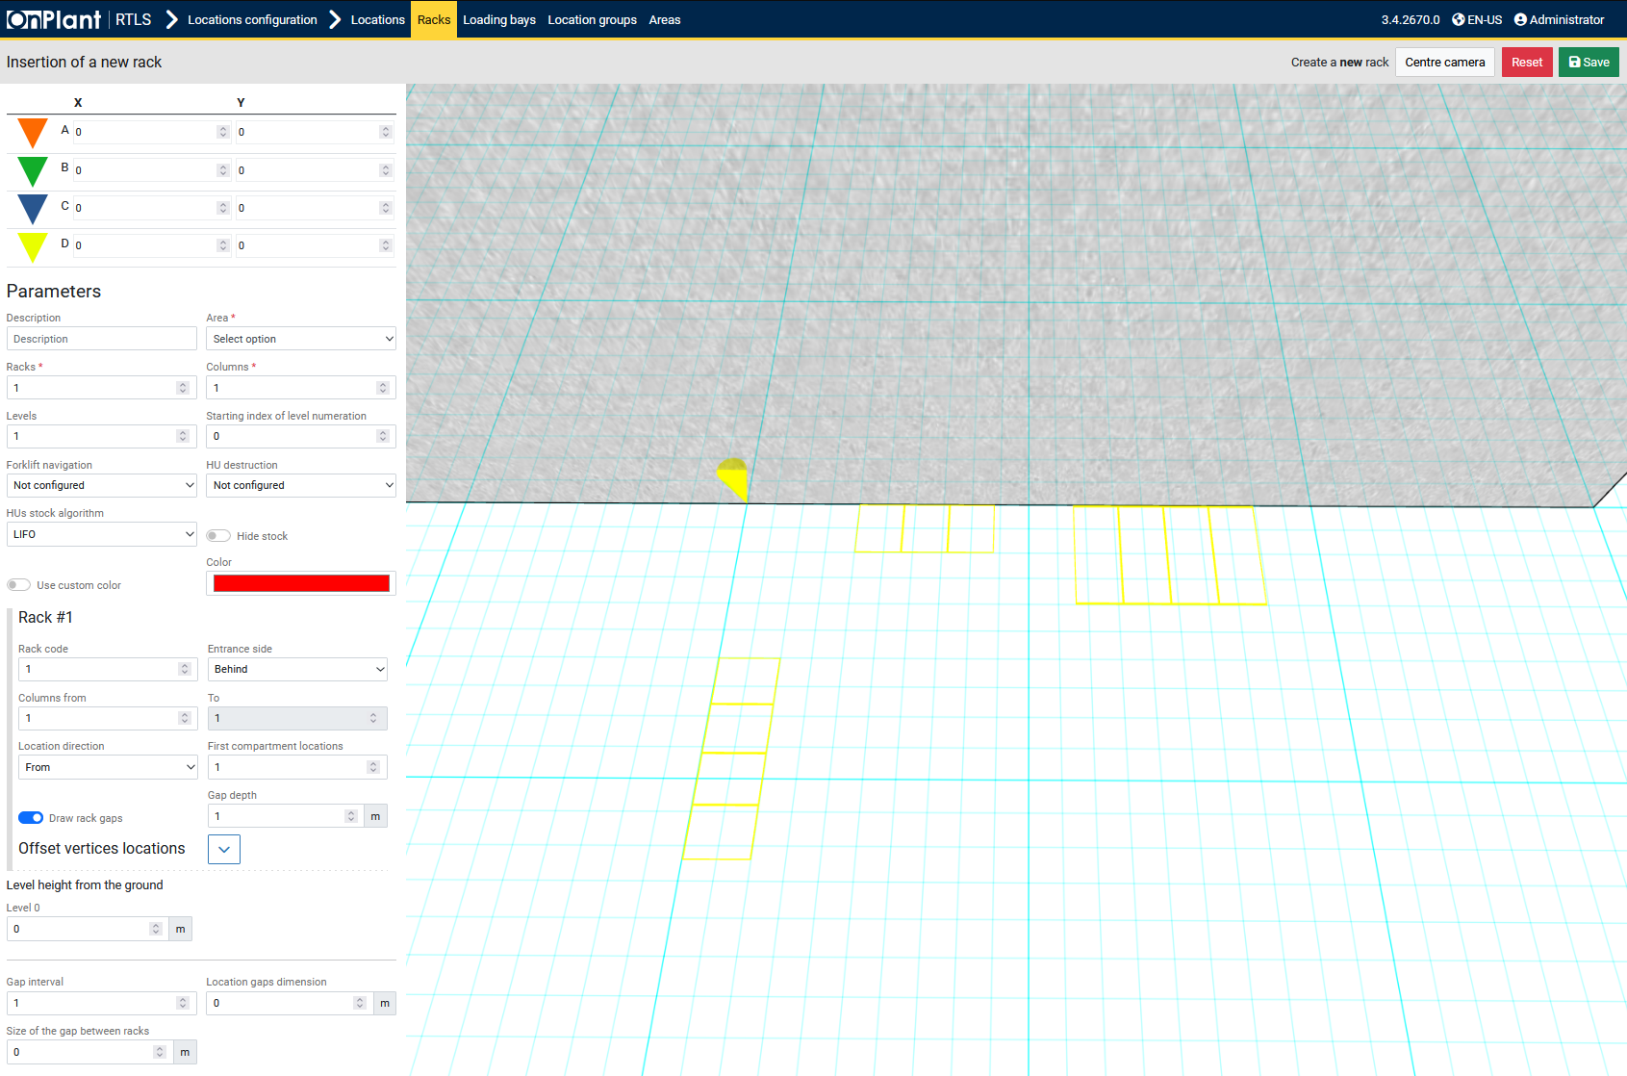  
The **Insertion of a new rack** page allows administrators to design and configure warehouse rack structures for Handling Unit (HU) storage. Each rack combines geometric coordinates, column and level counts, entrance side settings, and visual customization for precise RTLS representation and forklift navigation alignment.

**Layout Overview**

|  |  |
| --- | --- |
| Area | Description |
| Coordinate Points (A–D) | Four reference points (A, B, C, D) define the rack’s base corners on the warehouse grid. The X and Y coordinate values are used to position the rack accurately within the 3D layout. |
| Description | Text field for naming or describing the rack. Example: “Rack S3 East” or “Main Aisle.” |
| Area | Dropdown to assign the rack to a specific warehouse area. |
| Racks / Columns / Levels | Define the number of racks to generate, the number of columns per rack, and the number of levels vertically stacked. |
| Starting index of level numeration | Determines the starting number for level labels (0 or 1). |
| Forklift navigation | Dropdown to specify forklift accessibility: *Not configured*, *Enabled*, or *Disabled*. Determines if forklifts can route to or through this rack. |
| HU destruction | Configures whether Handling Units (HUs) in this rack can be destroyed or removed for test environments. |
| HUs stock algorithm | Sets how HUs are loaded and unloaded. Options: **LIFO** (Last-In, First-Out) and/or **FIFO** (First-In, First-Out). |
| Hide stock | When enabled, hides Handling Units stored in this rack from monitoring and map visualization. |
| Use custom color / Color | Enables color customization for the rack’s visual representation. Clicking the color field opens the color picker. |

**Rack Parameters Section**

|  |  |
| --- | --- |
| Field | Description |
| Rack code | Numeric identifier for the rack (e.g., 1, 2, 3). |
| Entrance side | Defines the loading side for forklift access: *Front* or *Behind*. |
| Columns from / to | Defines the start and end column index range. Example: *From 1 to 5* creates a five-column rack. |
| Location direction | Defines numbering direction of storage positions. Options: *From* or *To*. |
| First compartment locations | Starting index for compartment numbering (default = 1). |
| Gap depth | Distance between racks along the depth axis, measured in meters. |
| Draw rack gaps | Toggle switch to enable or disable visible spacing between racks in the visualization grid. |

**Offset and Height Settings**

|  |  |
| --- | --- |
| Field | Description |
| Offset vertices locations | Adjusts the X/Y offset for all corner points (A–D) collectively, shifting the rack position on the map. |
| Level height from the ground | Defines the base height (Level 0) in meters. Used for vertical positioning above floor level. |
| Gap interval | Distance between levels or tiers in meters. |
| Location gaps dimension | Controls spacing between storage compartments (widthwise). |
| Size of the gap between racks | Sets the space between adjacent racks, measured in meters. |

**User Actions**

1. Click **+New** on the *Racks* page to open the insertion interface.
2. Set X and Y coordinates (A–D) to define the rack’s footprint on the warehouse grid.
3. Under **Parameters**, enter a **Description** and assign the **Area**.
4. Configure **Racks**, **Columns**, and **Levels** according to the physical layout.
5. Set **Forklift navigation**, **HU destruction**, and **HU stock algorithm** as needed.
6. Choose whether to **Hide stock** or apply a **Custom color**.
7. In the **Rack #1** section, define **Entrance side**, **Columns from/to**, **Location direction**, and **Gap depth**.
8. (Optional) Toggle **Draw rack gaps** for visualization clarity.
9. Under **Offset vertices locations**, apply offsets if necessary to align geometry.
10. Define **Level height from ground**, **Gap interval**, and **Gap dimensions**.
11. Click **Save** (top-right) to store and render the new rack configuration.

## 5.3 Locations – Loading Bays

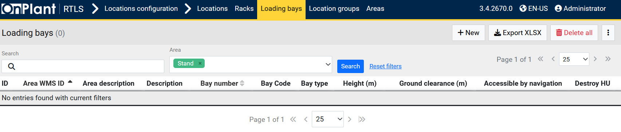

The **Loading Bays** page lists and manages all dock and transfer bay locations used for loading or unloading Handling Units (HUs) within the warehouse. Each loading bay entry defines its area, physical height, clearance, and navigation properties, allowing forklifts and missions to correctly associate pick-up or drop-off actions with specific dock positions.

**Layout Overview**

|  |  |
| --- | --- |
| Area | Description |
| Toolbar | • **+ New** – Opens the *Insertion of a new loading bay* page (see 5.3.1).  • **Export XLSX** – Exports the current table contents to an Excel spreadsheet.  • **Delete all** – Removes all loading bay entries from the system (use with caution).  • **⋮ (Three-dot menu)** – Opens additional options such as import/export or data tools if available. |
| Search Filters | Positioned below the toolbar. Includes:  • Search – Text field for locating loading bays by ID or description.  • Area – Dropdown selector for filtering bays by assigned area.  • Search / Reset search buttons – Apply or clear active filters. |
| Table | Displays all configured loading bays. Each row represents one bay record, showing its geometric and operational parameters. |

**Table Columns**

|  |  |
| --- | --- |
| Column | Description |
| ID | Unique identifier for the loading bay (e.g., bay/1-A). Clicking opens its configuration page. |
| Area WMS ID | References the Warehouse Management System area linked to this bay. |
| Area description | Name or label of the warehouse area containing the bay. |
| Description | Custom label for the loading bay (e.g., “Dock 01”, “Bay West A”). |
| Bay number | Internal numeric code representing the bay index. |
| Bay code | System code or short identifier for quick reference. |
| Bay type | Defines the function or structural type of the bay (e.g., truck dock, internal transfer, receiving). |
| Height (m) | Vertical measurement of the bay surface or platform height above ground level. |
| Ground clearance (m) | Distance between floor and bay structure; used to validate forklift approach and loading height. |
| Accessible by navigation | Indicates whether forklifts can navigate to this bay through the mission or navigation system. |
| Destroy HU | Shows whether Handling Units can be automatically destroyed or cleared when removed from this bay. |

**User Actions**

1. Use the Search field to locate bays by ID, description, or code.
2. Use the **Area** filter to view bays belonging to a specific warehouse zone.
3. Click Search to apply filters or Reset search to clear them.
4. Click **+ New** to register a new loading bay (see section **5.3.1 Locations – Loading Bays – +New**).
5. Click **Export XLSX** to download a spreadsheet of all visible loading bay data.
6. Use **Delete all** (with caution) to permanently clear all bay records.
7. Click an ID link to view or modify a bay’s configuration details.

**Technical Notes**

* Loading bay configurations define operational endpoints used in missions (e.g., “Load from Bay 1” or “Unload to Bay 3”).
* **Accessible by navigation** integrates directly with the Navigation Graph, ensuring forklift missions can route to valid dock positions.
* **Height** and **Ground clearance** values are essential for physical docking alignment between forklifts and platforms.
* **Destroy HU** should only be enabled for simulation or testing environments.
* Exported data includes all table columns and current filter results for documentation or audit purposes.

### 5.3.1 Locations – Loading Bays – +New

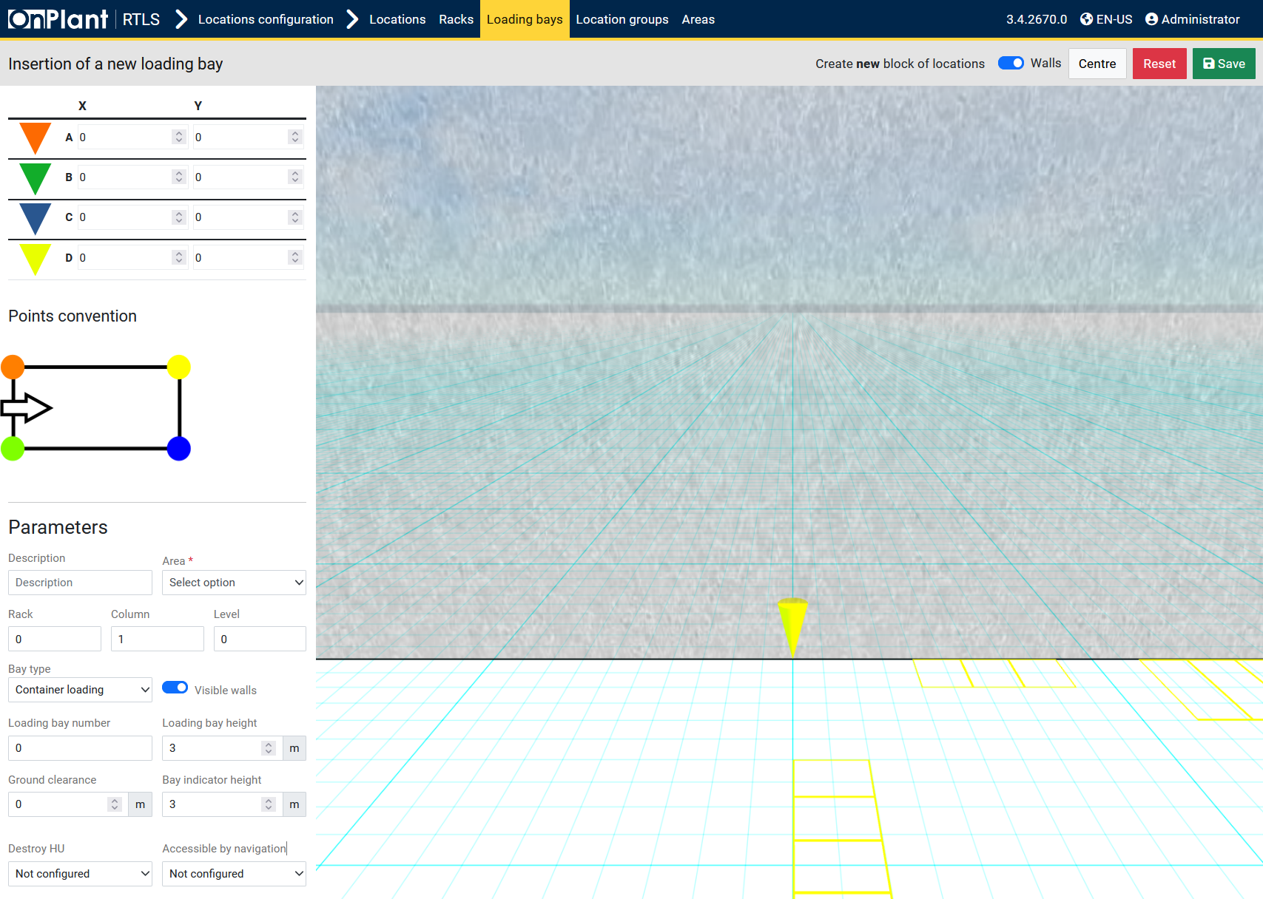

The **Insertion of a new loading bay** page allows administrators to define and position warehouse loading or unloading bays used by forklifts and missions. Each bay configuration establishes its coordinates, area assignment, type, height, and navigation visibility inside the 3D RTLS environment.

**Layout Overview**

|  |  |
| --- | --- |
| Area | Description |
| Coordinate Points (A–D) | Four vertices (A → D) define the loading bay’s footprint on the warehouse grid. X / Y values position the bay precisely in 3D space. |
| Points Convention Diagram | Visual guide showing the orientation of the four points that outline the bay rectangle and its forklift entry direction. |
| Description | Text field for naming or labeling the loading bay (e.g., “Dock 01” or “Container Bay A”). |
| Area* | Dropdown to assign the loading bay to an existing warehouse area. |
| Rack / Column / Level | Optional positional identifiers that define the bay’s logical grid reference. |
| Bay type | Dropdown specifying operational purpose: *Container loading*, *Truck dock*, *Internal transfer*, etc. |
| Visible walls (Toggle) | Shows or hides bay wall outlines within the 3D environment. |
| Loading bay number | Numeric field for sequential numbering of loading bays. |
| Loading bay height (m) | Sets the platform elevation from the floor in meters. |
| Ground clearance (m) | Defines the clearance space below the bay deck for forklift or truck alignment. |
| Bay indicator height (m) | Specifies how high the visual marker or indicator appears within the 3D map. |
| Destroy HU | Option for automatic Handling Unit removal when a bay is cleared (used for simulation/testing). |
| Accessible by navigation | Determines whether forklifts can navigate to this bay through the mission or routing system. |
| Save / Reset / Center Controls | Buttons at top-right: Save stores the bay configuration; Reset clears inputs; Center re-centers the 3D camera view. |

**User Actions**

1. Click **+ New** from the *Loading Bays* page.
2. Define X / Y coordinates for points **A–D** to outline the bay on the grid.
3. Enter a Description and select the warehouse Area*.
4. Set optional **Rack**, **Column**, and **Level** identifiers.
5. Choose a **Bay type** (e.g., *Container loading*).
6. (Optional) Enable **Visible walls** to display bay outlines in the 3D view.
7. Configure **Loading bay number**, **Height**, **Ground clearance**, and **Bay indicator height** in meters.
8. Select **Destroy HU** and **Accessible by navigation** options according to use case.
9. Use Center to reset the 3D camera view if needed.
10. Click **Save** (top-right) to register the new loading bay.

**Technical Notes**

* The four coordinate points (A–D) establish bay orientation and forklift entry alignment in the 3D scene.
* **Bay type** values determine how missions interpret the bay’s function (e.g., pickup vs delivery).
* **Height** and **Ground clearance** values must correspond to physical dock dimensions to ensure correct visualization and navigation offsets.
* **Accessible by navigation** integrates directly with the Navigation Graph for routing and mission assignment.
* **Destroy HU** should only be enabled in simulation setups; it permanently removes Handling Units when cleared.
* **Visible walls** helps verify geometric accuracy but may be disabled for performance or clarity in large facilities.
* Saved bays automatically appear in **Locations → Loading Bays** and become selectable in mission creation pages.

## 5.4 Locations – Location Groups

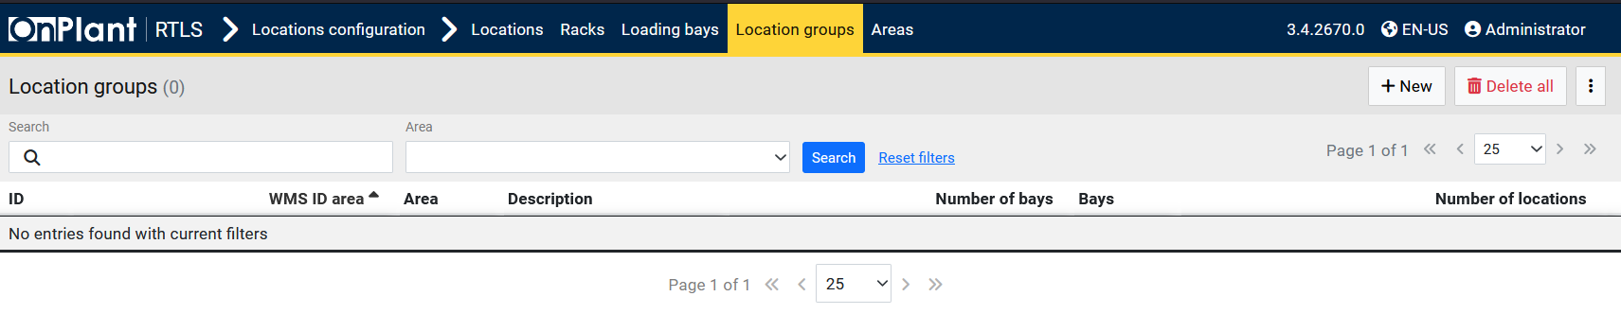

The **Location Groups** page allows administrators to organize warehouse racks, bays, and individual locations into logical groups. Grouping locations simplifies mission assignment, navigation, and stock organization by linking related areas under shared identifiers (e.g., all bays on the east wall, all racks in Zone A). These groups are also referenced by the Forklift Guidance System (FGS) for optimized route selection and zone-based operations.

**Layout Overview**

|  |  |
| --- | --- |
| Area | Description |
| Toolbar | Found at the upper-right corner. Provides page-level controls:  • **+ New** – Opens the *Insertion of a new location group* form (see 5.4.1).  • **Delete all** – Permanently removes all existing location groups (use with caution).  • **⋮ (Three-dot menu)** – Opens additional administrative options such as import/export or configuration tools if available. |
| Search Filters | Located under the header bar.  • Search – Searches groups by ID or description.  • Area – Dropdown filter to limit results by warehouse area.  • Search / Reset search – Apply or clear active filters. |
| Table | Displays all configured location groups with summarized details including assigned areas, number of bays, and number of locations. Each row represents a single group entry. |

**Table Columns**

|  |  |
| --- | --- |
| Column | Description |
| ID | Unique identifier of the location group (e.g., gruppoloc/1-A). Clicking opens the group configuration page. |
| WMS ID area | Identifies the Warehouse Management System (WMS) area associated with this location group, if applicable. |
| Area | Warehouse area in which this group operates (e.g., “Stand,” “Dock Zone”). |
| Description | Custom label for the location group (e.g., “Docking Area A,” “East Racks”). |
| Number of bays | Displays how many loading bays belong to this group. |
| Bays | Lists associated bay identifiers or codes within the group. |
| Number of locations | Shows how many total locations (rack positions, stands, or points) are contained in this group. |

**User Actions**

1. Use the Search field to find groups by ID or description.
2. Use the **Area** filter to narrow results to a specific warehouse zone.
3. Click Search to apply filters or Reset search to clear them.
4. Click **+ New** to create a new location group (see section **5.4.1 Locations – Location Groups – +New**).
5. Click a group ID to open and modify its configuration.
6. Use **Delete all** (with caution) to remove every existing group.

**Technical Notes**

* Location groups serve as hierarchical containers for **racks**, **loading bays**, and **standalone storage positions**.
* Groups can be used in mission planning, reporting, and warehouse visualization to quickly identify related storage areas.
* Assigning locations to groups helps automate forklift routing and simplify area-based filtering in the Monitoring → Stock and Missions pages.
* The WMS ID area ensures synchronization between OnRTLS and external Warehouse Management Systems.
* Deleting a group does not delete its underlying racks or bays; it only removes their group association.

### 5.4.1 Locations – Location Groups – +New

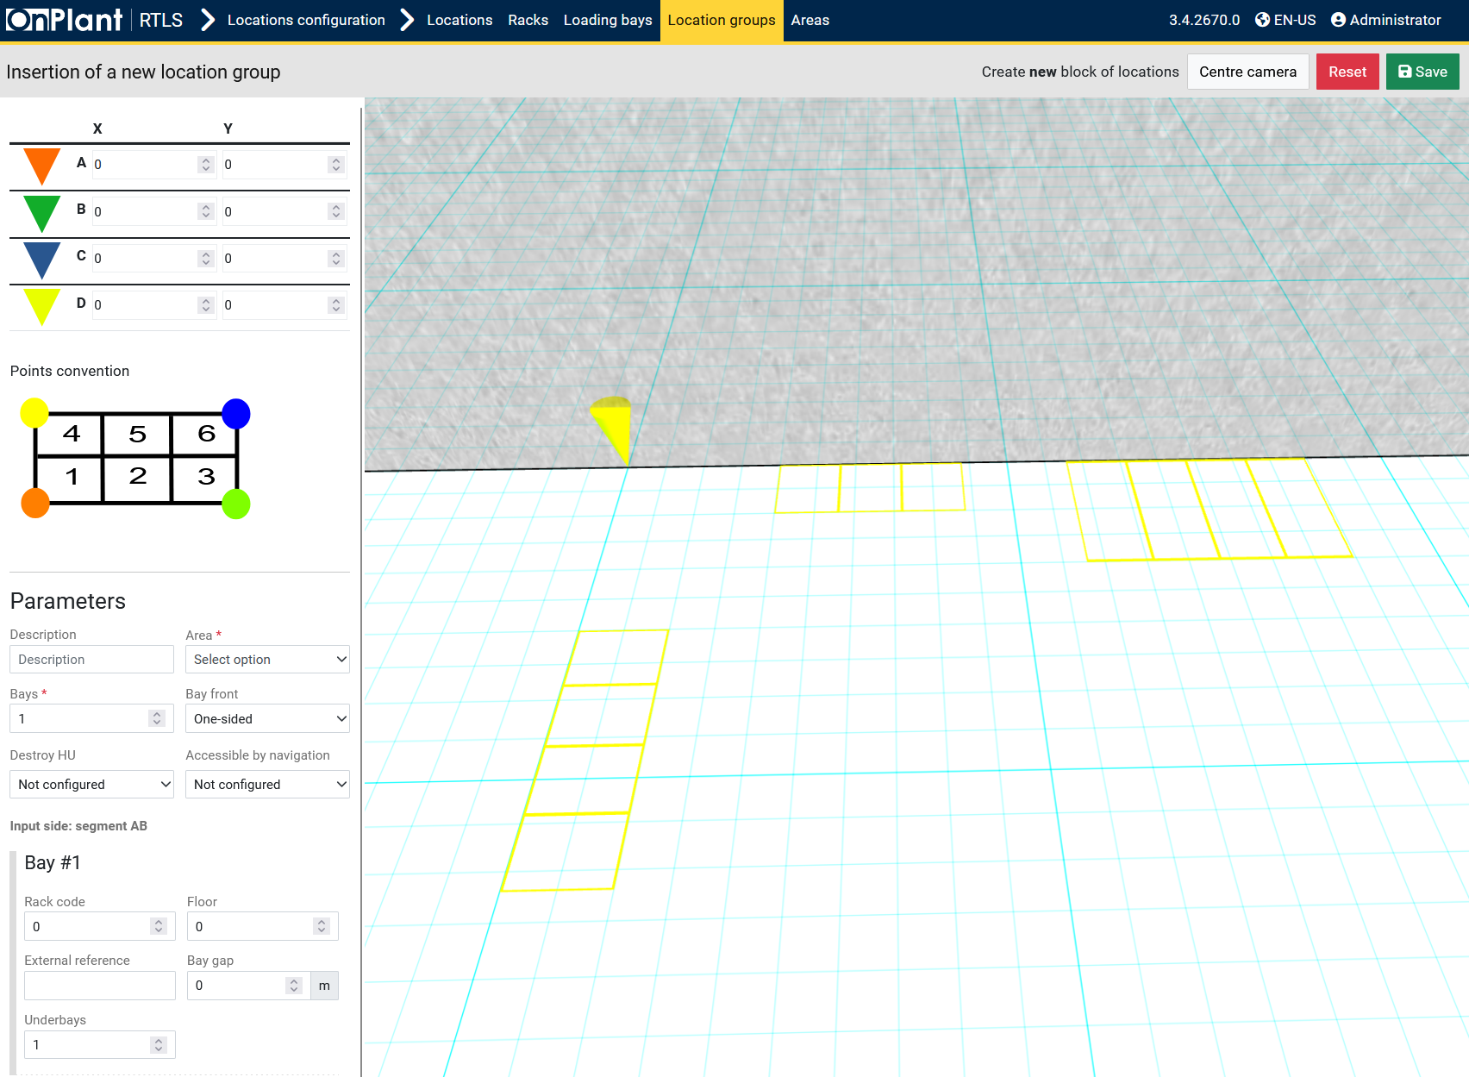

The **Insertion of a new location group** page allows administrators to create and define logical groupings of warehouse bays or racks within a shared area. Each group defines a geometric footprint, a set of bays, and structural references that determine how the grouped storage units appear and behave within the RTLS 3D environment.

**Layout Overview**

|  |  |
| --- | --- |
| Area | Description |
| Coordinate Points (A–D) | Four coordinate markers (A, B, C, D) define the outer corners of the location group on the warehouse grid. The X/Y fields position the group precisely in 3D space. |
| Points Convention Diagram | Illustrates the bay numbering pattern and forklift entry orientation. It displays the standard six-bay grid layout (1–6) for reference. |
| Description | Text field to name or describe the location group (e.g., “Group A – Front Docks”). |
| Area* | Dropdown list assigning the group to a warehouse area. Required field. |
| Bays* | Defines how many bays are contained within this group (e.g., 1–6). |
| Bay front | Determines access configuration: *One-sided* or *Two-sided*. This defines forklift entry direction relative to the bay layout. |
| Destroy HU | Sets whether Handling Units (HUs) within this group can be automatically destroyed when cleared (for test or simulation use). Options: *Configured / Not configured*. |
| Accessible by navigation | Determines whether forklifts can route to this group via mission or navigation paths. |
| Input side: segment AB | Displays which edge (segment) of the group serves as the entry side for forklift movement based on the coordinate points. |

**Bay (#1)**

|  |  |
| --- | --- |
| Field | Description |
| Rack code | Numeric identifier linking this group to a specific rack code if applicable. |
| Floor | Indicates the floor level index (default 0). |
| External reference | Optional external ID used for linking this group to a WMS or mapping system. |
| Bay gap (m) | Defines horizontal spacing between bays within the group in meters. |
| Underbays | Specifies how many sub-bays exist beneath the main bays (e.g., for multi-layered structures or mezzanine setups). |

**Top Bar Controls**

|  |  |
| --- | --- |
| Button / Toggle | Function |
| Center camera | Repositions the 3D camera to focus on the location group. |
| Reset | Clears all entered values and restores default parameters. |
| Save | Saves the new location group configuration and updates it in the main *Location Groups* list. |

**User Actions**

1. Click **+ New** on the *Location Groups* page to open the insertion interface.
2. Define coordinates **A–D** to set the group’s footprint.
3. Enter a **Description** and select the **Area**\* the group belongs to.
4. Specify the number of **Bays**\* and select **Bay front** configuration (*One-sided* or *Two-sided*).
5. Configure **Destroy HU** and **Accessible by navigation** options.
6. Under **Bay #1**, define the **Rack code**, **Floor**, **External reference**, and **Bay gap** as needed.
7. If multi-level bays are used, specify the **Underbays** count.
8. Use Center camera to reposition the map view or Walls toggle to visualize boundaries.
9. Click **Save** to register the new location group in the system.

**Technical Notes**

* The coordinate-based grid (A–D) defines the group’s orientation and physical placement within the RTLS map.
* Each group may include one or multiple bays arranged in the defined order from the *Points Convention* diagram.
* **Bay front** determines how forklifts and missions align with the bays—*One-sided* for front-facing docks, *Two-sided* for drive-through configurations.
* **Destroy HU** and **Accessible by navigation** interact directly with mission routing logic and simulation environments.
* Upon saving, each bay within the group automatically generates associated **locations** in the *Locations → Locations* table.
* Multi-level structures (using **Underbays**) are rendered in 3D visualization modules such as *3D Live Map* and *Replay* for spatial accuracy.

## 5.5 Locations – Areas

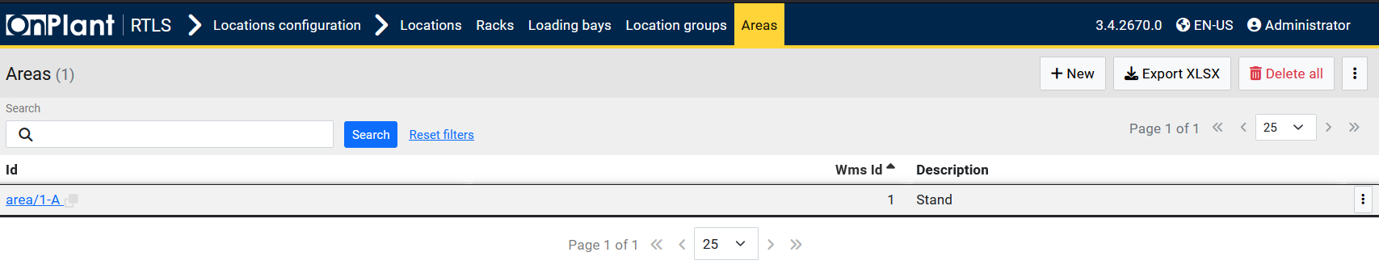

The **Areas** page manages the list of warehouse areas used throughout the OnRTLS system.  
Each area represents a distinct operational zone—such as *Stand*, *Dock*, or *Storage*—and is used to group racks, bays, and location groups under a single identifier.  
Areas serve as the foundation for all RTLS spatial configurations, ensuring forklifts, missions, and HUs are correctly associated with their physical regions in the warehouse.

**Layout Overview**

|  |  |
| --- | --- |
| Area | Description |
| Toolbar | Located in the top-right corner of the interface. Contains page-level controls:  • **+ New** – Opens the *Insertion of a new area* page.  • **Export XLSX** – Exports the current list of areas to an Excel file.  • **Delete all** – Permanently deletes all areas (use with caution).  • **⋮ (Three-dot menu)** – Opens additional import/export or administrative actions, if available. |
| Search Bar | Provides tools for filtering and locating specific areas:  • Search – Finds areas by ID, WMS ID, or description.  • Search / Reset search – Apply or clear active filters. |
| Table | Displays all defined warehouse areas. Each row corresponds to a single area and shows its identifiers and descriptions. |

**Table Columns**

|  |  |
| --- | --- |
| Column | Description |
| ID | Unique identifier for the area (e.g., area/1-A). Clicking the link opens the configuration page for that area. |
| WMS ID | Warehouse Management System identifier used to synchronize area information with external WMS or ERP systems. |
| Description | Text label or name of the area (e.g., “Stand,” “Dock,” “Rack Zone”). |

**User Actions**

1. Use the Search field to find specific areas by name or ID.
2. Click Search to filter or Reset search to clear the search.
3. Click **+ New** to create a new area.
4. Click **Export XLSX** to download the list of all visible areas.
5. Select **Delete all** to remove all entries (irreversible).
6. Click an ID link (e.g., area/1-A) to edit or review area details.

**Technical Notes**

* Every rack, bay, and location group must be assigned to one **Area**.
* The WMS ID ensures interoperability between OnRTLS and external warehouse systems.
* Areas act as parent entities in mission planning and forklift navigation logic, enabling area-based routing and mission restrictions.
* Deleting an area does **not** delete racks or bays but unlinks their area association until reassigned.
* Exported data includes all current areas and their corresponding WMS mappings for backup or audit purposes.

### 5.5.1 Locations – Areas – +New

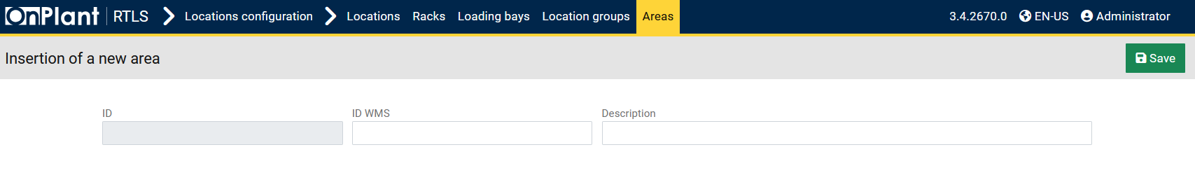

The **Insertion of a new area** page allows administrators to create and register a new warehouse area within the OnRTLS system. Each area defines a logical zone that groups racks, loading bays, and location groups. Areas are the highest organizational level in warehouse mapping and are referenced throughout mission planning, forklift routing, and stock management.

**Layout Overview**

|  |  |
| --- | --- |
| Area | Description |
| ID | Automatically generated unique identifier for the area (read-only). Example: area/1-A. |
| ID WMS | Optional identifier used to synchronize this area with an external Warehouse Management System (WMS). This ensures consistent mapping between OnRTLS and enterprise logistics systems. |
| Description | Text field for naming or labeling the area (e.g., “Stand,” “Dock Zone,” “Main Storage”). |
| Save Button | Located in the top-right corner. Saves the newly created area into the system database. |

**User Actions**

1. Navigate to **Locations → Areas**.
2. Click **+ New** to open the *Insertion of a new area* form.
3. (Optional) The ID field is generated automatically once saved.
4. Enter an ID WMS if integration with a warehouse system is required.
5. Provide a **Description** that clearly identifies the area’s purpose or region.
6. Click **Save** to confirm and register the new area.

**Technical Notes**

* Areas act as **parent entities** for racks, loading bays, and location groups, ensuring that all storage and mission points are properly categorized.
* Each area must have a **unique description** to avoid duplication in routing and reporting modules.
* The ID WMS field is optional but required for environments where OnRTLS is linked with ERP or WMS platforms.
* Once saved, the new area immediately appears in the **Areas** table and becomes selectable in the *Racks*, *Loading Bays*, and *Location Groups* creation forms.
* The ID value is auto-generated based on the system’s naming convention and cannot be edited manually.

## 6.1 Extensions

The **Extensions** module provides access to additional OnRTLS functionalities and third-party integrations. Each extension operates as an independent component that enhances the core system—for example, advanced analytics, automation scripts, or specialized tracking interfaces.

Detailed usage instructions, configuration parameters, and requirements for each extension are documented in their respective **extension-specific manuals**.  
Administrators should refer to those guides for setup, operational behavior, and maintenance procedures.

## 7.1 Glossary of Terms

|  |  |
| --- | --- |
| Term | Definition |
| RTLS | *Real-Time Location System* – Tracks forklifts, Handling Units, and assets in real time. |
| FGS | *Forklift Guidance System* – Provides on-board guidance, mission routing, and navigation control. |
| HU (Handling Unit) | A package, pallet, or load tracked within OnRTLS. Each HU carries identification, quantity, and position data. |
| WMS | *Warehouse Management System* – External system integrated for synchronization of missions and stock data. |
| KPI | *Key Performance Indicator* – Operational metric for measuring forklift activity, productivity, and utilization. |
| UWB | *Ultra-Wideband* – High-precision localization technology used for indoor tracking. |
| IMU | *Inertial Measurement Unit* – Sensor device measuring motion and orientation. |
| GPS | *Global Positioning System* – Satellite-based localization used for outdoor operations. |
| Dragonfly | Vision-based localization module providing camera-driven forklift positioning. |
| V2V | *Vehicle-to-Vehicle* – Safety communication for detecting and alerting nearby forklifts. |
| V2P | *Vehicle-to-Pedestrian* – Detection and alert system for pedestrians within forklift proximity. |
| Mission | A forklift task defining pick-up and drop-off operations for a Handling Unit. |
| Zone | Defined warehouse region grouping locations or safety areas. |
| Roaming Area | Defined area associated with a specific localization technology (e.g., Dragonfly, UWB). |
| Checklist Login | Operator safety checklist required before forklift activation. |
| Audit Log | Detailed telemetry record used for analysis and troubleshooting. |
| System Log | Centralized OnRTLS backend event record for services and processes. |
| FGS UI | Forklift terminal or web interface used by operators. |
| Navigation Graph | Node-based map defining forklift routing paths within the warehouse. |
| 3D Live Map | Interactive visualization showing forklift and HU positions in real time. |
| Safety Zone | Configurable area that triggers lights, buzzers, or slowdowns for hazard prevention. |
| Handling Unit Container | Template defining standard HU dimensions and physical container attributes. |

## 8.1 Document Control & Revision History

|  |  |  |  |
| --- | --- | --- | --- |
| Version | Date | Author / Department | Description of Changes |
| 1.0 | October 2025 | Onit OPE / Onit US | Initial release of the *OnRTLS Web Application – Comprehensive User Manual*. Includes all modules (RTLS, Monitoring, Configuration, Locations, Extensions) with screenshots and step-by-step instructions. |
| 1.1 | *—* | *—* | *Reserved for future feature updates, interface changes, and new extension modules.* |
| 1.2 | *—* | *—* | *Reserved for system configuration or workflow revision updates.* |

**Document Management**

* **File Name:** OnRTLS_Web_Application_Comprehensive_Manual_v1.0.docx
* **Maintained By:** Onit OPE / Onit US
* **Distribution:** Internal and Customer Release
* **Confidentiality:** Proprietary and confidential – Do not distribute outside authorized channels without permission.